Option C: Ecology and conservation
C.1 | Species and communities
U1 | The distribution of species is affected by limiting factors
U2 | Community structure can be strongly affected by keystone species
U3 | Each species plays a unique role within a community because of the unique combination of its spatial habitat and interactions with other species
U4 | Interactions between species in a community can be classified according to the effect
U5 | Two species cannot survive indefinitely in the same habitat if their niches are identical
A1 | Distribution of one animal and one plant species to illustrate limits of tolerance and zones of stress
A2 | Local examples to illustrate the range of ways in which species can interact within a community
A3 | The symbiotic relationship between Zooxanthellae and reef-building coral reef species
S1 | Analysis of a data set that illustrates the distinction between fundamental and realized niche
S2 | Use of a transect to correlate the distribution of plant or animal species with an abiotic variable
Limiting factors
- The distribution of a species describes the range where members of its population live
- Limiting factor is a factor present in an environment which limits the distribution or number of a population of organisms in an ecosystem
- Limiting factors can be either biotic (living) or abiotic (non-living)
  - Biotic factors include interactions between organisms. Either intraspecific (within) or interspecific (between species)
  - Abiotic factors include environmental conditions such as light, temperature, salinity, rainfall, wind velocity or soil pH
Law of Tolerance
- The law of tolerance was proposed by zoologist Victor Ernest Shelford in 1911
- This law states a certain organism’s survival and existence depend upon optimal survival conditions within critical minimal and maximal thresholds
- For every factor influencing growth, reproduction and survival there is an optimum level
- Above and below this optimum there is increasing stress until survival becomes impossible at limits of tolerance
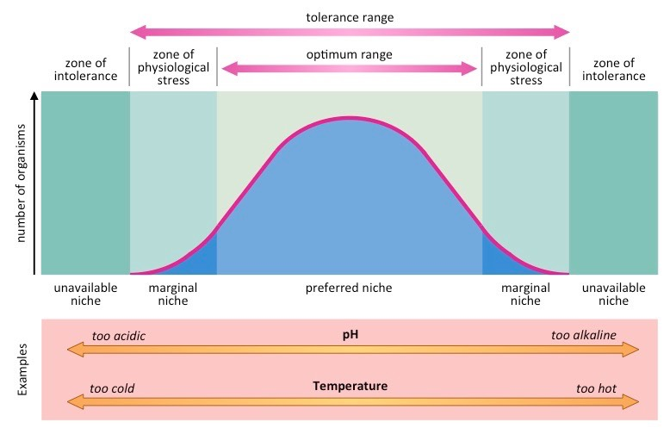
- The distribution of a species in response to a limiting factor can be represented as a bell-shaped curve with 3 distinct regions

- Optimal Range: Central Portion of the curve where the conditions favor maximal reproductive success and survivability
- Zones of stress: Regions surrounding the optimal zone, where organisms can survive but with reduced reproductive success
- Zones of intolerance: Outermost regions where organisms cannot survive (represents extremes of limiting factor)
- Examples of limits to tolerance and zones of stress:
 | Macropus rufus, red kangaroo | Encelia frutescens, button brittlebush
Adaptation | Has larger nasal openings than other kangaroos which gives it a good cooling ability  The kidney can also conserve water | Leaves transpire at a high rate which gives the plant evaporative cooling which prevents overheating
Distribution | Can be found in the arid (no rain) and hot area in the interior of Australia | Can be found in hot dry areas on the coast of California in areas of extreme heat and dryness
Zone of tolerance | Tolerates much lower mean precipitation and higher temperatures than other species of kangaroo. | Can tolerate hotter areas than other plants
Zones of Stress | However can’t live in the northern area of Australia because it is too wet | Must live where there are streambeds and desert washes. Its deep roots can reach moisture so that evaporative cooling can take place
Ecological Niche
- An ecological niche describes the relational and functional position and role of an organism in a particular ecosystem
- Niches consists of all physical and biological conditions which determine the organism’s survival and reproductive rates
- An ecological niche will be comprised of various components, including:
- Spatial habitat – the area in which the species lives
- Interactions with other species – depending on its place in the food chain it will have an impact on the species that it consumes and/or is consumed by
- If two species have the same niche, they cannot co-exist in the same community for long periods of time
- The two species will compete for the same resources (including habitat and nutrition)
- One species will out-compete the other, leading to the loss of one of the two species from the community. This is known as the competitive exclusion principle
- Some species may not be able to occupy their entire niche due to the presence or absence of other species
- Hence, a species may occupy a smaller subset of their niche than is theoretically possible (fundamental vs realized niche)
Fundamental Niche
- A fundamental niche represents the niche that a species could occupy
- It is the theoretical habitat and may not be fully occupied due to the presence of competing species
- Example: In a rocky shore environment, the Chthalamus barnacle can potentially occupy the entire rocky shore
Realized Niche
- A realized niche is the niche the species does occupy
- A realized niche is the set of conditions used by an organism after including interactions with other species
(where it does live)
- It is the actual habitat that is completely occupied by an organism in the presence of competing species
- Example: In a rocky shore environment, the Chthalamus barnacle only occupies regions where the Semibalanus barnacle is absent
- The reason why fundamental and realized niches aren’t ever the same is due to competition. Other species prevent a species from occupying part of its fundamental niche by out-competing or by excluding it in some other way

Species interactions
- Interactions between species in a community can be classified according to their effect on the organism involved
 | Definition | Examples
Herbivory | A herbivore consumes producers (plants). This affects numbers of herbivore and producer species in a community. | Monarch butterfly caterpillars feed on milkweed
Predation | Predation is consuming another consumer. Predation affects numbers of predator and prey species in a community. | Wolf and Deer
Parasitism | A type of symbiosis where one species benefits from the interaction and the other is harmed. Parasites typically live on or in a host species. | Ticks and Deer
Competition | Resources (such as nutrition and mates) are finite. Increased competition reduces the amount of resources. | Red oak and sugar maple in mixed forests
Mutualism | A type of symbiosis where both species benefit from their interaction (see card 132). A symbiotic relationship involves two species living closely together. | See below
Mutualism in Reef-Building Corals
- Most reef-building corals contain Zooxanthellae. Zooxanthellae are photosynthetic algae
- The interaction between algae and reef-building corals is mutualistic as both benefit from their close interaction.
- Most corals that build reefs contain mutualistic photosynthetic algae called zooxanthellae
- Benefits for coral:
  - Gain nutrients, including glucose, glycerol, and amino acids (these are the products of photosynthesis)
  - Waste products, including carbon dioxide and ammonia, are removed by the algae
- Benefits for Zooxanthellae:
  - Gain a protected environment that is exposed to sunlight
  - Gain carbon dioxide and water for photosynthesis.
Coral Bleaching
- It is the zooxanthellae which gives the coral its vibrant pigmentation
- When there is a large scale loss of zooxanthellae from the coral (due to environmental stress), bleaching will occur
- When bleaching occurs, coral begins to starve and die unless the zooxanthellae are restored
- Conditions which can cause coral bleaching include:
  - Changes in light availability: Sedimentation may increase the opacity of the water
  - Temperature increase: water temperatures in excess of 30°C can irrevocably stress the zooxanthellae
  - Ocean acidification: The build up of carbon dioxide concentrations in the oceans can lower pH and stress the algae

Keystone species
- A keystone species is a species on which many other species in a community depend
- Thus, they play a unique and essential role within a community
- A keystone species may be a predator that controls the numbers of herbivore species
  - For example, sea otters control numbers of sea urchins that would otherwise destroy kelp forests in the Pacific Northwest. Kelp forests are home to hundreds of species
- Herbivores can also be keystone species
  - For example, elephants maintain the African savanna by controlling tree numbers. The African savanna is home to a very diverse community of organisms. The loss of a keystone species would have a major impact on the structure of community, leading to the loss of many other species (directly or due to loss of habitat).
- A good method to determine whether an organism is a keystone species is to perform a removal experiment
Quadrats
- Quadrats and transects can measure the distribution of a plant or animal species in response to an incremental abiotic factor
- Quadrats are rectangular frames of known dimensions that can be used to establish population densities
- Transects are a straight line along an abiotic gradient from which population data can be recorded to determine a pattern
- Quadrats can be placed at regular intervals along the transect line in order to generate population data
- The quadrats will show the changing distribution pattern of a species in response to a change in an abiotic variable
- This data can be used to identify optimal conditinos as well as zones of stress and zones of intolerance
Transects
- A transect is a method of sampling at regular positions across an ecosystem, to investigate whether the distribution of a plant or animal species is correlated with an abiotic variable
- Sampling usually involves recording numbers of individuals in quadrats positioned along the transect line
C.2 | Community and ecosystems
U1 | Most species occupy different trophic levels in multiple food chains
U2 | A food web shows all the possible food chains in a community
U3 | The percentage of ingested energy converted to biomass is dependent on the respiration rate
U4 | The type of stable ecosystem that will emerge in an area is predictable based on climate
U5 | In a closed ecosystems energy but not matter is exchanged with the surroundings
U6 | Disturbance influences the structure and rate of change within ecosystems
A1 | Conversion ratio in sustainable food production practices
A2 | Consideration of one example of how humans interfere with nutrient cycling
S1 | Comparison of pyramids of energy from different ecosystems
S2 | Analysis of a climograph showing the relationship between temperature, rainfall and the type of ecosystem
S3 | Construction of Gersmehl diagrams to show the inter-relationships between nutrient stores and flows between taiga, desert and tropical rainforests
S4 | Analysis of data showing primary succession
S5 | Investigation into the effect of an environmental disturbance on an ecosystem
Food Webs
- A food web shows all the possible food chains in a community
- A food web is more representative of actual feeding pathways within an ecosystem because:
  - Organisms can have more than one food source
  - Organisms can have more than one predators
- This means that, unlike a food chain, organisms in a food web can occupy more than one trophic level
Energy Conversions
- Ecological production (or productivity) refers to the rate of generation of biomass in an ecosystem
- It is usually expressed in units of mass per area per time (kg m⁻² day⁻¹)
- Biomass is the total dry weight of organic matter in organisms or ecosystems
- Biomass is essentially the entirely of all biologically produced organic matter
- The percentage of energy that is converted into biomass is dependent upon a number of factors:
  - Energy is lost as inedible materials – such as bones, teeth and hair
  - Energy is lost via excretion of undigested and unabsorbed materials
  - Energy is lost as heat from cellular respiration (higher respiration rate results in more heat lost)
- After a consumer ingests food (chemical energy), organic molecules are taken up by cells (assimilated)
- The amount of energy assimilated is called gross production (GP)
- Only some of the assimilated molecules are converted to biomass (organic matter that is part of the organism)
- The amount of energy converted to biomass is called net production (NP)
- Not all assimilated molecules are converted to biomass because some are used in cell respiration (R)
- Energy released in the process of cell respiration is lost as heat. For an organism, NP = GP − R
- Respiration rate can vary in organisms; the higher the respiration rate, the lower the amount of ingested energy converted to biomass.
Energy conversion rates
- Feed conversion ratio (FCR) measures how efficiently an animal converts food to biomass
- It can be calculated using the following equation:
$$FCR=\frac{food intake (kg)}{net gain in biomass (kg)}$$
- The lower the feed conversion ratio the more efficient the method of food production
- Mammals and birds tend to have higher FCR values as they maintain a constant body temperature. Thus their, rates of respiration are higher
- Differences can also be explained by the type of feed used:
  - The higher the energy content of the food, the lower the FCR value
- The conditions the animals are kept in will also have an impact:
  - Reducing animal movement will also reduce the FCR value.
Types of ecosystems
- Ecosystems can be described as closed or open according to whether matter moves into and out of a system
  - In an open ecosystem, energy and matter (nutrients) are exchanged with the surroundings.﻿
  - In a closed ecosystem, energy is exchanged with the surroundings but matter is not exchanged
- An ecosystem is the interaction of living and non-living things within an area
- Particular types of stable ecosystems will emerge in a given geographical area according to climate conditions
- A biome is a geographical area that has a particular climate and sustains a specific community of plants and animals
- The main factors affecting the distribution of biomes is temperature and rainfall
- These factors will vary according to latitude and longitude, as well as altitude and proximity to the ocean
- There are a number of different biomes found across the continents, including:
  - Tropical rainforests: Hot and humid environments near the equator with dense vegetation and high biodiversity
  - Taiga: Coniferous forests near the poles that have cold temperatures and little precipitation (moisture trapped as snow)
  - Deserts: Dry and arid environment that display extreme temperature conditions (hot and cold)

Ecosystem Analysis
Climograph
- A climograph is a graphical representation of basic climatic parameters at a given geographical location
- It is a diagram which shows a combination of monthly average temperature and precipitation (rainfall) at a certain location
- Climographs provide a quick view of the climate of a region and can be used to identify seasonal patterns and changes
- Climographs can help distinguish biomes according to their average yearly temperatures and rainfall (precipitation)
  - Deserts will have high average temperatures but low precipitation (hot and dry)
  - Rainforests will have high average temperatures and high precipitation (warm and wet)
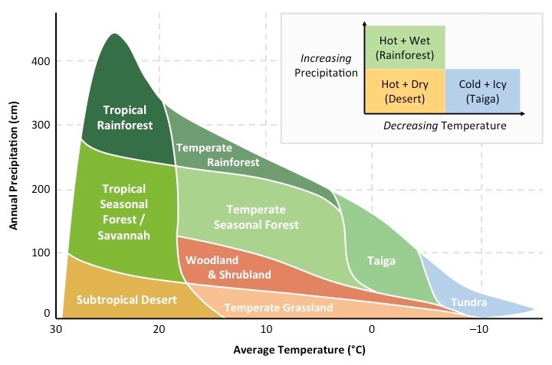
  - Taigas will have low average temperatures and reasonably low precipitation (cold and icy)

Pyramids of Energy
- Pyramids of energy show the flow of energy between trophic levels and are measured in units of energy per time
- The standard units for a pyramid of energy are kJ m⁻² y⁻¹
- Pyramids of energy are always triangular and never inverted as ~90% of energy is lost between trophic levels
- Pyramids of energy are different between ecosystems due to the effect of climate on primary productivity
  - Warmer temperatures will speed up enzyme reactions required for photosynthesis, increasing the amount of energy
  - High precipitation will also increase photosynthesis as the photolysis of water is essential for non-cyclic photophosphorylation
- Consequently, tropical rainforests have a high net primary productivity (NPP), whereas deserts have a low NPP
  - Ecosystems with higher productivity will be able to supply more energy to consumers and hence support more trophic levels. Therefore a pyramid of energy for a tropical rainforest will display a wider base and more levels than a desert
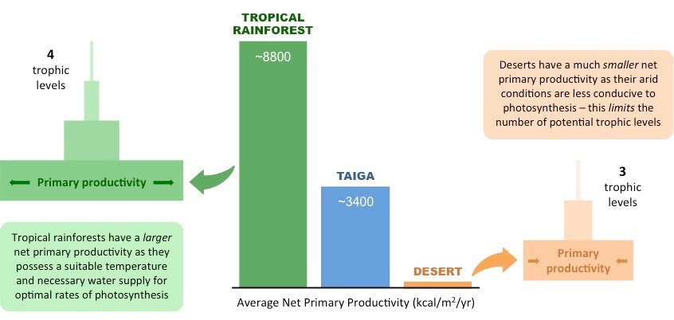

Gersmehl Diagrams
- Gersmehl diagrams show the differences in nutrient flow and storage between different types of ecosystems
- Nutrients are stored in one of three nutrient sinks:
  - Biomass is the total mass of living organisms (mainly plant tissue) in a given area
  - Litter is any organic matter in and on the soil. It includes humus and leaf litter
  - Soil is the top layer of the earth that is composed of disintegrated rock particles
- Nutrients can be transferred between nutrient sinks and may also be cycled via environmental inputs and outputs
  - Nutrients can be transferred from biomass to litter, litter to soil, or soil to biomass
  - Litter can additional gain nutrient via precipitation and lose nutrients in surface runoff
  - Soil can gain nutrients from the erosion of rocks via weathering, but will lose nutrients via leaching
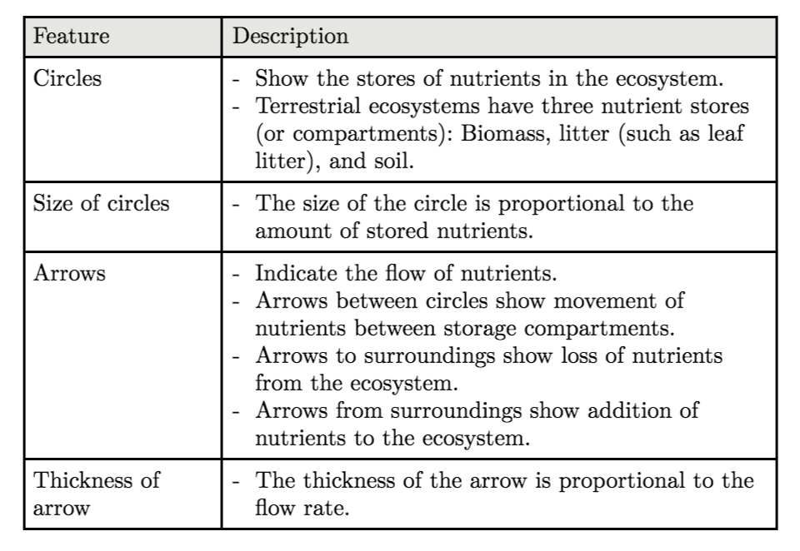

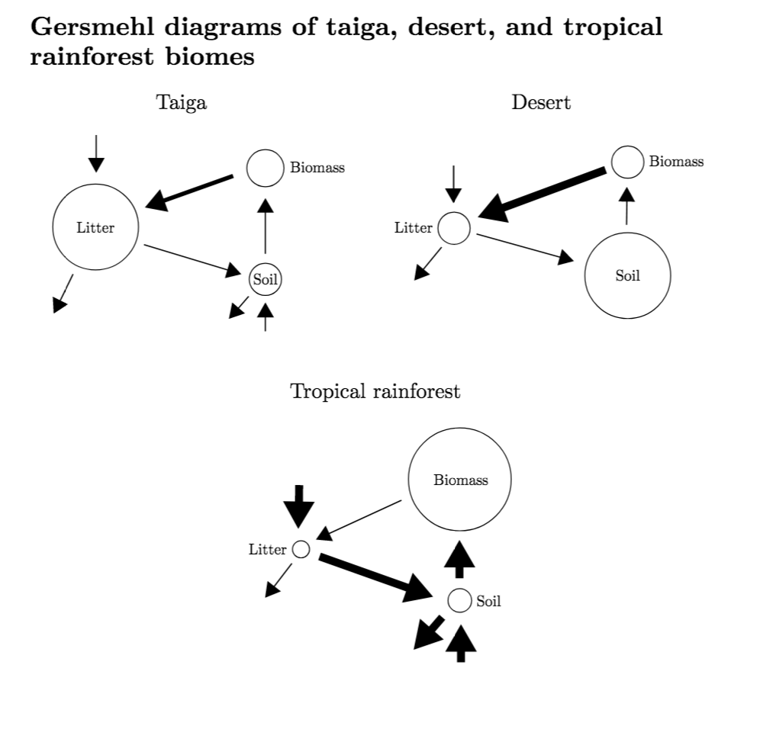

Ecological succession
- Ecological succession is the change in an ecosystem over time
- It involves interactions between the community and the abiotic environment
- The climax community is reached when succession has ended and the community has all of its characteristics
Primary Succession
- Primary succession occurs when communities develop on entirely new land without any established soil
- This may occur at river deltas, glaciers, sand dunes or on exposed rock
- The organisms which first colonize the region are called pioneer species and typically consist of lichen or moss
- As lichen and moss die, they decompose, which creates the first organic soil capable of sustaining plant growth
- As plant species colonize the area, the litter produced by their growth and their decomposing remains will cause changes:
  - Soil depth will increase (as plants add humus to the soil), and soil pH will become altered
  - Soil mineral content will increase and rocks will begin to be broken down by the action of roots
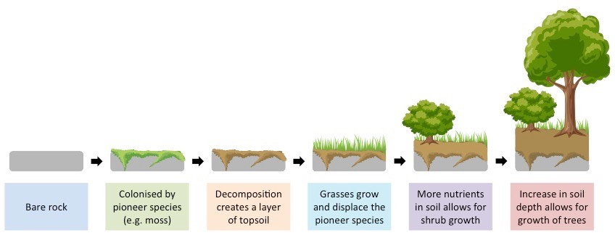
  - The soil will become aerated and water retentions is increased (drainage is reduced)
- These changes will allow for the growth of larger plants, which will reduce erosion through the binding of their roots
- Not all plants will thrive in unison, larger plants will eventually outcompete smaller shade intolerant plants

- A primary succession sequence can be identified according to the distribution of plants at a site of ecological nascency
  - This is a location where a new community may emerge from uninhabitable land: such as a costal sand dunes or glacier
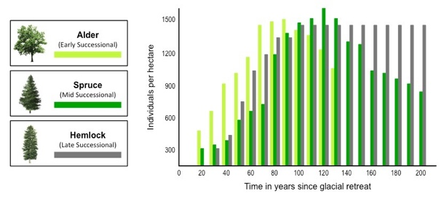
  - The religion closer to the site of ecological nascency will be in the earlier chronological stages of succession
- Glacial retreat exposes bare rock for colonization, so regions further from the glacier have had more time to develop life
- Hence regions further from the glacier are expected to contain larger trees common to a climax community while regions closer to the glacier are expected to contain plant life common to the earlier stages of primary succession
Ecological Disturbance
- A climax community is stable unless a disturbance occurs
- A disturbance can be caused by a natural event or by human activity
  - Natural events include fires, drought, and flooding
  - Human activities include logging, draining land, and introducing an alien species
- Environmental disturbances may cause fluctuations to the structure and rate of change within ecosystems
- Environmental disturbances may be natural or artificial (human induced) in origin
- Natural environment disturbance may give rise to secondary succession where one ecosystem is replaced by another
- Secondary succession occurs when succession starts on existing soil following the upheaval of a pre-existing ecosystem
  - This upheaval results in the removal of existing biota and allows a new ecosystem to develop on the site of the old
  - Because the soil is already developed, dominance is usually achieved by the fastest growing plants
- The progression of secondary succession can be summarized as follows:
  - An environmental disturbance, such as a bushfire or earthquake, destroys the pre-existing climax community
  - Grasses and herbaceous plants are the first to grow back as the soil is already present (no pioneer species required)
  - Fast growing trees will develop to their fullest, while shade tolerant trees will develop in the understory
  - Eventually the fast-growing trees may be overtaken by larger, slower growing trees as the ecosystem reverts to its prior state

C.3 | Impacts of humans on ecosystems
U1 | Introduced alien species can escape into local ecosystems and become invasive
U2 | Competitive exclusion and the absence of predators can lead to reduction in the number of endemic species when alien species become invasive
U3 | Pollutants become concentrated in the tissues of organisms at higher trophic levels by Biomagnification
U4 | Macroplastic and microplastic debris has accumulated in marine environments
A1 | Study of the introduction of cane toads in Australia and one other local example of the introduction of an alien species
A2 | Discussion of the trade-off between control of the malarial parasite and DDT pollution
A3 | Case study of the impact of marine plastic debris on Laysan albatrosses and one other named species
S1 | Analysis of data illustrating the causes and consequences of Biomagnification
S2 | Evaluation of eradication programmes and biological control as measures to reduce the impact of alien species
S2 | Analysis of a climograph showing the relationship between temperature, rainfall and the type of ecosystem
S3 | Construction of Gersmehl diagrams to show the inter-relationships between nutrient stores and flows between taiga, desert and tropical rainforests
S4 | Analysis of data showing primary succession
S5 | Investigation into the effect of an environmental disturbance on an ecosystem
Invasive Species
- An alien species is one that is not normally present in an ecosystem
- Species normally present are called endemic species
- Alien species are introduced into an ecosystem by humans; this can be deliberate or accidental
- If an alien species becomes present in high numbers, it is termed invasive; this is due to the absence of natural predators or pathogens. An invasive species has a damaging impact on the ecosystem.
  - If the alien species occupies the same niche as an endemic species, the two species will compete (interspecific competition)
  - Competitive exclusion by the alien species will lead to the reduction in numbers of the endemic species in the community (potentially leading to its complete loss)
  - Invasive species will also lead to a large reduction in other endemic species that it feeds upon.
- Example: Starlings have been introduced to North America and many other parts of the world and there are now hundreds of millions of these birds. They compete with endemic species for nest holes and food. They damage crops on farms and spread weed seeds in their feces
Population Control
- Controlling the population of invasive species once they become established is difficult and typically very expensive
- There are three main methods of population control:
Physical control
- Physical control involves the removal or restriction of invasive species by manual or mechanical measures
- This may include the installation of barriers and fences or the removal of habitat by excavation or trimming
- Population numbers may be reduced by hunting, trapping and culling, although these methods are labor intensive
- Physical methods to contain invasive species are usually not species specific and can also impede endemic wildlife
Chemical control
- Chemical control involves the use of chemical agents (poisons and toxins) to limit population numbers and spread
- Chemical agents may include herbicides, pesticides or other compounds
- Chemical agents may have moderate specificity, but can also detrimentally affect local wildlife and are costly to employ
- The effect of chemical agents may become more pronounced in higher trophic levels due to Biomagnification
Biological control
- Biological control involves using a living organisms (or a virus) to control an invasive species
- The biological agents must be carefully assessed before release to ensure they do not become invasive themselves
  - Ability to maintain its presence in the ecosystem
  - Impact on endemic species (considering interspecific competition, predator, and prey species)
  - Risk of it becoming invasive.
- Examples of agents include the Vedalia betle and the myxoma virus
- Biological control agents must be monitored for unintended side effects
Biomagnification
- Biomagnification is when the concentration of pollutants in the tissues of organisms increases with each trophic level
  - Bioaccumulation refers to the build up of a chemical substance in the tissues of a single organism
- Biomagnification occurs because organisms at higher trophic levels must consume more biomass to meet requirements
- Energy transformations are only ~10% efficient, so higher order consumers must eat more to meet energy demands
- This means that higher order consumers will experience increased contamination from a chemical substance
- An example of a chemical substance which is biomagnified is DDT (dichloro diphenyl trichloroethane)
- DDT is a chemical pesticide that is sprayed on crops and subsequently washed into waterways at lower concentrations
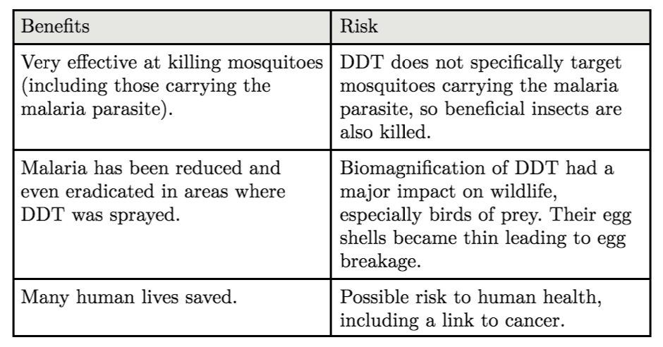
- It is fat soluble and is selectively retained within the tissues of an organism instead of being excreted

Plastic Pollution
- Plastics are a type of synthetic polymer found in certain types of clothes, bottles, bags food wrappings and containers
- Most plastics are not d=biodegradable and persist in the environment for many centuries
C.4 | Conservation of biodiversity
U1 | An indicator species is an organism used to assess a specific environmental condition
U2 | Relative numbers of indicator species can be used to calculate the value of a biotic index
U3 | In situ conservation may require active management of nature reserves or national parks
U4 | Ex situ conservation is the preservation of species outside their natural habitats
U5 | Biogeographic factors affect species diversity
U6 | Richness and evenness are components of biodiversity
A1 | Case study of the captive breeding and reintroduction of an endangered animal species
A2 | Analysis of the impact of biogeographic factors on diversity limited to island size and edge effects
S1 | Analysis of the biodiversity of two local communities using Simpson’s reciprocal index of diversity
Indicator species
- An indicator species can be used to determine specific environmental conditions, particularly types of pollution
- The extent of a type of pollution can be assessed by monitoring the presence or absence of indicator species
- For example, mayfly nymphs are only found in a stream if there is none or a very low level of organic pollution. Absence of mayfly nymphs indicates at least slight organic pollution in the stream

Biotic Index
- Biotic indices compare the relative frequency of indicator species and provide an overall assessment of environmental health
- In order to calculate biotic index:
$$Biotic Index=\frac{\sum{(n_{i}×a_{i})}}{N}$$
- Where:
  - $N$ is the number of individuals collected
  - $n_{i}$ is the number of individuals of a species
  - $a_{i}$ is the tolerance rating of a species
- A high biotic index indicates the presence of many pollution sensitive organisms, denoting an unpolluted environment
- A low biotic index indicates a polluted environment, due to a relative abundance of pollution tolerant organisms
- A change in the biotic index over time marks a change in the environmental conditions within a given ecosystem
Biodiversity
- Biodiversity describes the variety and variability of all living organisms within a given ecological area
- Biodiversity can be used to refer to the number of species, the genetic diversity or habitat variety
- There are two main components that contribute to biodiversity:
  - Species richness – this is the number of different species present
  - Species evenness – this is the number (abundance) of each species and allows comparison of population size.
Simpson’s reciprocal index
- The Simpson’s reciprocal index can be used to measure the relative biodiversity of a given community
- It takes into account both the number of species present and the number of individuals per species
- In order to calculate it:
- Use a random sampling technique to search for organisms in the ecosystem
- Identify each of the organisms found
- Count the total number of individuals of each species
- Calculate the index (D):
- $D=\frac{N(N-1)}{Σn(n-1)}$ where N=total number of organism n=number of individuals per species
- A higher index value is indicative of a greater degree of biodiversity within the community
- A high index value suggests a stable site with many different niches and low competition
- A low index suggests a site with few potential niches where only a few species dominate
- The index value may change in response to an ecological disturbance
In situ vs Ex Situ
- Conservation involves the protection and maintenance of natural resources – such as trees, water and wildlife
