Option B: Biochemistry
B.1 | Introduction to biochemistry
B.1.1 | The diverse functions of biological molecules depend on their structures and shapes
B.1.2 | Metabolic reactions take place in highly controlled aqueous environments
B.1.3 | Reactions of breakdown are called catabolism and reactions of synthesis are called anabolism
B.1.4 | Biopolymers form by condensation reactions and are broken down by hydrolysis reactions
B.1.5 | Photosynthesis is the synthesis of energy-rich molecules from carbon dioxide and water using light energy
B.1.6 | Respiration is a complex set of metabolic processes providing energy for cells
B.1.7 | Explanation of the difference between condensation and hydrolysis reactions
B.1.8 | The use of summary equations of photosynthesis and respiration to explain the potential balancing of oxygen and carbon dioxide in the atmosphere
Biochemistry
- Biochemistry: The study of chemical process in living matter
- Biochemical processes are known as metabolism
- Metabolism: The sum of the chemical reactions occurring in an organism
- Metabolic reactions take place in highly controlled aqueous environments
- Metabolic reactions can classified be anabolic or catabolic
Definitions
Anabolism – The synthesis of complex molecules from simpler units, it requires energy (endothermic)
Catabolism – The breakdown of complex molecules into simpler units, it releases energy (exothermic)

Formation of polymers
- The functions of biological molecules depend on their ﻿ shapes and structures.
- Biopolymers are commonly made of smaller, recurring sub units called monomers
- Biological polymers form by condensation reactions in which monomers react to form a polymer. This releases water
- Biological polymers are broken down by hydrolysis reactions in which a polymer breaks up into separate monomers. This requires water
Photosynthesis and Respiration
- Photosynthesis: The synthesis of energy rich molecules (like glucose) from carbon dioxide and water using light energy
- Photosynthesis Equation: 6CO₂ + 6H₂O → C₆H₁₂O₆ + 6O₂
- Photosynthesis is an anabolic process as photosynthesis takes CO₂ and H₂O (somewhat low energy molecules), and then assembles them into glucose. During photosynthesis oxygen is released
- Cell respiration: The controlled release of energy from organic compounds to produce ATP
- Respiration is a catabolic process because it breakdown small molecules. Respiration takes place in all living cells all the time.
  - Anaerobic respiration need oxygen molecules as reactants
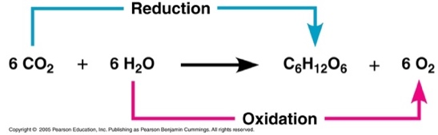
  - Aerobic respiration does not need oxygen molecules as reactants
- Respiration Equation: C₆H₁₂O₆ + 6O₂ → 6CO₂ + 6H₂O
- Respiration Half Equation: C₆H₁₂O₆ + 6H₂O → 6CO₂ + 24H⁺ + 24e⁻
6O₂ + 24H⁺ + 24e⁻ → 12H₂O
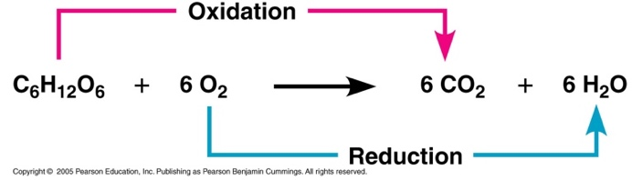
- Anaerobic respiration:
  - In yeast: C₆H₁₂O₆ → 2C₂H₅OH + 2CO₂ (Glucose → Ethanol + CO₂)
  - In animals: C₆H₁₂O₆ → 2C₃H₆O₃ (Glucose → Lactic Acid)
B.2 | Proteins and enzymes
B.2.1 | Proteins are polymers of 2-amino acids, joined by amide links (also known as peptide bonds)
B.2.2 | Amino acids are amphoteric and can exist as zwitterions, cations and anions
B.2.3 | Protein structures are diverse and are described at the primary, secondary, tertiary and quaternary levels
B.2.4 | A protein’s three-dimensional shape determines its role in structural components or in metabolic processes
B.2.5 | Most enzymes are proteins that act as catalysts by binding specifically to a substrate at the active site
B.2.6 | As enzyme activity depends on the conformation, it is sensitive to changes in temperature and pH and the presence of heavy metal ions
B.2.7 | Chromatography separation is based on different physical and chemical principles
B.2.8 | Deduction of the structural formulas of reactants and products in condensation reactions of amino acids, and hydrolysis reactions of peptides
B.2.9 | Explanation of the solubility’s and melting points of amino acids in terms of zwitterions
B.2.10 | Application of the relationships between charge, pH and isoelectric point for amino acids and proteins
B.2.11 | Description of the four levels of protein structure, including the origin and types of bonds and interactions involved
B.2.12 | Deduction and interpretation of graphs of enzyme activity involving changes in substrate concentration, pH and temperature
B.2.13 | Explanation of the processes of paper chromatography and gel electrophoresis in amino acid and protein separation and identification
Proteins
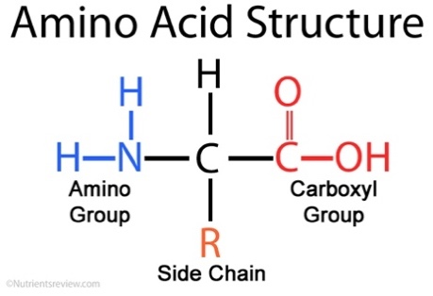
- Proteins are found in every cell and are fundamental to cell structure and operation
- Proteins are polymers built up from small monomer molecules called amino acids
- All amino acids have the alpha carbon bonded to a hydrogen atom (H), carboxyl group (COOH), and amino group (NH₂)
- The "R" group varies among amino acids
- 2-amino acids are proteins that specifically have a NH₂ and COOH bonded to the same carbon atoms
- Formula of 2-amino acids: RCH(NH₂)COOH
Functions of proteins in the body
- Structural: collagen
- Transportation: hemoglobin
- Enzymes: biological catalysts
- Protection: antibodies
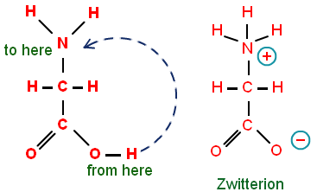
Amino Acids Characteristics
- Amino acids are also amphoteric (so amphiprotic). They can act as a Brønsted – Lowery acid or base by donating a proton or accepting a proton
- This also means that an ion can be formed that has both a negative and positive charge. This is called a zwitterion
- Zwitterion: A molecule having separate positively and negatively charged groups
- Since zwitterions contains both positive and negative charges they will cancel each other out and the overall charge will be neutral
- The isoelectric point of an amino acid is the pH that the amino acid will exist as a zwitterion
- A low pH has an acidic environment so there will be many H⁺ so the NH₂ becomes N⁺H₃. It becomes protonated
- A high pH has a basic environment so there will be many OH⁻ so the COOH becomes COO⁻. It becomes deprotonated
- Amino acids at a lower pH than its isoelectric point can be described as a cation
- Amino acids at a higher pH than its isoelectric point can also be described as an anion
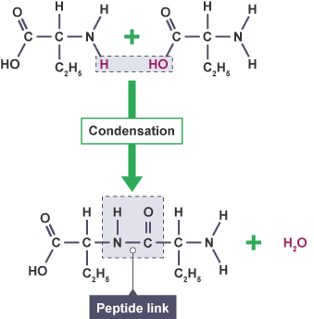
Peptide bonds/Amide Link
- Amino acids are linked together in proteins by a special kind of covalent bond known as a peptide bond or amide link
- Peptide bonds are formed by condensation reactions. H₂O is also released
- This bond occurs between a carboxyl group (COOH) on one molecule, and an amino group (NH₂) on another molecule
- Polypeptide chains can be broken down via hydrolysis reactions, which requires water to reverse the process
Peptides
- Molecules made from amino acids are called peptides
  - A dipeptide is formed when 2 amino acids join together to form a peptide chain
  - An oligopeptide is formed when 3-10 amino acids join together
  - A polypeptide is formed by many amino acids (>10)
- Polypeptides built with more than 50 amino acids are called proteins
- Polypeptides differ from one another by their length, number of amino acids and order of amino acids
- The amino acid sequence is what gives each polypeptide its unique properties
Protein Structure
- There are 4 levels of protein structure. These structures determine the function and shape of a protein
Primary Structure
- The primary structure refers to the sequence of amino acids in the polypeptide chain
- The primary structure is held together by peptide bonds (amide links)
- The sequence of a protein is unique to that protein, and defines the structure and function of the protein
Secondary structure
- The secondary structure of a protein refers to the folding of the polypeptide as a result of hydrogen bonding
- The folding can be either:
  - α-helix in which the protein twists in a spiraling manner rather like a coiled spring
  - β-pleated to give a sheet-like structure.
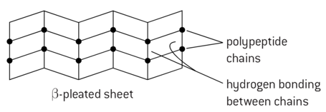
- Hydrogen bonds form between one of the lone oxygen atom and the hydrogen attached to a nitrogen atom (between amine and carboxylic groups)
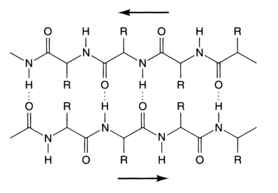

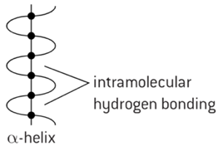

Tertiary Structure
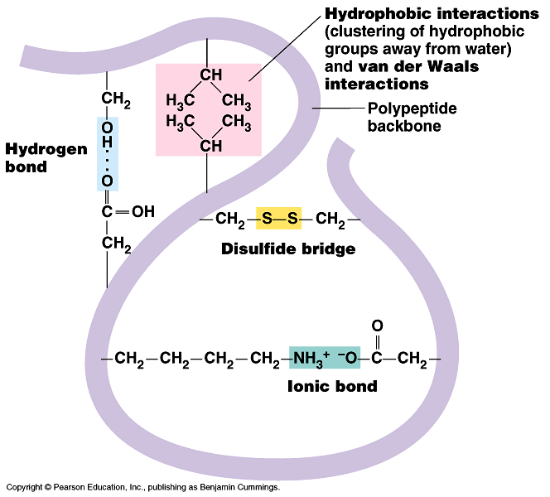
- The tertiary structure of a protein refers to the overall twisting and folding of the secondary structure to form a specific 3D shape
- The tertiary structure of a protein is held together by interactions between the side chains (The R groups)
- These interactions are:
  - Hydrogen bonds
  - Ionic interactions
  - Dispersion forces
  - Disulfide links (sulfur bridges)
- Some side groups present on the amino acid chain are capable of forming bonds with side groups elsewhere on the protein chain. As a result, sections of the chains may be folded back on each other in intricate and unique shapes
Quaternary Structure
- The quaternary structure of proteins refers to the interactions between polypeptide chains
- The bonding is the same as tertiary bonding
- An example is hemoglobin that has a quaternary structure composed of four polypeptide chains
Fibrous and Globular Proteins
- Fibrous proteins are elongated molecules with a well-defined secondary structure
  - Fibrous proteins have cross-linking at intervals to form long fibers or sheets
- Globular proteins are spherical molecules and have a well-defined tertiary structure
  - Globular proteins are usually soluble to some extent in water as the hydrophobic side tends to be in the center
Properties | Fibrous Proteins | Globular Proteins
Shape | Long and narrow | Rounded/Spherical
Role | Structural (strength and support) | Functional (Catalysts and transport)
Solubility in water | Insoluble in water | Soluble in water
Sequence of amino acids | Repetitive amino acid sequence | Irregular amino acid sequence
Stability | Less sensitive to changes in heat and pH | More sensitive to changes in heat and pH
Examples: | Collagen, keratin | Hemoglobin, insulin, catalase
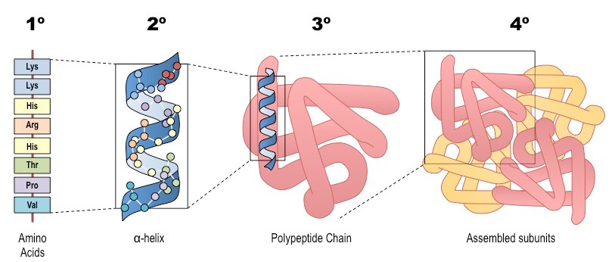
Summary:

Gel Electrophoresis
- Gel electrophoresis is technique used to separate mixtures of DNA, RNA or proteins according to molecular size
- The steps are as follows:
- A solution of the sample is placed in a well-cut block of special gel
- Positive and negative electrodes are connected to opposite ends of the gel, causing the ions in the sample to migrate towards the oppositely charged electrode
- When connected to a circuit, the amino acids move according to their electrical charge
- As previously mentioned, gel electrophoresis involves an electrical field. This field is applied such that one end of the gel has a positive charge and the other end has a negative charge. Because DNA and RNA are negatively charged molecules, they will be pulled towards the positively charged end of the gel
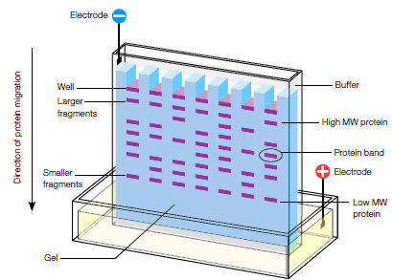
- However, proteins are not negatively charged, thus they must be mixed in a detergent called sodium dodecyl sulfate
- After the DNA, RNA or protein molecules have been separated using gel electrophoresis, bands representing molecules of different sizes can be detected
- The separated components are made visible by using various methods including
  - Adding a dye that binds to them and fluoresces (glows) in UV light
  - Adding radioactive probes that bind to them; the radiation is then used to expose a photographic plate
  - Shining lasers onto fragments that have a fluorescent dye incorporated into their structure
Paper Electrophoresis
- Paper electrophoresis is similar to gel electrophoresis, but instead the mixture is placed on the middle of a paper
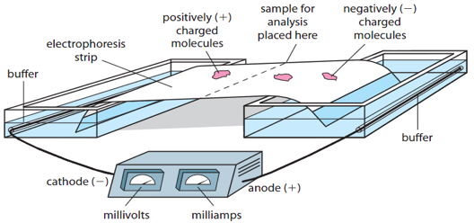

- When the pH is equal to their isoelectric point, amino acids will not move as they carry no net charge
- An amino acid is negatively charged when it’s isoelectric point is below the pH, therefore the amino acids exist as anions and move to the positive charged size (generally the anode)
- An amino acid is positively charged when it’s isoelectric point is above the pH, therefore the amino acids exist as cations and move to the negative charged size (generally the cathode)
Paper chromatography
- Paper chromatography can also be used to separate a mixture of amino acids
- The amino acids all differ in their ability to dissolve in the solvent (the mobile phase) and also in their ability to bind to the stationary phase. Therefore, they will move up at different rates and reach different heights. Ninhydrin is often used as locating agent to make the spots visible
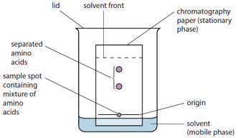
- The amino acids can now be identified by comparing the R_{f} values or to pure samples run under the same conditions
- The R_{f} values can be determined with the formula:
$$R_{f}=\frac{distance moved from origin by amino acid}{distance moved by solvent from origin}$$
- R_{f} is always less than or equal to 1 and has no units

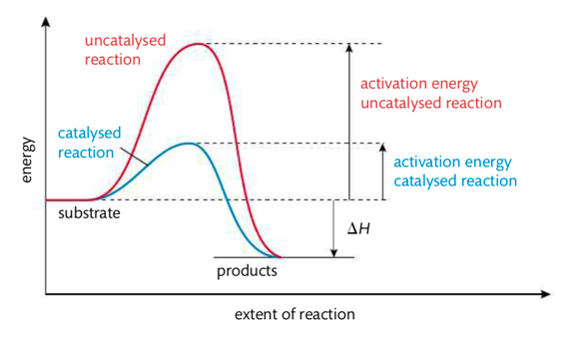
Enzymes
- Enzymes are globular proteins that act as biological catalysts, increasing reaction rates of biological processes without being used up in the process
- Enzymes control the manufacture of complex substances, such as skin and blood as well as the breaking down of chemicals to provide energy
- Compared with inorganic catalysts enzymes:
  - Produce much faster reaction rates
  - Operate under much milder conditions
  - More sensitive and selective
  - Can become denatured at high temperatures
- The active site of an enzyme is usually a flexible hollow or cavity within the molecule
- The induced-fit model is a theory that says the active site will change shape to enfold a substrate molecule
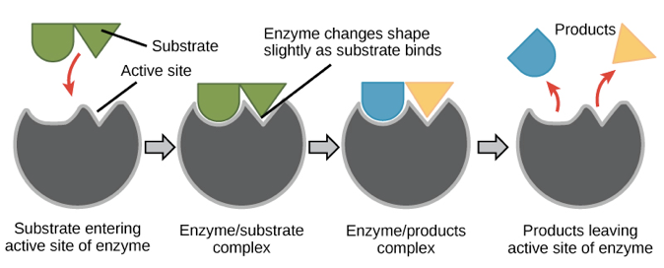
- A reactant molecule, known as the substrate is maneuvered into the site and it is there at the surface of the enzyme that the reaction takes place
- The reactant (substrate) enters the active site
- Bonds formed between the enzyme and substrate weaken lowering the reaction’s activation energy
- The substrate breaks or rearranges into new products and these products are released
- The selectivity of enzymes is one of their most important features
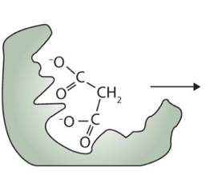
- It happens because the shape and functional groups in the active site of the enzyme allow it to bind only with certain substrates. This is known as the Key and Lock model (however it is outdated)
- 4 types of active site and substrate interaction
  - Hydrogen bonding
  - Ionic interactions
  - Ion-dipole
  - Dispersion force
- Characteristics of enzymes: biological catalysts, made of proteins, very specific, affected by change in pH and temperature
Denaturation
- The catalytic activity of an enzyme depends on its tertiary structure. A slight change in its three-dimensional shape can render an enzyme inoperative as if the structure is disrupted, the substrate can no longer bind to the active site
- Loss of tertiary structure is known as denaturation (irreversible). It can be caused by:
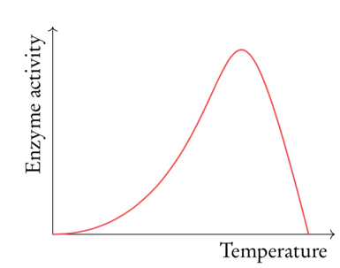
Temperature
- Increasing temperature also increases enzyme activity at around double for every 10°C
- This is because collisions between substrate and active site happen more frequently at higher temperatures due to faster molecular motion
- However, at high temperature the enzymes will become denatured and stop working. This is because the heat causes vibrations inside the enzymes which break bonds needed to maintain the structure of the enzyme
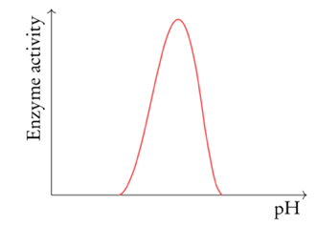
pH levels
- Increasing pH increases enzyme activity to an optimum point. Increasing pH beyond this optimum point will reduce enzyme activity as about a certain pH the alkalinity denatures the enzyme so it can’t catalyze the reaction at all
Heavy metal ions
- Heavy metals can poison enzymes by reacting with -SH groups replacing the hydrogen atom with a heavy metal atom or ion so that the tertiary structure is altered

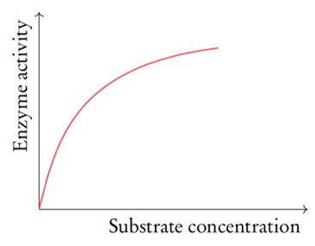
Concentration
- Increasing substrate concentration increases enzyme activity. This is because random collisions between substrate and active site happens more frequently with higher substrate concentrations
- However, at high substrate concentrations the active site of the enzyme is saturated therefore raising the substrate concentration has little effect on enzyme activity
B.3 | Lipids
B.3.1 | Fats are more reduced than carbohydrates and so yield more energy when oxidized
B.3.2 | Triglycerides are produced by condensation of glycerol with three fatty acids and contain ester links. Fatty acids can be saturated, monounsaturated or polyunsaturated
B.3.3 | Phospholipids are derivatives of triglycerides
B.3.4 | Hydrolysis of triglycerides and phospholipids can occur using enzymes or in alkaline or acidic conditions
B.3.5 | Steroids have a characteristic fused ring structure, known as a steroidal backbone
B.3.6 | Lipids act as structural components of cell membranes, in energy storage, thermal and electrical insulation, as transporters of lipid soluble vitamins and as hormones
B.3.7 | Deduction of the structural formulas of reactants and products in condensation and hydrolysis reactions between glycerol and fatty acids and/or phosphate
B.3.8 | Prediction of the relative melting points of fats and oils from their structures
B.3.9 | Comparison of the processes of hydrolytic and oxidative rancidity in fats with respect to the site of reactivity in the molecules and the conditions that favor the reaction
B.3310 | Application of the concept of iodine number to determine the unsaturation of a fat
B.3.11 | Comparison of carbohydrates and lipids as energy storage molecules with respect to their solubility and energy density
B.3.12 | Discussion of the impact of lipids on health, including the roles of dietary high density lipoprotein (HDL) and low-density lipoprotein (LDL) cholesterol, saturated, unsaturated, and trans-fat and the use and abuse of steroids
Types of fatty acids
- Fatty acids are key components of lipids, in plants, animals and microorganisms
- Fatty acids consist of a straight chain of an even number of carbon atoms, with hydrogen atoms
- Fatty acids all have a methyl group (CH₃) on one end and a carboxyl group (COOH) at the other end
- In the middle is a chain of anywhere between 11-23 CH₂ groups
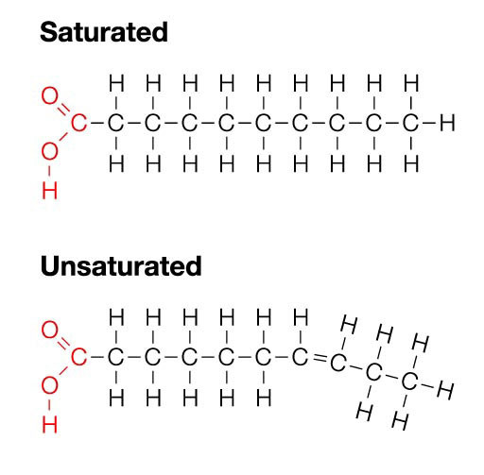
- Fatty acids can be classified as follows:
Saturated Fatty Acids
- Saturated fatty acids only have single bonds between carbon atoms therefore they have a straight structure
- These fatty acids are saturated because the carbons are carrying as many hydrogen atoms as they can
- Because there are no bends, saturated fatty acids can pack more tightly together, therefore saturated fatty acids are solid at room temperature
- General formula: C_{n}H_{2n+1}COOH
Unsaturated Fatty Acids
- Monounsaturated fatty acids have one double bond somewhere in the chain therefore they have a bent structure
- Polyunsaturated fats have at least two double bonds in their chain therefore have many bends/kinks in the chain
- Because they can’t pack closely together they are liquid at room temperature
- General formula of monounsaturated fatty acid: C_{n}H_{2n-1}COOH
- General formula of polyunsaturated fatty acid: C_{b}H_{2n-3}COOH
Lipids
- Lipids are a diverse group of hydrophobic compounds that include molecules like fats, oils, phospholipids and steroids
- Most lipids are hydrocarbons: molecules that include many non-polar carbon-carbon or carbon-hydrogen bonds
- Lipids are carbon compounds made by living organisms that are mostly or entirely hydrophobic
- There are three main types of lipids:
Phospholipids
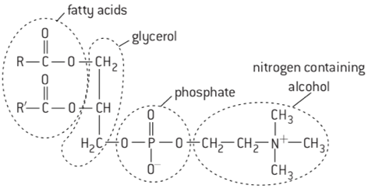
- Phospholipids have only two fatty acids condensed onto the glycerol molecule
- The third –OH position of the glycerol molecule is occupied with a phosphate group
- Phospholipids are characterized by having a polar or hydrophilic head and two non-polar hydrophobic tails
- As a result- phospholipids form a phospholipid bilayer which maximizes the interactions between the non-polar tails and water
- Phospholipids bilayers provide the basis of membrane structures
Triglycerides
- A triglyceride molecule is derived from two types of molecular components:
  - Polar head: This is derived from a single glycerol molecule. Glycerol is composed of three carbons, five hydrogens and three hydroxyl groups
  - Non polar tail: The non polar fatty acid tail group consists of three hydrocarbons (a functional group composed of C-H bonds) and also have a polar carboxyl functional group
- The number of carbons in the fatty acid may range from 4-36
- Fats contain saturated fatty acids, whereas oils contain unsaturated fatty acids.
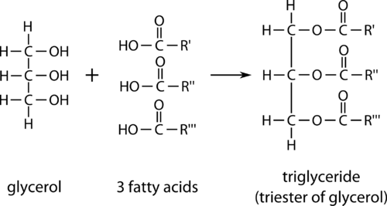
- Oils and fats are triglycerides, while other lipids like phospholipids and steroids have different structures
- Fats and oils are formed by condensation reactions between a single molecule of glycerol and three molecules of fatty acids
- Triglycerides are broken down by hydrolysis reactions to produce a single molecule of glycerol and three molecules of fatty acids
- Triglycerides at standard room temperature:
  - Liquid = Oil
  - Solid = Fats
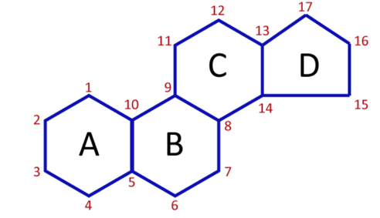
Steroids
- Steroids are a type of lipid
- The steroid backbone is formed by the four rings of carbon.
- Although they do not resemble other lipids they are classified as lipids because they are largely composed of carbons and hydrogens
- Cholesterol is the most common steroid. It is used as a precursor of many biomolecules, including other steroids and the sex hormones
- Uses of steroids:
  - Used to build up depleted muscle due to lack of activity and to assist in recuperation from an illness
- Abuses of steroids:
  - Anabolic steroids are sometimes used by athletes to increase muscle and strength for an unfair advantage in sport
- Effects on males:
  - Infertility, breast development, shrinking of balls, male pattern baldness
- Effects on females:
  - Decrease in breast size and body fat, deepening of the voice, excessive growth of body hair

Functions of lipids
- Functions of lipids include
  - Hormones
  - Insulation
  - Cell Membranes
  - Energy storage
Iodine Number
Definitions
Iodine Number – The iodine number of a fat or an oil is the mass of iodine that reacts with 100g of the lipids

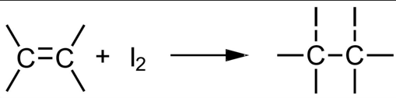
- The addition of iodine to unsaturated fats can be used to break the carbon double bonds, since one mole of double bonds reacts with one mole of I₂

- The iodine will bond to the double bonds so the mass of iodine used will depend on the number of double bonds
  - Stearic/Palmitic/Lauric acids: no double bonds
  - Oleic acid: one double bond
  - Linoleic acid: two double bonds
  - Linolenic acid: three double bonds
- The more unsaturated an oil is, the higher its iodine number will be
Question: Linoleic acid has the formula C₁₈H₃₂O₂. Determine the iodine number of linoleic acid
1 mol of linoleic acid has 2 moles of double bonds
Therefore, two moles of I₂ react with two moles of double bonds = 2 x 254(mass of iodine) = 508g I₂
Furthermore 281 grams of linoleic acid react with 508 grams of iodine.
$$508 g I_{2} ×\frac{100g}{281 g linoleic acid}=181 g$$
Answer: the iodine number of linoleic acid is 181 (no units)
Rancidity of fats
- When fats used in the food industry are stored for long periods of time, they can undergo chemical change which causes them to become rancid. The result is fats and oils that cause a disagreeable smell, texture or appearance
- The two main causes of this are hydrolytic and oxidative rancidity
Hydrolytic Rancidity | Oxidative Rancidity
- Hydrolytic rancidity is the hydrolysis of triglycerides to produce glycerol and (smelly) fatty acids  - Hydrolytic rancidity occurs more quickly in the presence of heat and moisture  - It is catalyzed by the enzyme lipase  - The rancid smell is due to the release of fatty acids  - Hydrolytic rancidity can be reduced by refrigeration | - Oxidative rancidity is caused by the oxidation  - This reaction is catalyzed by light, or enzymes and metal ions  - It occurs in fats and oils with a high proportion of carbon to carbon double bonds  - It can be controlled with anti-oxidants
Cholesterol: HDL and LDL
- Cholesterol is transported through the body inside of lipoproteins. Lipoproteins consists of both lipids and proteins
- There are two types of lipoproteins: high density lipoprotein (HDL) and low-density lipoprotein (LDL)
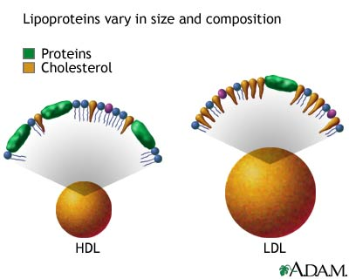
- HDL has more protein and less fat, LDL has less protein and more fat
  - HDL is known as “good cholesterol” as it removes cholesterol from the arteries
  - LDL is called “bad cholesterol” as it deposits cholesterol on the arteries
- Too much cholesterol in your arteries may lead to a buildup of plaque known as atherosclerosis
- A high ratio of LDL to HDL can lead to an increased risk of heart disease, obesity, atherosclerosis and blocked arteries
B.4 | Carbohydrates
B.4.1 | Carbohydrates have the general formula C_{X}(H₂O)_{y}
B.4.2 | Haworth projects represent the cyclic structures of monosaccharides
B.4.3 | Monosaccharides contain either and aldehyde group (aldose) or a ketone group (ketose) and several –OH groups
B.4.4 | Straight chain forms of sugar cyclize in solution to form ring structures containing an ether linkage
B.4.5 | Glyosidic bonds form between monosaccharides forming disaccharides and polysaccharides
B.4.6 | Carbohydrates are used as energy sources and energy reserves
B.4.7 | Deduction of the structural formulas of disaccharides and polysaccharides from given monosaccharides
B.4.8 | Relationship of the properties and functions of monosaccharides and polysaccharides to their chemical structures
Carbohydrates
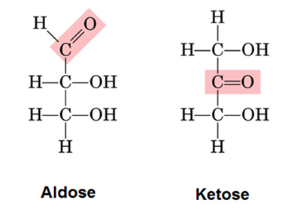
- Carbohydrates is another term for a sugar
- Carbohydrates have several carbon atoms that have a hydrogen and a hydroxyl group
- All carbohydrates have an aldose or ketose group:
  - Aldose carbohydrates contains one aldehyde group per molecule
  - Ketose carbohydrates contain one ketone group per molecule
- Carbohydrates can be written as a straight chain structure or Haworth projections
  - Haworth projections represent the 3D (cyclic) structures of monosaccharides
Monosaccharides
- The building blocks of carbohydrates are simple sugars called monosaccharides
- All monosaccharides have the molecular formula C₆H₁₂O₆ (Empirical formula: CH₂O)
- All monosaccharides contain a carbonyl (C=O) group and have at least two hydroxyl (-OH) groups
- In solution, isomers of monosaccharides are in equilibrium – two with ring structures and a straight chain molecule
Disaccharide
- Disaccharides: A molecule formed by condensation reactions between two monosaccharides
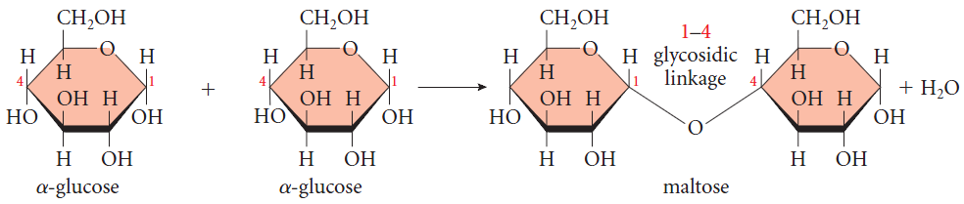
- As a result, a glyosidic bond is formed
- Like monosaccharides, disaccharides dissolve in water, taste sweet and are also called sugars
Polysaccharides
- Polysaccharides are polymers of carbohydrates made by linking monosaccharides into a chain
- Polysaccharides are polymers of glucose molecules linked together in different ways by condensation reactions
- Digestion of polysaccharides involves the hydrolysis (adding water) of the bonds between the monosaccharide residues
- Enzymes catalyze these reactions in the digestive tract of animals, including humans
- Polysaccharides are insoluble in water as they are much larger molecules compared to monosaccharides/disaccharides
- One of the most important polysaccharides is starch. Starch exists in two forms:
Amylose | Amylopectin
Amylose is a straight chain polymer of D-glucose units with 1,4 glycosidic bonds | Amylopectin consists of D-glucose units with both 1,4 and 1,6 glycosidic bonds
Soluble in water | Insoluble in water
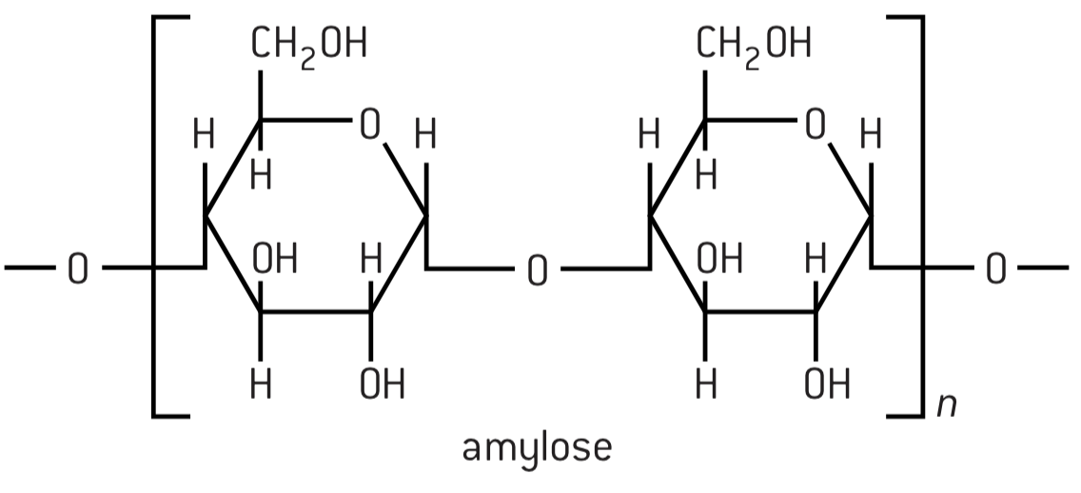 | 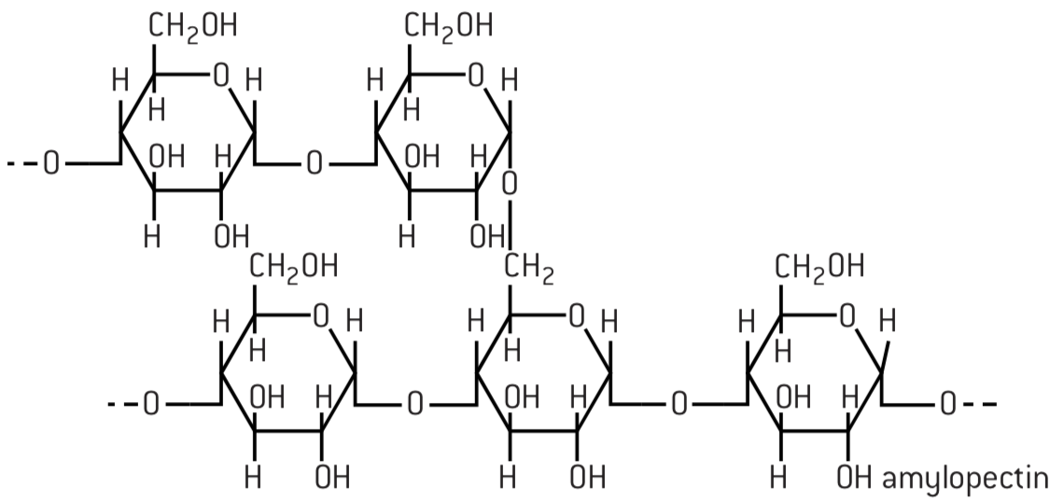
- Most plants use starch as a store of carbohydrates and thus energy
- Cellulose is a polymer of D-Glucose contains 1,4 linkages
- Cellulose, together with lignin, provides the structure to the cell walls of green plants
- Most animals, including all mammals do not have the enzyme cellulase so are unable to digest cellulose or other dietary fiber polysaccharides
Functions of carbohydrates
- Functions of carbohydrates include
  - To provide energy: Foods such as bread, biscuits, cakes, potatoes and cereals are all high in carbohydrates
  - To store energy: Starch is stored in the liver of animals in the form of glycogen. Glycogen has almost the same chemical structure as amylopectin
  - As precursors for other important biological molecules
B.5 | Vitamins
B.5.1 | Vitamins are organic micronutrients which (mostly) cannot be synthesized by the body but must be obtained from suitable food sources
B.5.2 | The solubility (water of fat) of a vitamin can be predicted from its structure
B.5.3 | Most vitamins are sensitive to heat
B.5.4 | Vitamin deficiencies in the diet cause particular diseases and affect millions of people worldwide
B.5.5 | Comparison of the structures of vitamins A, C and D
B.5.6 | Discussion of the causes and effects of vitamin deficiencies in different countries and suggestion of solution
Vitamins
- Vitamins are organic micronutrients which cannot be synthesized by the body and must be obtained from suitable food sources (except vitamin D)
- The ability of vitamins to be transported and stored in the essentially aqueous environment of the body is important, so vitamins are classified as either fat-soluble or water-soluble
- Water solubility of any organic molecule depends on forming many hydrogen bonds (many –OH groups)
- Vitamins that consist almost entirely of carbon and hydrogen are fat-soluble
- All vitamins have two common functional groups: carbon-carbon double bone and hydroxyl group
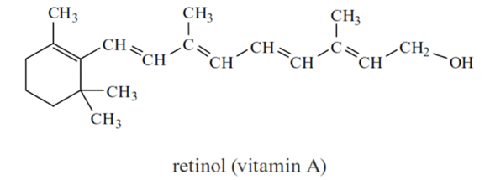
Vitamin A (Retinol)
- Fat soluble as there are non-polar hydrocarbon chain and ring
- Vitamin A is important for low-light vision
- A lack of vitamin A causes night blindness
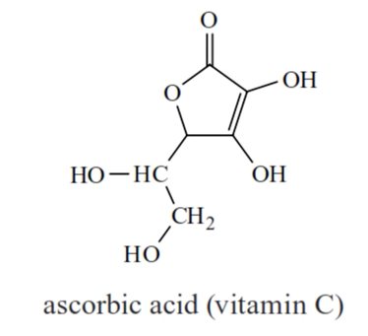
Vitamin C (Ascorbic Acid)
- Water soluble as there is a large number of polar OH groups which are able to form hydrogen bonds with water molecules
- Due to its solubility in water, it is not retained by the body for long periods
- Water soluble vitamins such as vitamin C are sensitive to heat and are destroyed by cooking
- Keeping food containing vitamin C in the refrigerator slows down this process
- A lack of vitamin C causes scurvy
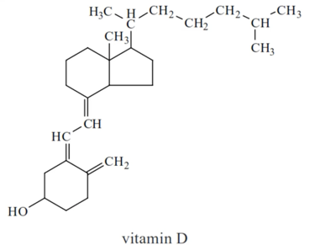
Vitamin D (Calciferol)
- Fat soluble: non-polar hydrocarbon chain and ring
- Vitamin D stimulates the uptake of calcium ions, important for healthy bones and teeth
- Vitamin D is made in the body by the action of sunlight on the skin
- A lack of vitamin D can cause rickets
Vitamin deficiencies
- The absence of a regular, balanced supply of the diverse nutrients needed in the diet is known as malnutrition
- Malnutrition occurs when either too much food is consumed, which leads to obesity, or the diet is lacking in one or more essential nutrients
- Causes of vitamin deficiencies:
  - Lack of distribution of global resources
  - Depletion of nutrients in the soil
  - Lack of education about balanced diets
- Solutions to vitamin deficiencies:
  - Taking nutritional supplements
  - Genetically modifying foods to increase vitamin content
  - Educating people about balanced diets
B.6 | Biochemistry & the environment
B.6.1 | Xenobiotics refer to chemicals that are found in an organism that are not normally present there
B.6.2 | Biodegradable/compostable plastics can be consumed or broken down by bacteria or other living organism
B.6.3 | Host-guest chemistry involves the creation of synthetic host molecules that mimic some of the actions performed by enzymes in cells, by selectively binding to specific guest species, such as toxic materials in the environment
B.6.4 | Enzymes have been developed to help in the breakdown of oil spills and other industrial wastes
B.6.5 | Enzymes in biological detergents can improve energy efficiency by enabling effective cleaning at lower temperatures
B.6.6 | Biomagnification is the increase in concentration of a substance in a food chain
B.6.7 | Green chemistry, also called sustainable chemistry, is an approach to chemical research
B.6.8 | Discussion of the increasing problem of xenobiotics such as antibiotics in sewage treatment plants
B.6.9 | Description of the role of starch in biodegradable plastics
B.6.10 | Application of host-guest chemistry to the removal of a specific pollutant in the environment
B.6.11 | Description of an example of Biomagnification, including the chemical source of the substance,
B.6.12 | Discussion of the challenge sand criteria in assessing the “greenness” of a substance used in biochemical research

Biodegradability
- Biodegradable plastics and compostable plastics can be broken down or consumed by bacteria or ﻿﻿other living organisms through natural processes.
- However, although some plastics are organic in origin they are petroleum based so cannot easily be broken down by natural organisms and cause big pollution problems
  - PLA (polylactide) is a biodegradable plastic derived from renewable resources such as corn starch
  - The breakdown of starch based plastics (bioplastics) produces carbon dioxide and water
  - Starch based polymers constitute over 50% of the biodegradable plastics as it is easily broken down by microorganisms and being renewable it is good alternative to fossil fuel based plastics
  - Starch grains in the plastic will swell when they come in contact with water (e.g. in a landfill). This breaks the plastic up into many much smaller pieces, which increases the overall surface area and consequently the rate of the breakdown reactions
- Specific enzymes have been developed to help in the ﻿﻿dispersal and breakdown of oil spills and other industrial wastes
- Bioplastics can be broken down in hydrolysis reactions due to the presence of ester linkages or glyosidic links (requires heat and moisture)/ When some biodegradable plastics decomposed in landfills, they produce methane gas which is a very powerful greenhouse gas (anaerobic conditions)
Advantages | Disadvantages
- Renewable resource  - Broken down by bacteria or other organism  - Reduces plastic waste  - Reduce use of petrochemicals | - Require use of land  - Increases use of fertilizes and pesticides  - Might breakdown before end of use  - Release of methane/greenhouse gas during degradation
Host-Guest chemistry
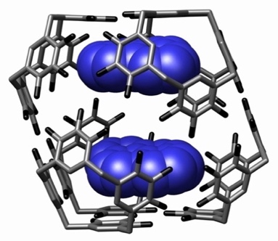
- Host-guest complexes are composed of two or more molecules or ions that are held together through non-covalent bonding
- Host–guest chemistry is very similar to enzymes as it uses host molecules (like enzymes) that bond with specific guest molecules (like substrates) to form host-guest complexes (like enzyme-substrate complexes)
- The difference between host-guest complexes and enzyme-substrate complexes is that in host-guest chemistry the host is a synthetic molecule specially developed to bond to a specific ‘target’ molecule (guest)
- Note that – as in enzyme-substrate complexes – the bonds that hold the host-guest complex together are all non-covalent attractions, e.g. hydrogen bonds and dipole-dipole, ionic and hydrophobic attractions
- Host-guest chemistry can be applied to the removal of xenobiotics in the environment
- The binding between a xenobiotic and a host produces a supramolecule
Biomagnification and Bioaccumulation
- Biomagnification: A process that leads to increasing concentrations of (unwanted) substances in animals as you go higher up the food chain
- Bioaccumulation: The accumulation (build up) of a substance within an organism over time
- An example includes DDT:
- DDT is an insecticide that was used to control mosquito populations that spread diseases such as malaria and typhus
- DDT is readily soluble in fat and does not break down therefore it accumulates in fatty tissue
- In the 1960s bird of prey such as ospreys suffered a decline in numbers which was due to the toxic effect of DDT
- The use of DDT as an insecticide was banned in many countries in the 1970s

Xenobiotics
- Xenobiotics are chemical substances found within an organism that are not naturally produced by or expected to be present within an organism
- Antibiotics are xenobiotics in animals as they are not produced by animals, nor are they part of a normal diet
Dioxins and PCBs
- Dioxins and polychlorinated biphenyls (PCBs) are toxic chemicals that persist in the environment
- Once dioxins enter the body, they accumulate due to their chemical stability and can be absorbed by fatty tissue
- Long term exposure to these substances causes a range of adverse effects on the nervous, immune, and endocrine systems
- They may also be carcinogenic (cancer causing)
Green Chemistry
- ‘Green chemistry’ is an approach to chemical research and engineering that seeks to minimize the production and release to the environment of hazardous substances.﻿ The five principles that aim to achieve green chemistry include:
  - Developing water based processes and products instead of solvent-based processes and products
  - Efficient use of energy in processes such as developing new catalysts for lower production temperatures
  - Efficient use of reactants in processes. i.e. developing a reaction with high atom economy
  - Developing processes that can use renewable reactants
  - Developing waste-free products
B.7 | Proteins and enzymes
U1 | Inhibitors play an important role in regulating the activities of enzymes
U2 | Amino acids and proteins can act as buffers in solution
U3 | Protein assays commonly use UV-vis spectroscopy and a calibration curve based on known standards
U4 | Determination of the maximum rate of reaction (V_{max}) and the value of the Michaelis constant (K_{m}) for an enzyme by graphical means, and explanation of its significance
U5 | Comparison of competitive and non-competitive of enzymes with reference to protein structure, the active site and allosteric site
U6 | Explanation of the concept of product inhibition in metabolic pathways
U7 | Calculations of the pH of buffer solutions, such as those used in protein analysis and in reactions involving amino acids in solution
U8 | Determination of the concentration of a protein in solution from a calibration curve using the Beer-Lambert Law
Induced-fit model
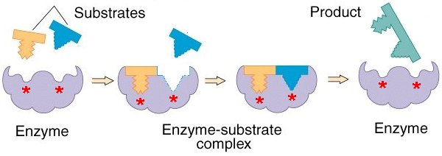
- A more recent model which improves on the lock and key model is the induced fit model
- The induced-fit model: A theory that states the active site of an enzyme will change shape to enfold a substrate molecule
- Since enzymes are rather flexible structures, the active site is continually reshaped by interactions with the substrate
- This enables a more precise fit to be achieved between the enzyme and substrate
- When the product leaves the enzyme, the enzyme returns to its original form

Inhibitors
- The binding of an inhibitor can stop a substrate from entering the enzyme's active site
- Inhibition of enzymes occurs when a substance prevents the enzyme from doing its job
- These inhibitors work as either a competitive inhibitor or a non-competitive inhibitor
Competitive inhibitors
- Competitive inhibition: These inhibitors have a similar structure to the substrate therefore they compete for the enzyme’s active site. These reduce the activity of the enzyme because they block the substrate entering the active site
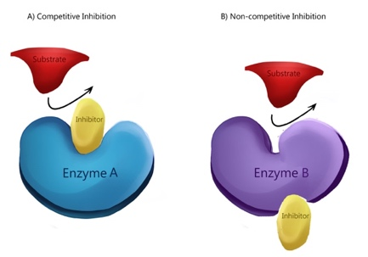
- To reduce the impact of competitive inhibition we can increase the concentration of the substrate
- The enzyme can still reach maximum efficiency in the presence of a competitive inhibitor, just at a decreased rate as the active site conformation is not changed
Non-Competitive inhibitors
- Non-competitive inhibition: Impede enzymatic reactions by binding to the allosteric site which is away from the enzyme active site
- This changes the conformation of the active site, so the substrate can no longer bind with the enzyme
- A non-competitive inhibitor reduces the efficiency of an enzyme, as the substrate can no longer bind to the enzyme because the active site conformation was changed
Competitive inhibition | Non-competitive inhibition
Substrate and inhibitor are (chemically) the same shape | Substrate and inhibitor are (chemically) not a similar shape
Inhibitor binds to the active site | Inhibitor binds to the allosteric site
Inhibitor does not change the shape of the active site | Inhibitor changes the shape of the active site
Increases in substrate concentration reduce the inhibition | Increases in substrate concentration do not affect the inhibition
Both types of inhibitor reduce enzyme activity
Both types of inhibitor bind to the enzyme
Both types of inhibitor prevent the substrate from binding to the active site
Graphical analysis of enzyme activity
- The relationship between substrate concentration and enzyme activity can be shown by a graph where:
- V_{max} occurs when all active sites are saturated with substrate
- When this happens increasing the substrate concentration does not increase the rate of an enzyme-catalyzed reaction
- Michaelis constant (K_{m}): K_{m} is the substrate concentration at one-half of its V_{max}
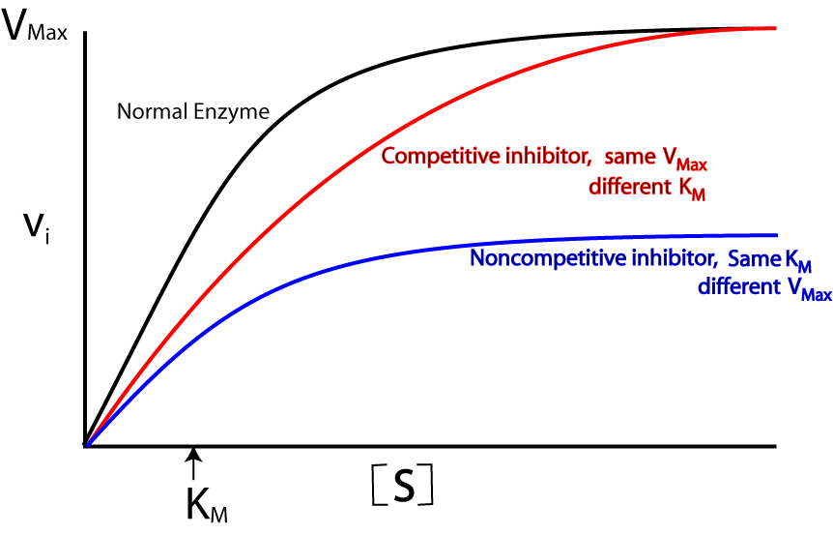
- K_{m} is inversely proportional to enzyme activity
  - A higher K_{m} the lower the activity of the enzyme
  - A lower K_{m} the higher the activity of the enzyme
- V_{max} has units of rate (e.g. mol dm⁻³ s⁻¹)
- K_{m} has units of concentration (e.g. mol dm⁻³)
- Competitive inhibitor: Same V_{max} different K_{m}
- Non-competitive inhibitor: Different V_{max} same K_{m}

B.8 | Nucleic acids
U1 | Nucleotides are the condensation products of a pentose sugar, phosphoric acid and a nitrogenous base – adenine (A), guanine (G), cytosine (C), thymine (T) or uracil (U)
U2 | Polynucleotides form by condensation reactions
U3 | DNA is a double helix of two polynucleotides strands held together by hydrogen bonds
U4 | RNA is usually a single polynucleotide chain that contains uracil in place of thymine, and a sugar ribose in place of deoxyribose
U5 | The sequence of bases in DNA determines the primary structure of proteins synthesized by the cell using a triplet code, known as the genetic code, which is universal
U6 | Genetically modified organisms have genetic material that has been altered by genetic engineering techniques, involving transferring DNA between species
A1 | Explanation of the stability of DNA in terms of the interactions between its hydrophilic and hydrophobic components
A2 | Explanation of the origin of then negative charge on DNA and its association with basic proteins (histones) in chromosomes
A3 | Deduction of the nucleotide sequence in a complementary strand of DNA or a molecule of RNA from a given polynucleotide sequence
Structure of nucleotides
- DNA and RNA are two types of nucleic acid. They are both polymers of sub-units called nucleotides
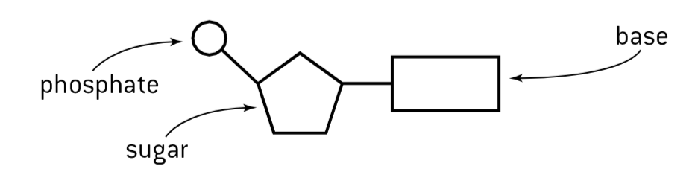
- Each nucleotide consists of three parts:
- A pentose group (A five-carbon sugar)
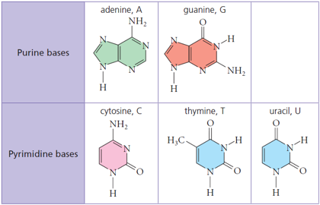
- Phosphate Group (PO₄⁻³)
- A nitrogenous base
- There are two differences between DNA and RNA nucleotides
- The type of pentose is ribose in RNA but deoxyribose in DNA
- In both DNA and RNA there are four possible bases. There of these are the same. However, the fourth base is thymine in DNA but uracil in RNA
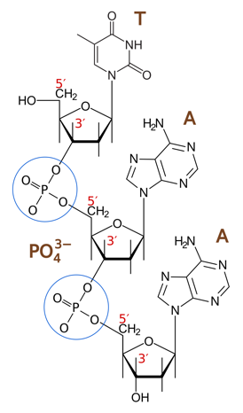
DNA Structure
- Nucleotides are formed by condensation reactions between the components mentioned above
- The phosphate group of one nucleotide attaches to different sugar molecules at C₃ and C₅ forming phosphodiester links between sugar molecules (+H₂O)
- The negative charge in DNA is caused by the phosphate groups in the sugar-phosphate backbone. The phosphate groups carry a 1– negative charge
- The negative charge of the phosphate groups causes DNA to bond closely with histones, which are positively charged proteins found in chromosomes
- The backbone of the polynucleotide strand is an alternating sequence of sugar and phosphate groups
- The double helix of the DNA is stabilized by hydrogen bonds between complementary pairs of bases
  - Adenine pairs with Thymine via two hydrogen bonds
  - Guanine pairs with Cytosine via three hydrogen bonds
- In order for the bases to be facing each other and thus able to pair the strands must be running in opposite directions. Therefore the two strands of DNA are described as being antiparallel.
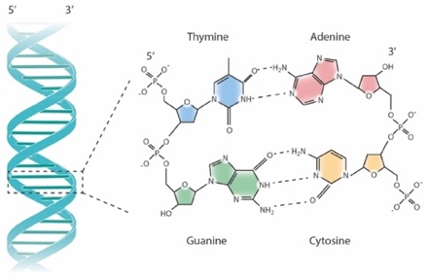
Primary structure of DNA
- The primary structure consists of a linear sequence of nucleotides (the order of base pairs covalently bonded to a sugar)
- Type of bonding: Covalent bonds
Secondary structure of DNA
- The secondary structure is the set of interactions between the bases (which parts of strands are bound to each other)
- In a DNA the two strands of DNA are held together by hydrogen bonds
- The greater degree of hydrogen bonding between G and C pairs makes these sections of the DNA chain harder to separate
DNA Charge
- The phosphate groups are negatively charged and give DNA molecules a negative charge
- This enables the molecules to interact with a group of proteins called histones
- The DNA molecules wrap around histones are become super coiled (called nucleotides)
RNA Structure
- RNA differs from DNA in that it has
  - Ribose sugar instead of deoxyribose
  - Uracil instead of thymine
  - A single-stranded structure
DNA Replication
- Before DNA can be replicated the double stranded molecule must be “unzipped” into two single strands
- In order to unwind DNA the hydrogen bonds between the two DNA strands are broken
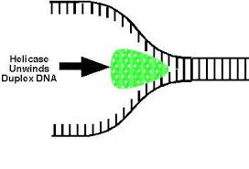
- This is done with an enzyme called helicase. DNA Helicase disrupts the hydrogen bonding between base pairs to separate the strands into a Y shape (called replication fork)
- Now that the bases are exposed on the separated strands, they can act as a template where new nucleotides attach by hydrogen bonds between complementary base pairs, C and G, A and T
- These bases then undergo a condensation polymerization reaction catalyzed by the enzyme DNA polymerase to form two exact copies of the original DNA double helix
Transcription/Translation
- In transcription a segment of DNA is copied into mRNA by the enzyme RNA polymerase. The newly formed mRNA then leaves the nucleus and heads to the ribosomes.
- Transcription uses an enzyme called RNA polymerase and a number of necessary proteins called transcription factors:
- RNA polymerase separates the DNA strands and synthesizes a complementary RNA copy from one of the DNA strands
- When the DNA strands are separated, ribonucleotide triphosphates align opposite their exposed complementary base
- RNA polymerase removes the additional phosphate groups and uses the energy from this cleavage the covalently join the nucleotide to the growing sequence
- RNA sequence has now been synthesized, so RNA polymerase detaches from the DNA Molecule
- In translation mRNA is decoded by a ribosome to produce a polypeptide chain. In order to achieve this a triplet code (codons) is used. Each codon consists of three nucleotides, corresponding to a single amino acid
- The triplet code allows up to 64 permutations. The 64 permutations represent the 20 naturally occurring amino acids
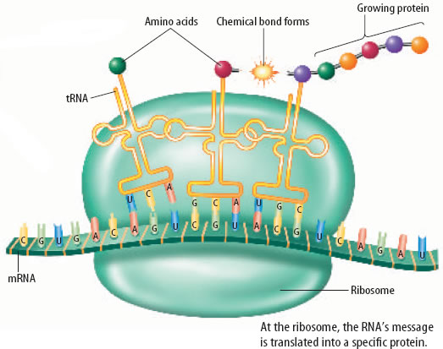
- Translation of an mRNA molecule by the ribosome occurs in the following stages:
- mRNA binds to a ribosome
- A tRNA molecule with an anticodon that is complementary to the codon on mRNA binds to the mRNA
- Another tRNA with an anticodon complementary to the second mRNA codon attaches to the mRNA molecule at the ribosome
- An enzyme joins the two amino acids on the tRNA molecules together via a condensation reaction
- The bond is broken between the tRNA molecule and the amino acid that was just added to the polypeptide chain
- The tRNA molecule is released and the ribosome moves down to the next mRNA codon
- This process is repeated many times to form the amino acid chain
DNA Transfer
- DNA can be transferred between species as the universal nature of the genetic code makes it possible for DNA from one organism to be expressed into the DNA of a different species
- A genetically modified organism is one whose DNA has been altered, often by the insertion of DNA from a different species
- This is the bases of genetic engineering and gives rise to genetically modified organisms (GMO’s)
Benefits | Concerns
- Longer shelf life  - Improved flavor, texture and nutritional value  - Increased resistance to disease  - Increased yields | - Long term effects unknown  - Linked to allergies (for people involved in their processing)

B.9 | Biological pigments
B.9.1 | Biological pigments are colored compounds produced by metabolism
B.9.2 | The color of pigment is due to highly conjugated systems with delocalized electrons, which have intense absorption bands in the visible region
B.9.3 | Porphyrin compounds, such as hemoglobin, myoglobin, chlorophyll and many cytochromes are chelates of metals with large nitrogen-containing macrocyclic ligands
B.9.4 | Hemoglobin and myoglobin contain heme groups with the porphyrin group bound to an iron (II) ion
B.9.5 | Cytochromes contain heme groups in which the iron ion interconverts between iron (II) and iron (III) during redox reactions
B.9.6 | Anthocynins are aromatic, water-soluble pigments widely distributed in plants. Their specific color depends on metal ions and pH
B.9.7 | Carotenoids are lipid-soluble pigments, and are involved in harvesting light in photosynthesis. They are susceptible to oxidation, catalyzed by light
B.9.8 | Explanation of the sigmoidal shape of hemoglobin’s oxygen dissociation curve in terms of the cooperative binding of hemoglobin to oxygen
B.9.9 | Discussion of the factors that influence oxygen saturation of hemoglobin, including temperature, pH and carbon dioxide
B.9.10 | Description of the greater affinity of oxygen for fetal hemoglobin
B.9.11 | Explanation of the action of carbon monoxide as a competitive inhibitor of oxygen binding
B.9.12 | Outline of the factors that affect the stabilities of anthocyanins, carotenoids and chlorophyll in relation to their structures
B.9.13 | Explanation of the ability of anthocyanins to act as indicators based on their sensitivity to pH
B.9.14 | Description of the function of photosynthetic pigments in trapping light energy during photosynthesis
B.9.15 | Investigation of pigments through paper and thin layer chromatography
Biological Pigments
- Biological pigments are colored compounds produced by living organisms (by metabolism)
- Pigment molecules absorb light in the visible region of the spectrum (400 – 700 nm). Pigment molecules absorb visible light due to the nature of their chemical bonds
- The color that we see is the light that is not absorbed, but instead reflected
- The light that is reflected by the pigment is the complementary color of the light that is absorbed

Conjugated Systems
- Most simple organic compounds that have a few multiple bonds and functional groups do not absorb visible light. These compounds appear colorless or white
- Pigment molecules absorb visible light because of the nature of their chemical bonds. In most cases they are highly conjugated structures, meaning that the electrons in p-orbitals are delocalized through alternating single and double bonds and through benzene ring structures.
- For multiple bonds to be conjugated they must be in an alternating double and single carbon-carbon bond
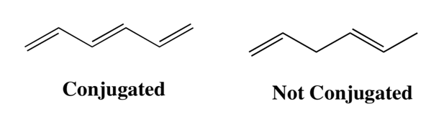
- As these electrons are not held tightly in one position they are able to become excited as they absorb certain wavelengths of light energy. For molecules having conjugated systems, the ground states and excited states of the electrons are closer in energy than non-conjugated systems
- This means that:
  - Larger conjugated systems absorb light of lower energy (longer wavelength)
  - Smaller conjugated systems absorb light of higher energy (shorter wavelength)
Porphyrin ring compounds
- All porphyrin compounds are chelates of metals with large nitrogen-containing macrocyclic ligands
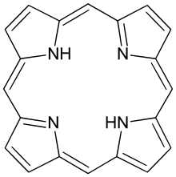
- Porphyrin compounds are planar ring structures with extensive conjugated systems
- It is made up of four heterocyclic rings, containing carbon and nitrogen, linked by bridging carbon atoms
- The ring acts as a ligand, forming a chelate with a metal involving coordinate bonds
- Different porphyrin compounds contain different metals
- The whole structure formed is what known as a heme group
Hemoglobin and myoglobin
- The heme group, which is common to hemoglobin and myoglobin contains iron, usually in the +2 oxidation state
- Hemoglobin and myoglobin are only slightly related in primary structure and are both porphyrin compounds
- The secondary structures of myoglobin and the subunits of hemoglobin and myoglobin are also virtually identical
- Heme is a prosthetic group within protein molecules. Hemoglobin contains four heme groups, each bound within a polypeptide chain. Therefore, hemoglobin has a quaternary structure, while myoglobin has a tertiary structure
- Hemoglobin is designed to carry oxygen in the blood, and myoglobin is designed to store oxygen in the blood
- Hemoglobin and myoglobin both bind reversibly with oxygen (O₂) via the Fe (II) ion. The binding of oxygen is cooperative in nature meaning it gets easier to bind oxygen after an initial heme group is bond to oxygen
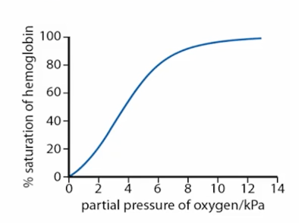
- This is known as a conformational shift
Hemoglobin and oxygen
- From the graph, we can deduce the following about how this effects hemoglobin’s ability to bind to oxygen
- At low concentrations of O₂, hemoglobin has a low affinity for O₂
- At high concentrations of O₂, hemoglobin has a high affinity for O₂
- Factors that affect the binding of oxygen to hemoglobin are
- Temperature: At higher temperatures hemoglobin can hold less O﻿₂
- pH and partial pressure of CO₂: At a lower pH, hemoglobin can hold less O₂
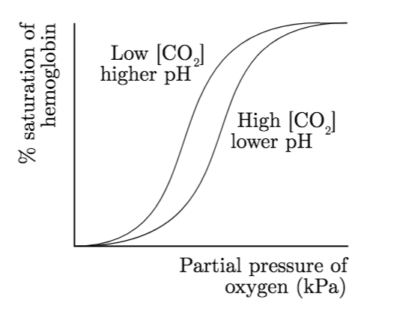
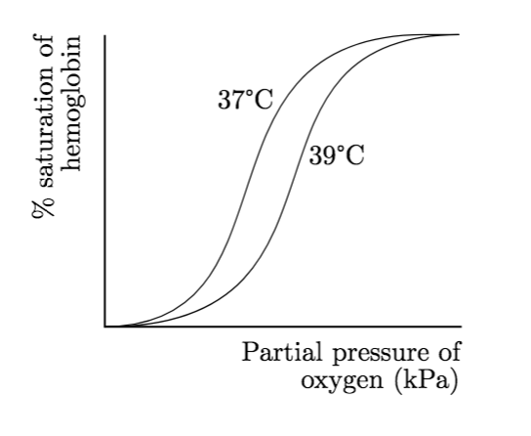

- Increasing the temperature, increasing the partial pressure of CO₂ and decreasing the pH all reduce the affinity of hemoglobin for O₂
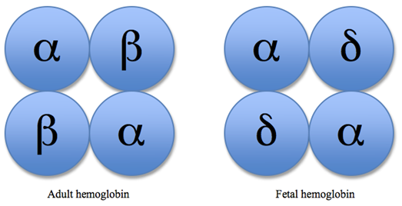
Adult hemoglobin
- Adult hemoglobin contains four polypeptide chains
- Two alpha chains and two beta chains
- Fetal hemoglobin contains two alpha chains and two gamma chains
- Fetal hemoglobin has greater affinity for oxygen than adult hemoglobin:
- Adult hemoglobin has two alpha and beta chains while fetal hemoglobin has two alpha and two gamma chains
- This means the fetal hemoglobin can absorb O₂ from the mother’s blood in the placenta.
Carbon monoxide
- Carbon monoxide (CO) commonly known as the silent killer has a strong affinity for hemoglobin
- CO is toxic to humans because it is a competitive inhibitor of oxygen and prevents the oxygen from bonding with the heme group at the active site
- As a result:
  - less oxygen is transported
  - uptake of oxygen decreases
  - it could cause hypoxia
Chlorophyll
- Chlorophyll, the main photosynthetic pigment, absorbs most strongly in the blue region of the light spectrum
- There are several forms of chlorophyll, but the pigment always contains magnesium. This is why magnesium deficiency in the soil leads to loss of the green color in leaves
Cytochromes
- Cytochromes are proteins that also contain the heme group
- They are found embedded in membranes and are responsible for electron transport during the redox reactions of aerobic respiration and photosynthesis. During these reactions they become successively reduced and then reoxidized as they in turn accept and then pass on electrons
Pigments
- Pigments are colored biological compounds produced by metabolism (as opposed to synthetically produced).
  - Anthocyanins are aromatic, water-soluble pigments widely distributed in plants. Their specific colour depends on pH and the presence of certain metal ions.﻿
  - Carotenoids are lipid-soluble pigments, involved in harvesting light in photosynthesis. They are ﻿oxidized during light-catalyzed reactions
Carotenoids
- Carotenoids are lipid-soluble pigments, involved in harvesting light in photosynthesis
- They are oxidized during light-catalyzed reactions
- Their molecules have extensive conjugated systems of alternative double carbon-to-carbon and single carbon-to-carbon double bonds which gives them their color but also makes them susceptible to oxidation, including being catalyzed by light
- This is why they can act as antioxidants as oxidation can lead to a loss of vitamin A activity
Anthocyanins
- Anthocyanins are aromatic, water-soluble pigments widely distributed in plants
- Their specific colour depends on pH and the presence of certain metal ions
- Anthocyanins are water soluble as they have polar hydroxyl groups which allow them to form hydrogen bonds
- Anthocyanins are very sensitive to pH which also means they can be used as pH indicators. Although with different pH they undergo different structures
- The color changes arise form transfer of H⁺ from OH groups, which alters the conjugation and so the absorbance at the chromophore
B.10 | Stereochemistry in biomolecules
U1 | With one exception, amino acids are chiral, and only the L-configuration is found in proteins
U2 | Naturally occurring unsaturated fat is mostly in the cis form, but food processing can convert it into the trans form
U3 | D and L stereoisomers of sugars refer to the configuration of the chiral carbon atom furthest from the aldehyde or ketone group, and D forms occur most frequently in nature
U4 | Ring forms of sugars have isomers, known as alpha and beta, depending on whether the position of the hydroxyl group at carbon 1 (glucose) or carbon 2 (fructose) lies below the plane of the ring (alpha) or above the plane of the ring (beta)
U5 | Vision chemistry involves the light activated interconversion of cis- and trans- isomers of retinal
A1 | Description of the hydrogenation and partial hydrogenation of unsaturated fats, including the production of trans-fats and a discussion of the advantages and disadvantages of these processes
A2 | Explanation of the structure and properties of cellulose, and comparison with starch
A3 | Discussion of the importance of cellulose as a structural material and in the diet
A3 | Outline of the role of vitamin A in vision, including the roles of opsin, rhodopsin and cis- and trans-retinal
A4 | Explanation of how the complementary pairing between bases enables DNA to replicate itself exactly
A5 | Discussion of the benefits and concerns of using genetically modified foods
U12 | Deduction and interpretation of graphs of enzyme activity involving changes in substrate concentration, pH and temperature
U13 | Explanation of the processes of paper chromatography and gel electrophoresis in amino acid and protein separation and identification
Stereochemistry
- Stereoisomers represent different spatial arrangements of the atoms in a molecule
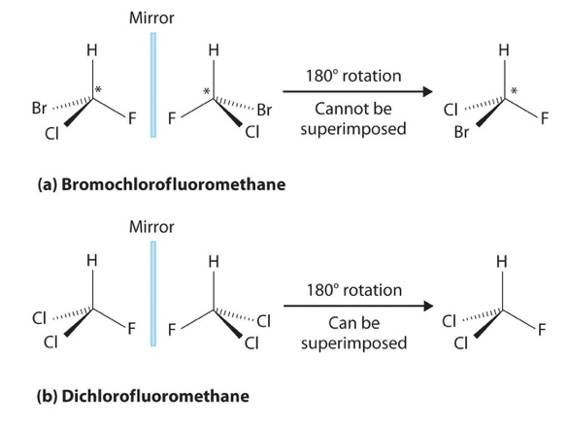
- Many biopolymers can exist as stereoisomers, each with distinct characteristics generally meaning that only one form of the isomer can be used
- A chiral molecule is non-superimposable on its mirror image so that the mirror image is actually a different molecule
- An achiral molecule is a molecule that is superimposable on its mirror image
Enantiomers
- Enantiomers are pairs of stereoisomers that are chiral
- They have exactly the same connectivity but opposite three-dimensional shapes
- However, enantiomers are not the same as each other, one enantiomer cannot be superimposed on the other but is a mirror image of the molecule
- Two enantiomers have identical physical properties, except for rotation
Proteins: Amino acids
- In amino acids, the carboxyl group, amino group, hydrogen atom and R group are all bonded to the same carbon
- Because there are four different groups all amino acids are chiral (except glycine) meaning that the amino acids are optically active and can exist as two different stereoisomers (known as enantiomers)
- The different stereoisomers of amino acids are most commonly known as L and D forms
- The L and D forms of amino acids have identical physical properties and chemical reactivity’s
  - L: Laevorieterity
  - D: Dextroretarary
- All naturally occurring amino acids in proteins are in the L form
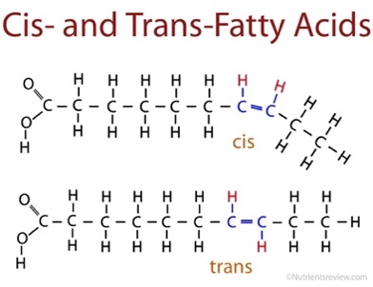
Lipids
- Unsaturated fatty acids can exist as cis or trans isomers, which arise due to the restriction on rotation around the double bond
- The cis forms occurs when the same group has the same orientation relative to the double bond
- The trans from occurs when the same group has opposite orientation across the double bond
- Cis double bonds are naturally occurring fatty acids
- Trans double bonds are sometimes found in man-made fatty acids
- Molecules of the cis isomer cannot easily arrange themselves side by side to solidify so they tend to have lower melting points than the corresponding trans isomer
- Partial hydrogenation of lipids occurs when only some of the carbon-to-carbon double bonds in the fat are broken
- Those that remain often get chemically modified from the cis-position to the trans-position
- The resulting fatty acids therefore are known as trans fats and can be found more readily in processed foods
- Consumption of a diet high in trans fats raises the level of Low Density Lipoprotein (LDL) cholesterol
Carbohydrates
- All simple sugars are chiral molecules as they contain at least on chiral carbon atom
- The stereoisomers are described as D and L again
- For sugars having two or more chiral carbon atoms the prefixes D and L refers to the configuration of the chiral carbon atom furthest away from the carbonyl carbon
- D sugars are the most frequently occurring in nature
- The conversion of sugars in a straight chain into the Hayworth projects also creates an additional type of isomer, known as α and β forms
- These are distinguished by the relative position of the OH group at C₁
- Starch and glycogen are polymers of α–glucose, cellulose is a polymer of β-glucose
Vitamins
- Vitamin A also known as retinal is involved in the so-called visual cycle (the photochemical changes associated with our ability to detect light)
- The retina of the eye contains two types of light-sensitive cells, known as rods and cones. The rod are stimulated by light of lower intensity and do not provide color vision
- The major photoreceptor pigment in rods is a large conjugated protein molecule called rhodopsin. This consist of a protein, rhodopsin, tightly bound to 11-cis-retinal, which is derived from vitamin A
- Rhodopsin is able to absorb light due to it’s highly congugated system
- When rhodopsin is exposed to light, a transformation of 11-cis retinal occurs, changing it to 11-trans retinal
- As a result 11-trans retinal no longer fits into the rhodopsin/protein. This leads to a conformational change in rhodopsin/protein generating nerve signal

