Topic 8: Acids and bases
8.1 | Theories of acids and bases
8.1.1 | A Brønsted-Lowry acid is a proton/H⁺ donor and a Brønsted-Lowry base is a proton/H⁺ acceptor
8.1.2 | Amphiprotic species can act as both Brønsted-Lowry acids and bases
8.1.3 | A pair of species differing by a single proton is called a conjugate acid-base pair
8.1.4 | Deduction of the Brønsted-Lowry acid and base in a chemical reaction
8.1.5 | Deduction of the conjugate acid or conjugate base in a chemical reaction
Brønsted-Lowry theory
- According to the Brønsted-Lowry theory, a substance behaves as an acid when it donates a proton to a base. A substance behaves as a base when it accepts a proton from an acid. Thus:
  - A Brønsted-Lowry acid is a proton (H⁺) donor
  - A Brønsted-Lowry base is a proton (H⁺) acceptor
- Acids can be a combination of hydrogen ions ($H^{+}$) and an anion. Examples include: $HCl, {HNO}_{3}, HC_{2}H_{3}O_{2}$
- Bases can be a combination of hydroxide ions (${OH}^{-}$) and metal cations. Examples include: $NaOH, KOH$
  - However, sometimes a hydrogen next to a metal signifies a base such as $NaH$
- Acid-Base Conjugate Pairs: A conjugate pair is two species which differ by a single proton:
  - The acid will become the conjugate base
  - The base will become the conjugate acid
Conjugate-Base Pair Question:
Label the conjugate acid-base pairs in the following reactions:
$${CH}_{3}COOH+H_{2}O\left(g\right)⇌{CH}_{3}COO^{-}+H_{3}O^{+}$$
Conjugate pair 1: ${CH}_{3}COOH/{CH}_{3}COO^{-}$
${CH}_{3}COOH$ is the acid because it donates a $H^{+}$, so ${CH}_{3}COO^{-}$ is conjugate base
Conjugate pair 2: $H_{2}O/H_{3}O^{+}$
$H_{2}O$ is the base because it accepts a $H^{+}$, so $H_{3}O^{+}$ is the conjugate acid
- To find the conjugate acid of a species, add one $H^{+}$
- To find the conjugate base of a species, takeaway one $H^{+}$
- Before the Brønsted-Lory theory acids and bases were distinguished by their taste, acids tasted sour
Amphiprotic
- Some substances can behave as either acids and bases, depending on what they react with, and can therefore donate or receive protons. Such substances are said to be amphiprotic
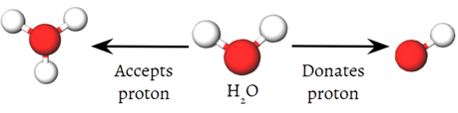
  - Amphiprotic: A chemical species capable of accepting and donating protons, thus able to act as a Brønsted-Lowry acid and a base
- This means the species must be able to accept or donate a proton to another species
- H₂O is amphiprotic as it is able to donate a proton to form a ${OH}^{-}$ or accept a proton to form $H_{3}O^{+}$ therefore acting as a Brønsted-Lowry acid or base
Amphiprotic Species Question:
Write an equation to show hydrogen phosphate acting as and an acid and a base in water
Acting like an Acid: ${{HPO}_{4}}^{2-}+H_{2}O\left(g\right)⇌{{PO}_{4}}^{3-}+H_{3}O^{+}$
Acting like a Base: ${{HPO}_{4}}^{2-}+H_{2}O\left(g\right)⇌{{HPO}_{4}}^{-}+{OH}^{-}$

Amphoteric
- Amphoteric: A species that can act as an acid or base, including reactions that do not involve a proton
- Amphiprotic specifically relates to the Brønsted-Lowry acid-base theory, where the emphasis is on the transfer of a proton. Amphoteric is a more general term that isn’t just confined to proton transfer
- All amphiprotic species are also amphoteric but not all amphoteric species are amphiprotic
8.2 | Properties of acids and bases
8.2.1 | Most acids have observable characteristic chemical reactions with reactivate metals, metal oxides, metal hydroxides, hydrogen carbonates and carbonates
8.2.2 | Salt and water are produced in exothermic neutralization reactions
8.2.3 | Balancing chemical equations for the reaction of acids
8.2.4 | Identification of the acid and base needed to make different salts
Neutralization Reactions
- Neutralization: A chemical reaction where a base and an acid react to form a salt and water
  - Salt: An ionic Compound
- Acid base reactions will always produce a salt and water
- Salt and water are neither acidic nor basic. They are called neutral solutions
- Neutralization reactions are exothermic as heat is released
- There are different types of bases that acids react with to form salt:
Hydroxyl Base:
- Equation: $Acid+Base→Salt+Water$
- To find the salt formula, take away the hydrogen from the acid and the hydroxyl group from the base (these will join together to give $Water$. Then join remaining terms (Ensure charge is the same, positive term is listed first)
Neutralization Reaction Question:
Write the equation for the reaction between hydrochloric acid ($HCl$) and a solution of sodium hydroxide ($NaOH$) to form a salt and water:
$$HCl+NaOH→H_{2}O+NaCl$$
Take away $H^{+}$ from $HCl$, and ${OH}^{-}$ from $NaOH$ to get $H_{2}O$, then join last remaining pieces (positive ion listed first)
Carbonate Base
- Equation:$Acid+Carbonate Base→Salt+{Water+CO}_{2}$
- Metal carbonates include Na₂CO₃, MgCO₃ and CaCO₃
- To find the salt formula, perform the same steps as before, but account for CO₂
Metal Reactions:
- Equation $Acid+Metal→Salt+H_{2}$
- Reactive metals include Ca, Mg, K and Zn but not Cu, Ag or Au
- To find the salt formula, perform the same steps as before, but account for H₂
Acids and Metal Reactions Question:
Write the equation for the reaction when zinc is added to hydrochloric acid
$$2HCl+Zn→{ZnCl}_{2}+H_{2}$$

8.3 | The pH scale
8.3.1 | $$pH=-log⁡[H^{+}\left(aq\right)] and {[H}^{+}]={10}^{-pH}$$
8.3.2 | A change of one pH unit represents a 10-fold change in the hydrogen ion concentration ${[H}^{+}]$
8.3.3 | pH values distinguish between acidic, neutral and alkaline solutions
8.3.4 | The ionic product constant, ${Kw=[H}^{+}]\left[{OH}^{-}\right]={10}^{-14}$ at 298K
8.3.5 | Solving problems involving pH, ${[H}^{+}]$ and ${[OH}^{-}]$
8.3.6 | Students should be familiar with the use of a pH meter and universal indicator
Self-Ionization of Water
- Because of its amphoteric (or amphiprotic) nature, water does not always remain as $H_{2}O$ molecules.
- Water will self-ionize, where it will exist in equilibrium between two water molecules and $H_{3}O^{+}$ and $OH^{-}$
$${2H}_{2}O⇌H_{3}O^{+}+OH^{-}$$
- $K_{W}$ is the ionization constant of water:
$$K_{W}=\left[H^{+}\right]\left[OH^{-}\right]=\left(1.0×{10}^{-7}\right)\left(1.0×{10}^{-7}\right)=1.0×{10}^{-14}$$
pH and pOH
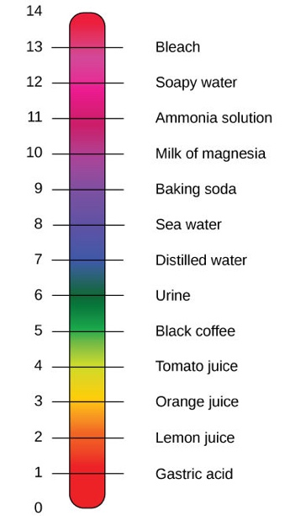
- “$p$” represents taking the negative logarithm of the value ($p=-log⁡)$ Therefore:
  - ${pK}_{W}=pH+pOH=14$
  - $pH=-\log{[H^{+}]}$
  - $pOH=-\log{[OH^{-}]}$
- The pH scale represents the concentration of $H^{+}$. The acidity of a solution is a measure of the concentration of hydrogen ions present. Using $pH+pOH=14$:
- When pH<7, the solution is acidic as $\left[H^{+}\right]>[OH^{-}]$
- When pH=7, the solution is neutral as $\left[H^{+}\right]=[OH^{-}]$
- When pH>7, the solution is basic as $\left[H^{+}\right]<[OH^{-}]$
- Log laws allow us to find $[H^{+}]$ and $[OH^{-}]$:
  - $\left[OH^{-}\right]={10}^{-pOH}$
  - $\left[H^{+}\right]={10}^{-pH}$
- The pH scale is logarithmic, meaning that an increase or decreases of an integer value changes the concentration by ten
- A two-unit change represents a one-hundred-fold change and so on
- There are no units for pH
Acid-Base Indicators
- Acid-Base Indicators (also known as pH indicators) are weak acids that indicate the concentration of $H^{+}$ in a solution by changing color
- base indicators undissociated and dissociated forms of acid-base indicators have different colors
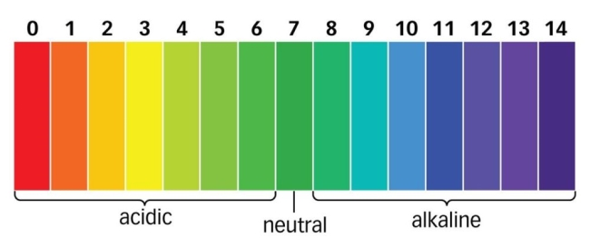
- They exist as liquid types or dye-infused paper strips. In liquid form indicators are directly added to solutions whereas paper form indicators are dipped into solutions then removed
- Both liquid and paper form pH indicators are then compared against a pH/color key to determine the solutions acidity or alkalinity
- Common indicators (In Data booklet):
Indicator | Color in Acid | Color in Alkali (Base)
Litmus | Red | Blue
Methyl Orange | Red | Yellow
Phenolphthalein | Colorless | Pink

- When titrating and acid against a base (or the other way), the indicator will change color at the equivalence point
- Using a titration curve, choose an indicator that changes color at the steepest part of the curve (equivalence point)
8.4 | Strong and weak acids and bases
8.4.1 | Strong and weak acids and bases differ in the extent of ionization
8.4.2 | Strong acids and bases of equal concentrations have higher conductive than weak acids and bases
8.4.3 | A strong acid is a good proton donor and has a weak conjugate base
8.4.4 | A strong base is a good proton acceptor and has a weak conjugate acid
8.4.5 | Distinction between strong and weak acids and bases in terms of the rates of their reactions with metals, metal oxides, metal hydroxides, metal hydrogen carbonates and metal carbonates and their electrical conductivities for solutions of equal concentrations
Strong and Weak Acids/Bases
- All acids and bases do not dissociate to the same extent. Not all acids and bases are of equal strength in producing $\left[H^{+}\right]$ and $[OH^{-}]$ in solution. The terms “strong” and “weak” give an indication of the strength of an acid/base
Strong acid |  |  | Weak acid
Strong acids fully dissociate in solution (~100%) |  |  | Weak acids partially dissociate in solution (<5%)
Form strong electrolytes when absorbed in Water |  |  | Form weak electrolytes when absorbed in water
At the same concentration, strong acids will produce more $\left[H^{+}\right]$ than weak acids
Examples: |  |  | Examples
hydrochloric acid, HCl | nitric acid, HNO₃ |  | ethanoic acid, CH₃COOH | carbonic acid, H₂CO₃
sulphuric acid, H₂SO₄ |  |  | Propanoic Acid | phosphoric acid, H₃PO₄
Strong bases |  |  | Weak bases
Strong bases fully ionize in solution (~100%) |  |  | Weak bases partially ionize in solution (<5%)
At the same concentration, strong bases will produce more $\left[{OH}^{-}\right]$ than weak acids
Examples: |  | sodium hydroxide, NaOH | Examples |  | ammonia, NH₃
 |  | potassium hydroxide, KOH
 |  | barium hydroxide, Ba(OH)₂ |  |  | Ethylamine, CH₃CH₂NH₂
- When dealing with strong acids/bases use a single arrow as it will ionize completely
- When dealing with weak acids/bases use a double arrow as it will not ionize completely and exists in equilibrium
- A strong acid has a weak conjugate base while a strong base has a weak conjugate acid

Strong and Weak Acid and Bases Question:
Compare 1M CH₃COOH vs 1M HCl
CH₃COOH is a weak acid, while HCl is a strong acid
Therefore, HCl will fully ionize while CH₃COOH will only partially ionize
Experimental techniques to determine acid or base strengths
- Conductivity: Strong acids and strong bases will be a better conductor
  - At the same concentration of acids and bases, the concentration of hydrogen ions will be higher in a strong acid than in a weak acid, and the concentration of hydroxide ions will be higher than in a weak base
  - The more ions present, the more conductive a solution
  - Conductivity can be measured with pH meter or an electrodes/conductivity meters
- pH: At the same concentration, strong acids have lower pH than weak acids, and strong bases have a higher pH than weak bases
  - Because pH is a measure of $H^{+}$ concentration, the pH scale can be used directly to compare the strengths of acids (provided they are of equal molar concentration)
  - Remember, the higher the $H^{+}$ concentraiton, the lower the pH value
  - A universal indicator of a pH meter can be used to measure pH
- Rates of Reactions
  - The reaction of acids depend on the concentration of $H^{+}$ ions
  - Reaction rate will be sped up with stronger acids
- Reactions with metals/carbonates: Strong acids will react more vigorously with metals/carbonates
8.5 | Acid deposition
8.5.1 | Rain is naturally acidic because of dissolved CO₂ and has a pH of 5.6. Acid deposition has a pH below 5.6
8.5.2 | Acid deposition is formed when nitrogen or sulfur oxides dissolve in water to form HNO₃, HNO₂, H₂SO₄ and H₂SO₃
8.5.3 | Sources of the oxides of sulfur and nitrogen and the effects of acid deposition should be covered
8.5.4 | Balancing the equations that describe the combustion of sulfur and nitrogen to their oxides and the subsequent formation of H₂SO₃, H₂SO₄, HNO₂ and HNO₃
8.5.5 | Distinction between the pre-combustion and post-combustion methods of reducing sulfur oxides emissions
8.5.6 | Deduction of acid deposition equations for acid deposition with reactive metals and carbonates
Pollution
- Acid deposition: Process by which acid forming pollutants are deposited on the Earth’s surface
- Rain is naturally acidic because of dissolved CO2 and has a pH of 5.6. Acid deposition has a pH below 5.6.
  - However, carbon dioxide itself is not responsible for acid rain since the pH of acid rain is around 5.6
- Acid deposition occurs when nitrogen or sulfur oxides dissolve in water to form HNO₂, H₂SO₄ and H₂SO₃ (weak acids)
  - Sulfur oxides can be formed from various natural processes, including the burning of sulfur containing fuels
  - Nitrogen oxides can be produced in combustion (coal, gas, oil fueled power stations)
Sulfurous Acid: H₂SO₄ | Nitrous Acid: HNO₂ | Carbonic Acid: H₂CO₃
Corrodes marble, limestone buildings and statues | Corrodes marble, limestone buildings and statues | Corrodes marble, limestone buildings and statues
Leaching in soils | Leaching in soils | Acidification of lakes
Harms/Kills Plants | Harms/Kills Plants
- Acid rain results when sulfur dioxide (SO₂) and nitrogen oxides (NO_{X}) are emitted into the atmosphere and transported by wind and air currents. The SO₂ and NO_{X} react with water, oxygen and other chemical sot form sulfuric and nitric acids. These then mix with water and other materials before falling to the ground
- Effects of Acid deposition on the environment
  - Displaces metal ions from soil, and prevents the growth/development of plants
  - Elevated acid levels in lakes and rivers, affect pH sensitive ecosystems
  - Causes the poisoning of fish, eventually resulting in the uptake of poison and damage to human healthy
  - Irritates mucous membrane causing respiratory illness (asthma)
- Methods to lower or counteract the effects of acid deposition:
- Lower the amounts of NO_{X} and SO_{X} formed. This can be done by improved engine design, the use of catalytic converts, and removing sulfur before, during and after combustion of sulfur containing fuels
- Switch to alternative methods of energy (wind and solar power) and reduce the amount of fuel burned
- Liming of lakes: Adding calcium oxide or calcium hydroxide (lime) neutralizes the acidity, increases the amount of calcium ions and precipitates aluminum from solution. This has been shown to be effective in many, but not all, lakes where it has been tried

18.1 | Lewis acids and bases
18.1.1 | A Lewis acid is a lone pair acceptor and a Lewis base is a lone pair donor
18.1.2 | When a Lewis base reacts with a Lewis acid a coordinate bond is formed
18.1.3 | A nucleophile is a Lewis base and an electrophile is a Lewis acid
18.1.4 | Application of Lewis’ acid-base theory to inorganic and organic chemistry to identify the role of the reacting species
Lewis Acids & Bases
- A Lewis Acid is any species that can accept a pair of electrons
- A Lewis Base is any species that can donate a pair of electrons
- A coordinate covalent bond is formed when these two substances react
- All transition metals ions with ligands as Lewis acid and Lewis bases
- Electrophiles act as Lewis bases. Nucleophile act as Lewis acids
Brønsted-Lowry vs Lewis Theory
Theory | Definition of acid | Definition of base
Brønsted-Lowry | Proton donor | Proton acceptor
Lewis | Electron acceptor | Electron donor
- A Lewis base is also a Brønsted-Lory base, but not all Lewis acids are Brønsted-Lowry acids
  - The term Lewis Acid is reserved for those acids which cannot donate a H⁺ ion (don’t have a hydrogen atom, but can still donate accept a pair of electrons)
- Many reactions can be described as acid-base as a transfer of protons that take place. Lewis acid-base reactions take place when no protons are transferred.
18.2 | Calculations involving acids and bases
18.2.1 | The expression for the dissociation constant of a weak acid (K_{a}) and a weak base (K_{b})
18.2.2 | For a conjugate acid base pair, $K_{a}×K_{b}=K_{w}$
18.2.3 | The relationship between $K_{a}$ and ${pK}_{a}$ is (${pK}_{a}=-logK_{a}$) and between $K_{b}$ and ${pK}_{b}$ is (${pK}_{b}=-logK_{b}$)
18.2.4 | Solution of problems involving $[H^{+}\left(aq\right)]$, $[{OH}^{-}\left(aq\right)]$, pH, pOH, $K_{a},{pK}_{a}, K_{b}$ and ${pK}_{b}$
18.2.5 | Discussion of the relative strengths of acids and bases using values of $K_{a}$, ${pK}_{a}$, $K_{b}$, and ${pK}_{b}$
Weak Acids and Bases
- $K_{a}$ is the equilibrium constant for an weak acidr reacting with water
- The partial dissociation of a weak acid $HA$ in water can be written as: $HA+H_{2}O⇌H^{+}+A^{-}$
  - Where $HA$ is the acid with hydrogen, and $A^{-}$ is the conjugate base taken away one hydrogen
- The equilibrium expression for this reaction is as follows where $K_{a}$is known as the acid dissociation constant
$$K_{a}=\frac{[H^{+}]\left[A^{-}\right]}{[HA]}$$
- $K_{b}$ is the equilibrium constant for a weak base reacting with water
- The partial dissociation of a weak base can be written as: $A^{-}+H_{2}O⇌{OH}^{-}+HA$
- The equilibrium expression for this reaction is as follows where $K_{b}$is known as the base dissociation constant
$$K_{b}=\frac{[{OH}^{-}]\left[HA\right]}{[A^{-}]}$$
- Therefore: $K_{a}×K_{b}=\frac{[H^{+}]\left[A^{-}\right]}{[HA]}×\frac{[{OH}^{-}]\left[HA\right]}{[A^{-}]}=\left[H^{+}\right]\left[{OH}^{-}\right]=K_{W}$
- Therefore: $K_{W}=K_{a}×K_{b}.$This can also be expressed as: ${pK}_{a}+{pK}_{b}=14$
  - ${pK}_{a}={-logK}_{a}$
  - ${pK}_{b}={-logK}_{b}$
18.3 | pH curves
18.3.1 | The characteristics of the pH curves produced by the different combinations of strong and weak acids and bases
18.3.2 | An acid-base indicator is a weak acid or a weak base where the components of the conjugate acid-base pair have different colors
18.3.3 | The relationship between the pH range of an acid-base indicator, which is a weak acid, and its ${pK}_{a}$ value
18.3.4 | The buffer region on the pH curve represents the region where small additions of acids or base result in little or no change in pH
18.3.5 | The composition and action of a buffer solution
18.3.6 | The general shapes of graphs of pH against volume for titrations involving strong and weak acids and bases with an explanation of their important features
18.3.7 | Selection of an appropriate indicator for a titration, given the equivalence point of the titration and the end point of the indicator
18.3.8 | While the nature of the acid-base buffer always remains the same, buffer solutions can be prepared by either mixing a weak acid/base with a solution of a salt containing its conjugate, or by partial neutralization of a weak acid/base with a strong acid/base
18.3.9 | Prediction of the relative pH of aqueous salt solutions formed by the different combinations of strong and weak acid and base
Acid-Base Titration
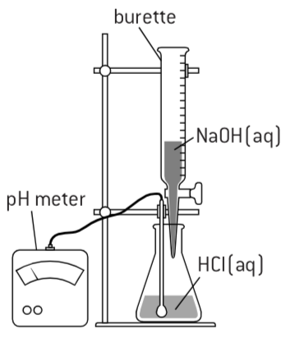
- Titration is a technique used in analytical chemistry to determine the concentration of an unknown acid or base
- Titration involves the slow addition of one solution where the concentration is known to a known volume of another solution where the concentration is unknown until the reaction reaches the desired level. For acid/base titrations, a color change from a pH indicator is reached or by using a pH meter
- A titration curve is a graph of the pH (vertical axis) versus the amount of reagent progressively added to the original sample. All acid titration curves follow the same basic shapes
- At the beginning the solution has a low pH. This pH will increase as a strong base is added
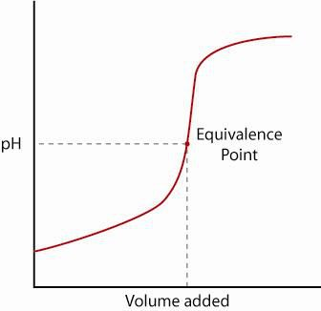
Strong Acid and Strong Base Titration Curve
- The first curve shows a strong acid being titrated by a strong base
- There is the initial slow rise in pH until the reaction nears the point where just enough base is added to neutralize all the initial acid. This is where the volume of acid is equal to the volume of the base and has the maximum gradient
- This point is called the equivalence point (also called, point of inflection or end point)
- For a strong acid-base reaction, this occurs at pH=7
- As the solution passes the equivalence point, the pH slows its increase where the solution approaches the pH of the titration solution
Weak Acid and Strong Base Titration Curve
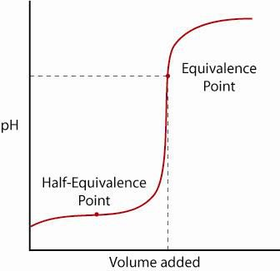
- A weak acid only partially dissociates from its salt
- The pH will rise normally at first, but as it reaches a zone where the solution seems to be buffered, the slope levels out. This is called the buffer region. This happens because the weak acid will only partially dissociate
- After this zone the pH will rise sharply through its equivalence point and levels out again like the strong acid/strong base reaction
- The equivalent point is more than 7 because the strong base will neutralize the weak acid more compared to neutralizing a strong acid
- The half-equivalent point is when just enough base is added for half of the acid to be converted to the conjugate base
- When this happens, the concentration of $H^{+}$ ions equals the $K_{a}$ value of the acid, where $pH=pK_{a}$
- The half-equivalent point occurs halfway through a buffered region where the pH barely changes for a lot of base added
Strong Acid and Weak Base or Weak Acid and Weak Base Titration Curves
- For a strong acid and a weak base the equivalence point will be below 7, because the strong acid will take longer to neutralize with a weak base

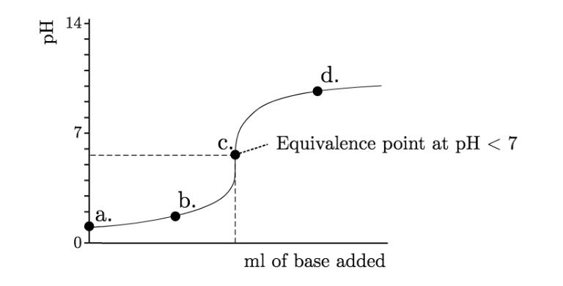

Indicators
- An indicator is a weak acid (or base) in where $HIn$ and ${In}^{-}$ are different colors:
$$HIn⇌H^{+}+{In}^{-}$$
$$K_{in}=[H^{+}]×\frac{\left[{In}^{-}\right]}{[HIn]}$$
- In basic solution equilibrium moves to the right. In acid equilibrium moves to the left
- Indicator should change color at equivalence point. The color will change at equivalent point when $\left[{In}^{-}\right]=[HIn]$, therefore $K_{in}=[H^{+}]$
- Thus ${pK}_{in}=pH$
- Different indicators have different $K_{in}$ values and so change color within different pH ranges
Indicator | $${pK}_{in}$$ | pH Range | Use
Methyl Orange | 3.7 | 3.1-4.4 | Titration with strong acids
Phenolphthalein | 9.3 | 8.2-10.0 | Titration with strong bases
Bromophenol Blue | 9.3 | 3.0-4.6
- To find which indicator to use, the pH at the equivalent point must be in the appropriate pH range
Salts Hydrolysis
- Salt Hydrolysis: The process in which a salt reacts with water to give back the acids and the base
$$Salt+Water→Acid+Base$$
- To predict whether a salt will form an acidic, basic or neutral solution when dissolved in water, split the salt into individual ions, and find out if those ions are acidic or basic
  - If the salt is composed of a strong acid and weak base it will produce an acidic solution
  - If the salt is composed of a weak acid and a strong base it will produce a basic solution
  - The salt of a strong acid and a strong base is always neutral
- Or, split to salt into individual atoms, then pair the individual ions with either a hydrogen ion or the OH group.
  - If the charge on the individual atom is positive (cation), it is a base
  - If the charge on the individual atom is negative (anion), it is an acid
- Then compare whether it’s a strong acid or a strong base
- Example: NaCl gives Na⁺ and Cl⁻. Therefore Na⁺ is a cation so has an OH group which gives NaOH while Cl⁻ is an anion so is paired with a hydrogen ion to give HCl
Buffers
- Buffer: Solutions that can resist pH change upon the addition of an acidic or basic components
- Buffer solutions can be prepared by mixing a weak acid with a solution of salt containing its conjugate base
- Buffer solutions can also be prepared by partial neutralization of a weak acid with a strong base

