Topic 5: Evolution
5.1 | Evidence for evolution
U1 | Evolution occurs when heritable characteristics of a species change
U2 | The fossil record provides evidence for evolution
U3 | Selective breeding of domesticated animals shows that artificial selection can cause evolution
U4 | Evolution of homologous structures by adaptive radiation explains similarities in structure when there are differences in function
U5 | Populations of a species can gradually diverge into separate species by evolution
U6 | Continuous variation across the geographical range of related populations matches the concept of gradual divergence
A1 | Development of melanistic insects in polluted areas
A2 | Comparison of the pentadactyl limb of mammals, birds, amphibians and reptiles with different methods of locomotion
Evolution
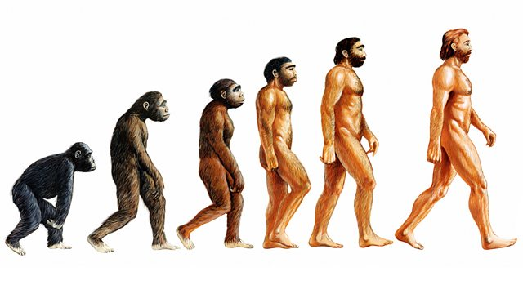
- Evolution: The cumulative change in the heritable characteristics of a population
  - Cumulative change: Small change over many generations
  - Heritable characteristics: Gene-controlled factors
  - Population: Not an individual
- These traits cannot be acquired over a lifetime, they are heritable traits or alleles in an organism’s DNA
Evidence for Evolution
- There is various evidence to support the theory of evolution:
The Fossil Record
- Fossils are the preserved remains or traces of animals, plants and other organisms from the past
- They can either be direct (body fossils such as bones, teeth and shells) or indirect (trace fossils such as footprints)
- The fossil record is the sum of all discovered and undiscovered fossils and their relative placement in rock. Simply the deeper the fossil is the older it is.
- Fossils are important evidence for evolution because they show that life on earth was once different from life found on earth today. Therefore the fossil record shows a gradual change of a species over time
- However, not all organisms are fossilized and there may be undiscovered organisms hidden therefore there are gaps in the fossil record. But fossils are really helpful to show organisms from a long time ago and compare it to that organism now
Selective breeding
- Selective breeding of domesticated animals shows that artificial selection can cause evolution
- Selective breeding (also called artificial selection) is the process where humans breed animals or plants for particular traits
- Individuals which show the most desirable traits are chosen to breed together, therefore the next generation will have an increased frequency of the desired trait. This process is repeated for many generations until the entire population shows the desired trait
- Selective breeding provides evidence of evolution as targeted breeds can show significant variation in a relatively short period
  - Selective breeding of plant crops has allowed for the generation of new types of foods from the same ancestral plant source. This includes broccoli (modified flower buds), cabbage (modified leaf buds), and kale (modified leaves)
  - Example: Carnis Lupus (Gray Wolf) now is the common ancestor for a wide variety of dogs from sheep dogs, beagles and greyhounds

Comparative anatomy
- Evolution of homologous structures by adaptive radiation explains similarities in structure when there are differences in function
- Comparative anatomy of groups of animals or plants show certain structural features are basically similar. Structures or anatomical features having similar basic structure as in other species are said to be homologous
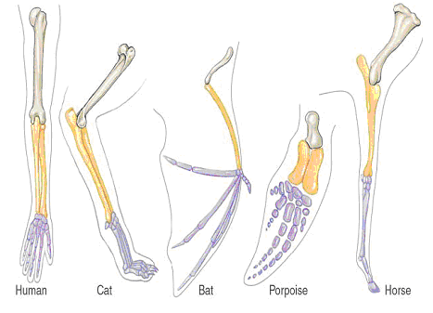
- Homologous structures are similar structures in organisms that evolved from a common ancestor. (Same ancestor and structure, different function) These structures may or may not have the same function in the descendants. However they all have the same basic pattern of bones.
- For example, the pentadactyl limb is a bone arrangement all present in mammals, birds, amphibians and reptiles based on a five digit limb
- Despite possessing similar bone arrangement, there are different functions depending on the mode of locomotion:
  - Human hands are adapted for tool manipulation
  - Bird and bat wings are adapted for flying
  - Horse hooves are adapted for galloping
  - Whale and dolphin fins are adapted for swimming
- Analogous structures are similar structures having the same function, but do not share a common ancestor (same function, similar structure, different origin)
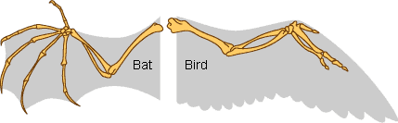
- The structures are similar because they evolved to perform the same function, not because they were inherited from a common ancestor
- For example the wings of a bat and a bird both look similar and have the same function, however their wings evolved independently in the two groups of animals
- Vestigial structures are structures that no longer serve a purpose in the organism such as the human tail bone or a whale pelvis. Evolution has reduced their size because the structures are no longer used
Speciation
- If two populations of a species become geographically separated then they will likely experience different ecological conditions. If separated for too long the two populations will adapt to the different environmental conditions and gradually diverge from one another. When two populations can no longer interbreed and produce fertile, viable offspring they are considered to be separate species. The evolutionary process by which two related populations diverge into separate species is called speciation
- The degree of divergence will depend on the extent of geographical separation and the amount of time since separating occurred. The degree of divergence will gradually increase the longer they are separated
  - Populations located in close proximity that separated recently will show less variation (less divergence)
  - Distant populations that are separated for a longer period of time will show more variation (more divergence)
Peppered moths
- Peppered moths exist in two distinct polymorphic forms: a light coloration and a darker melanic variant
  - In an unpolluted environment, the trees are covered by a pale-colored lichen, which provides camouflage for the lighter moth
  - In a polluted environment, sulphur dioxide kills the lichen while soot blackens the bark, providing camouflage for the dark moth
- The frequency of the two different forms of peppered moth is dependent on the environment and evolves as conditions change. Before the industrial revolution, the environment was largely unpolluted and the lighter moth had a survival advantage. Following the industrial revolution, the environment became heavily polluted, conferring a survival advantage to the darker moth
- Recent environmental policies in Europe are reducing pollution levels, altering the frequency of the two populations once again

5.2 | Natural selection
U1 | Natural selection can only occur if there is variation among members of the same species
U2 | Mutation, meiosis and sexual reproduction causes variation between individuals in a species
U3 | Adaptations are characteristics that make an individual suited to its environment and way of life
U4 | Species tend to produce more offspring than the environment can support
U5 | Individuals that are better adapted tend to survive and produce more offspring while the less well adapted tend to survive and produce more offspring while the less well adapted tend to die or produce fewer offspring
U6 | Individuals that reproduce pass on characteristics to their offspring
U7 | Natural selection increases the frequency of characteristics that make individuals better adapted and decreases the frequency of other characteristics leading to changes within the species
A1 | Changes in beaks of finches on Daphne Major
A2 | Evolution of antibiotic resistance in bacteria
Natural Selection
- The theory of natural selection was proposed by Charles Darwin who described it as survival of the fittest
- According to this theory it is not necessarily the strongest or most intelligent that survives, but the ones most responsive to change. The process of natural selection occurs in response to a number of conditions:
Variation
- Natural selection cannot occur unless there is variation in a species. If all organisms had identical genotype none would be favored more than other
- There are three main mechanisms by which genetic variation between individuals in a species may occur:
  - Mutations: New alleles are produced, hence the gene pool is enlarged
  - Meiosis: Through sexual reproduction
  - Sexual reproduction: Produces new combinations of alleles by breaking up existing combinations in diploid cells. Each cell would carry new sets of alleles because of crossover + independent assortment
Competition
- Competition: There’s a struggle for survival as species sometimes produce more offspring than resources
- When there’s an increase in offspring there are less resources available for the rest of the population
- If a species keeps overproducing, this will lead to competition for survival
Adaptations
- Adaptations: Individuals with beneficial traits will be more likely to survive and pass these traits on to their offspring
- Species tend to produce more offspring than the environment can support. When this happens individuals that are better adapted, tend to survive and produce more offspring while the less well adapted tend to die or produce fewer offspring
- These adaptations may be classified in a number of different ways
  - Structural: Physical differences in biological structure
  - Behavioral: Difference in patterns of activity
  - Physiological: Variation in detection and response by vital organs
  - Biochemical: Differences in molecule composition of cells and enzyme functions
  - Developmental: Variable changes that occur across the life span of an organism
- Biological adaptations have a genetic basis and may be passed to offspring when the parents reproduce
- Organisms with beneficial adaptations will be more likely to survive long enough to reproduce and pass on these genes
- Organisms without these beneficial adaptations will be less likely to survive long enough to reproduce and pass on their genes. Hence adaptations result in differential reproduction within a species, allowing for natural selection to occur

Allele Frequency
- Evolution: Over time, there is a change in allele frequency within the population gene pool
- Over time, there is a change in allele frequency within the population gene pool
- Due to natural selection the proportion of different alleles will change across generations
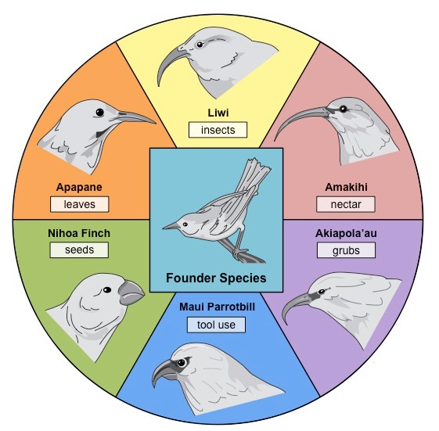
Adaptive Radiation
- Adaptive radiation describes the rapid evolutionary diversification of a single ancestral line
- It occurs when members of a single species occupy a variety of distinct niches with different environmental conditions
- Consequently, members evolve different morphological features in response to the different selection pressures
- Example: The finches of the Galapagos Island. These finches have specialized beak shapes depending on their primary source of nutrition
Antibiotic Resistance
- After an antibiotic is introduced bacterial resistance appears in a few years
- Proportions of infections caused by resistant strains increased as resistance spreads to more and more species
- This is caused by a mutation in a single bacterium, then when antibiotic administered, there is strong natural selection for resistance there we have a great increase in resistant bacteria
- A bacterial population with no resistance to an antibiotic may develop into a bacterial population with some resistance to an antibiotic because an antibiotic resistance plasmid is received from a bacterium in another population
5.3 | Classification of biodiversity
U1 | The binomial system of names for species is universal among biologists and has been agreed and developed at a series of congresses
U2 | When species are discovered they are given scientific names using the binomial system
U3 | Taxonomists classify species using a hierarchy of taxa
U4 | All principal taxa for classifying eukaryotes are kingdom, phylum, class, order, family, genus and species
U5 | In a natural classification, the genus and accompanying higher taxa consist of all the species that have evolved from one common ancestral species
U6 | Taxonomists sometimes reclassify groups of species when new evidence shows that a previous taxon contains species that have evolved from different ancestral species
U7 | Natural classifications help in identification of species and allow the prediction of characteristics shared by species within a group
A1 | Classification of one plant and one animal species from domain to species level
A2 | Recognition features of bryophyte, filicinophyta and angiospermophyta
A3 | Recognition of features of birds, mammals, amphibians, reptiles and fish
S1 | Construction of dichotomous keys for use in identifying specimens
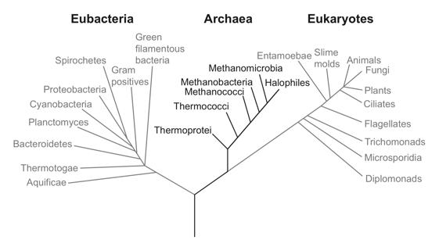
Domains of Life
- Currently, all living organisms are classified into three domains
  - Eukaryotes
  - Archaea
  - Eubacteria
- Only eubacteria don’t have organelles
- Originally the two prokaryotic domains were considered as only a single kingdom

Hierarchy of Taxa
- Taxonomy is the science involved with classifying groups of organisms on the basis of shared characteristics
- Organisms are ground according to a series of hierarchical taxa. The more taxa organisms share the more similar they are
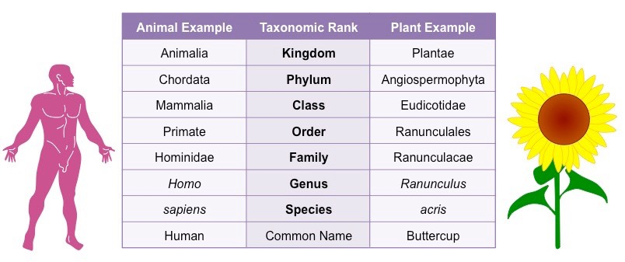
- The order is:
- Domain
- Kingdom
- Phylum
- Class
- Order
- Family
- Genus
- Species
Does King Philip come over for grape sex
Binomial System
- The binomial system of nomenclature is the formal system by which all living species are classified (taxonomy)
- It was initially developed by a Swedish botanist named Carolus Linnaeus in 1735
- It is periodically assessed and updated at a series of international congresses which occur every 4 years
- The binomial system of nomenclature provides value because:
  - It allows for the identification and comparison of organisms based on recognized characteristics
  - It allows all organisms to be named according to a globally recognized scheme
  - It can show how closely related organisms are, allowing for the prediction of evolutionary links
  - It makes it easier to collect, sort and group information about organisms
- Every organism is designated a scientific name with two parts:
  - Genus is written first and is capitalized
  - Species follows and is written in lower case
  - When typing the scientific name it should be presented in italics
  - When hand writing the scientific name it is customary to underline
Classification
- There are two main classification schemes used to identify living organisms
Animal Classification
Phylum name | Anus | Mouths | Symmetry | Segmentation | Other features | Example
Porifera | None | None | None | None | Attach to rocks | Spongebob
Cnidaria | None | Yes | Radical | None | Stinging cells | Tentacruel
Platyhelminthes | None | Yes | Bilaternal | None | Flattern body | Flatworm
Annelida | Yes | Yes | Bilaternal | None | Bristles | Caterpie
Mollusca | Yes | Yes | Bilaternal | None | Have shells | Omanyte
Athropoda | Yes | Yes | Bilaternal | Yes | Exoskeleton and joints | Ariados

Plant Classification
Phylum name | Vascular Tissue | Means of reproduction | Roots and stems | Examples
Bryophytes | None | Spores | No roots, simple leaves and stems | Mosses
Filicinophytes | Yes | Spores | Has root, short non-woddy stems | Ferns
Coniferophytes | Yes | Naked seeds | Has roots, woody stems | Pines
Angiospermophytes | Yes | Flowering | Has roots, variable leaves and stems | Peach tree
Dichotomous Keys
- A dichotomous key is a method of identification whereby groups of organisms are divided into two categories repeatedly
- With each sequential division, more information is revealed about the specific features of a particular organism
- When the organism no longer shares its totality of selected characteristics with any organism, it has been identified
- When using a dichotomous key to identify specimens it is preferable to use immutable features (features that don’t change)
- They are either represented as a branching flowchart or a series of paired statements laid out in a number sequence
5.4 | Cladistics
U1 | A clade is a group of organisms that have evolved from a common ancestor
U2 | Evidence for which species are part of a clade can be obtained from the base sequences of a gene or the corresponding amino acid sequence of a protein
U3 | Sequence differences accumulate gradually so there is a positive correlation between the number of differences between two species and the time since they diverged from a common ancestor
U4 | Traits can be analogous or homologous
U5 | Cladograms are tree diagrams that show the most probable sequence of divergence in clades
U6 | Evidence from cladistics has shown that classifications of some groups based on structure did not correspond with the evolutionary origins of a group or species
A1 | Cladograms including humans and other primates
A2 | Reclassification of the figwort family using evidence from cladistics
S1 | Analysis of cladograms to deduce evolutionary relationships
A3 | Recognition of features of birds, mammals, amphibians, reptiles and fish
S1 | Construction of dichotomous keys for use in identifying specimens
Clades
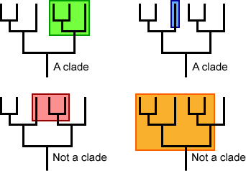
- Clade: A monophyletic group (meaning a group compound of the most recent common ancestor of the group and all of its descendants)
- Organisms are placed in clades because they share characteristics developed from a common ancestor
- Branching points on the diagram is called nodes
- Nodes denote a speciation event where a common ancestor splits into two or more species
- Sometimes determining which species are part of a certain clade is difficult

Analogous and Homologous Traits
- Analogous and homologous traits are two types of traits that are considered when putting organisms into their appropriate clades
- Homologous traits: A trait/structure that is derived from the same part of a common ancestor
- Analogous traits: Characteristics that may have the same function but they do not necessarily have the same structure and they are not derived from a common ancestor
Molecular Evidence
- The number of differences between comparable base sequences demonstrates the degree of evolutionary divergence
- A greater number of differences between comparable base sequences suggests more time has past since two species diverged
- Hence, the more similar the base sequence of two species are, the more closely related the two species are expected to be
Structural Evidence
- A clade is a group of organisms that have evolved from a common ancestor

