Topic 4: Ecology
4.1 | Species, communities and ecosystems
U1 | Species are groups of organisms that can potentially interbreed to produce fertile offspring
U2 | Members of a species may be reproductively isolated in separate populations
U3 | Species have either an autotrophic or heterotrophic method of nutrition (a few species have both methods)
U4 | Consumers are heterotrophs that feed on living organisms by ingestion
U5 | Detritivores are heterotrophs that obtain organic nutrients from detritus by internal digestion
U6 | Saprotrophs are heterotrophs that obtain organic nutrients from dead organisms by external digestion
U7 | A community is formed by populations of different species living together and interacting with each other
U8 | A community forms an ecosystem by its interactions with the abiotic environment
U9 | Autotrophs obtain inorganic nutrients from the abiotic environment
U10 | The supply of inorganic nutrients is maintained by nutrient cycling
U11 | Ecosystems have the potential to be sustainable over long periods of time
S1 | Classifying species as autotrophs, consumers, detritivores or saprotrophs from a knowledge of their mode of nutrition
S2 | Setting up sealed mesocosms to try to establish sustainability
S3 | Testing for association between two species using the chi-squared test with data obtained by quadrat sampling
S4 | Recognizing and interpreting statistical significance
Definitions
Ecology – The study of the relationships between living organisms and their environment
Species – A group of organisms that can potentially interbreed to produce fertile offspring
Population – A group of the same species, living in the same area at the same time
Communities – A group of populations living together and interacting with each other within a given area
Habitat – The environment in which a species normally lives, or the location of a living organism
Ecosystems – A community and its abiotic environment

- A community is formed by populations of different species living together and interacting with each other
- An ecosystem is formed from community interactions with the abiotic environment
Species
- Members of a species:
  - Have similar physical characteristics
  - Can interbreed and produce fertile offspring
  - Share common phylogeny (family tree)
  - Has different gene pools compared to other organisms
- However, some species don’t a follow the species definition as:
  - Just because organisms are separated by long distances (speciation) doesn’t mean they can’t interbreed and aren’t a part of the same species
  - Some organisms reproduce asexually (like bacteria) so we can’t use the “interbreeding” definition
  - Some members of different species can interbreed
    - Hybrids are the offspring of two similar but different species
    - A horse and a zebra can interbreed and produce offspring (a mule) as they are closely related
    - However, the offspring is usually infertile as there will be an odd number of chromosome
    - Most hybrids are infertile, meaning a second generation of hybrids isn’t possible
Mode of Nutrition
- Species can be classified according to their mode of nutrition
Autotrophs | Heterotrophs
Synthesizes their own organic molecules from inorganic molecules (usually through the process of photosynthesis) | Obtains organic molecules from other organisms (via different feeding mechanisms and food sources)
Commonly referred to as producers since they synthesize their own organic molecules | Commonly referred to as consumers since they only consumer organic materials
Example: Plants, algae, some bacteria | Examples: Animals, fungi, some bacteria

- Autotrophs obtain inorganic nutrients from the abiotic environment
- Heterotrophs can be classified even further according to their feeding pattern
  - Consumers: Heterotrophs that feed on living organisms by ingestion
    - Herbivores are consumers that feed principally on plant matter
    - Carnivores are consumers that feed principally on animal matter
    - Omnivores are consumers that have a principle diet composed of both plant and animal matter
    - Scavengers are consumers that principally feed on dead and decaying carcasses rather than hunting live prey. Examples include hyenas, vultures and carrion birds (such as crows)
  - Saprotrophs: Heterotrophs that obtain organic nutrients from dead organisms by external digestion
    - They live on (or in) non-living organic matter, secrete digestive enzymes into it and absorbing the products
    - Unlike other types of heterotrophs, saprotrophs do not ingest food but use enzymatic secretion to facilitate external digestion
  - Detritivores: Heterotrophs that obtain nutrients from detritus by internal digestion
    - Detritus is dead, particulate organic matter – such as decaying organic material and fecal matter
    - Humus is the term given specifically to the decaying leaf litter intermixed within the topsoil
    - Detritivores include dung beetles, earthworms, woodlice, snails and crabs
Mixotrophs
- Certain unicellular organisms may on occasion use both modes of nutrition, depending on resource availability
- Euglena gracilis possess chlorophyll for photosynthesis (autotrophic) but may also feed on detritus (heterotrophic)
Ecosystem sustainability
- Ecosystems have the potential to be sustainable over long periods of time
- There are three main components required for sustainability in an ecosystem
  - Energy availability: Light form the sun provides the initial energy source for almost all communities
  - Nutrient availability: Saprotrophs decomposers ensure the constant recycling of inorganic nutrients
  - Recycling of wastes: Certain bacteria can detoxify harmful waste by-products (E.g. denitrifying bacteria such as Nitrosomnas)
Nutrient cycling
- The supply of nutrients is limited so it is maintained by nutrient cycling to ensure the continuing availability of nutrients.
- Autotrophs produce organic molecules as they transform inorganic molecules into organic molecules
- Consumers will then obtain the organic molecules as they will eat the produces and obtain the organic molecules
- When those consumers die, their cells are broken down by the digestive enzymes of decomposers and the nutrients are returned to the soil

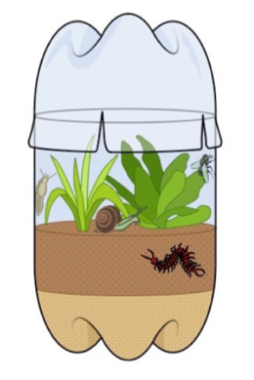
Mesocosms
- Mesocosms are enclosed environments that allow a small part of a natural environment to be observed under controlled conditions
- They are usually used to test the sustainability of a nutrient cycle
Chi-Squared test
- The presence of two species within a given environment will be dependent upon potential interactions between them
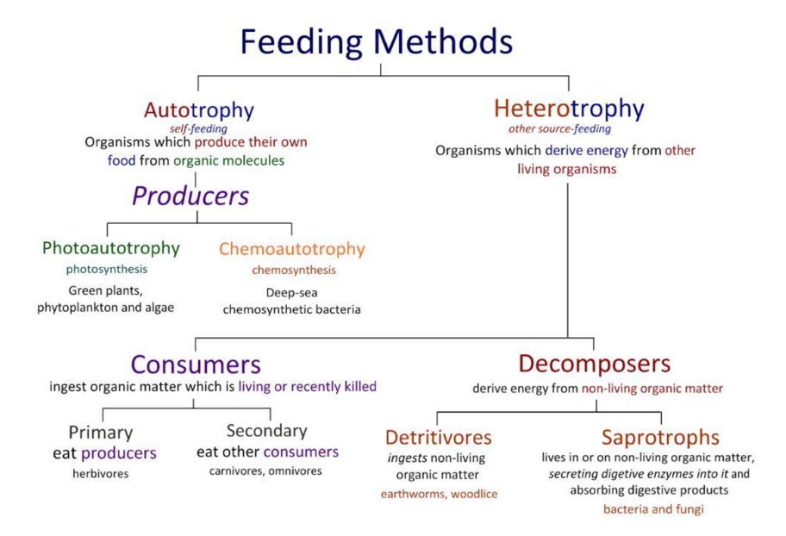
- (Be able to do a Chi-Squared Test)
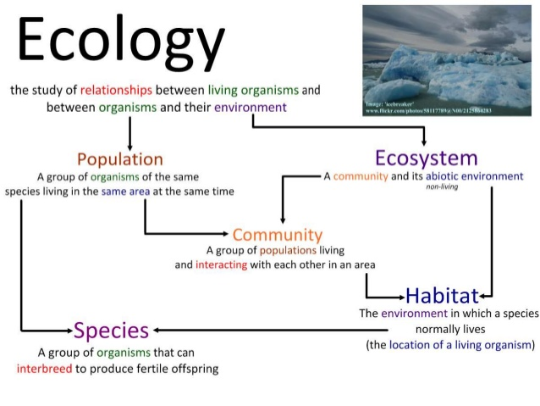
Using Quadrat
- A quadrat is a square that generally measures 1m on all sides
- The basic idea of a quadrat is to help count a small percentage of the sample
- The quadrat will be randomly placed around a location and the number of organisms inside of it will be counted
- Then by estimating how many quadrats can be placed in the location by extrapolating the data the total number of that organism can be found
4.2 | Energy flow
U1 | Most ecosystems rely on a supply of energy from sunlight
U2 | Light energy is converted to chemical energy in carbon compounds by photosynthesis
U3 | Chemical energy in carbon compounds flow through food chains by means of feeding
U4 | Energy released from carbon compounds by respiration is used by living organisms and converted to heat
U5 | Living organisms cannot convert heat to other forms of energy
U6 | Heat is lost from organisms
U7 | Energy losses between trophic levels restrict the length of food chains and the biomass of higher trophic levels
S1 | Quantitative representations of energy flow using pyramids of energy
Energy sources
- Energy enters most ecosystems through sunlight where it is converted into chemical energy by producers (photosynthesis)
- This makes light the initial source of energy for almost all communities
- All green plants and some bacteria are photoautotrophic. These organisms use sunlight as a source of energy
- However in a few ecosystems some producers are chemoautotrophic bacteria, which convert their energy from chemical processes
Light energy
- Light energy is absorbed by autotrophs and is converted into chemical energy via photosynthesis
- This light energy is used to make organic compounds (e.g. sugars) from inorganic sources (e.g. CO₂)
- Heterotrophs ingest these organic compounds in order to derive their chemical energy (ATP)
- When organic compounds are broken down via cell respiration, ATP is produced to fuel metabolic processes
Energy storage in the form of ATP
- Energy stored in organic molecules (e.g. sugars and lipids can be released by cell respiration to produce ATP)
- This ATP is then used to fuel metabolic reaction required for growth and homeostasis
- A by-product of these chemical reactions is heat (thermal energy) which is released from the organism
Energy Loss
- When energy transformations take place in living organisms the process is never 100% efficient
- Typically, energy transformations are ~10% efficient, with about 90% available energy lost between trophic levels
- Reasons for energy loss:
  - Energy is lost as heat
  - Not all the parts of an organism are swallowed
  - Not all of the parts of an organism can be digested and used
  - Some organisms die before being eaten by an organism in the next trophic level
- Energy losses between trophic levels restrict the length of food chains and the biomass of higher trophic levels
- The amount of energy transferred depends on how efficiently organisms can capture and use energy (usually between 5 – 20%). This can be represented using a pyramid of energy
Pyramids of Energy
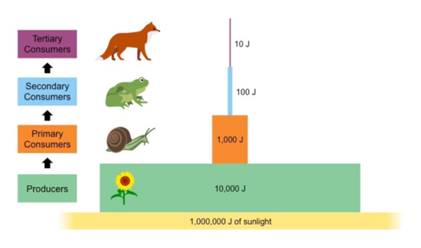
- Pyramid of energy: A diagram that shows how much energy flows from one trophic level to the next in a community
- Units: kJ m⁻² year⁻¹
- Pyramids of energy will never appear inverted as so much energy is lost as heat and after many trophic levels, not much energy is left
- Each level should be roughly one tenth of the size of the preceding level (as around 90% of the energy is lost between trophic levels)
- The bottom level always represents the producers, with subsequence levels representing consumers (primary, secondary, etc)
Energy Conversion
- The chemical energy produced by an organism can be converted into a number of forms, including:
  - Kinetic energy (e.g. during muscular contractions)
  - Electrical energy (e.g. during the transmission of nerve impulses)
  - Light energy (e.g. producing bioluminescence)
Heat Energy
- All these reactions are exothermic and release thermal energy (heat) as a by-product
- Heat is lost from ecosystems as living organisms cannot turn this heat into other forms of usable energy
- Hence ecosystems require a continuous influx of energy from an external source (such as the sun)

Food Chains
- Energy flow: The process of passing energy from one organism to another through feeding
- A food chain shows the flow of energy through the trophic levels of a feeding relationship
- Arrows represent the transfer of energy and matter as one organism is eaten by another (arrows point in direction of energy flow)
- The first organism in a food chain is always a producer, followed by consumers (primary, secondary, tertiary, etc.)
Trophic Levels
Trophic Level 1 | Producer
Trophic Level 2 | Primary consumer
Trophic Level 3 | Secondary Consumer
Trophic Level 4 | Tertiary Consumer
- Trophic level: Feeding position of an organism in a food chain
  - Producers always occupy the first trophic level in a feeding sequence
  - Primary consumers feed on producers and hence occupy the feeding sequence
  - Further consumers (e.g. secondary, tertiary, etc.) may occupy subsequence trophic levels
Biomass
- As energy is lost between trophic levels, higher trophic levels store less energy as carbon compounds and so have less biomass
Definitions
Biomass – The total mass of a group of organisms – consisting of the carbon compounds contained in the cells and tissues
- Because carbon compounds store energy, scientists can measure the amount of energy added to organisms as biomass
- Biomass diminished along food chains with the loss of carbon dioxide, water and waste products to the environment
4.3 | Carbon Cycling
U1 | Autotrophs convert carbon dioxide into carbohydrates and other carbon compounds
U2 | In aquatic ecosystems carbon is present as dissolved carbon dioxide and hydrogen carbonate atoms
U3 | Carbon dioxide diffuses from the atmosphere or water into autotrophs
U4 | Carbon dioxide is produced from organic matter in anaerobic conditions by methanogenic archaea’s and some diffuses into the atmosphere or accumulates in the ground
U5 | Methane is oxidized to carbon dioxide and water in the atmosphere
U6 | Peat forms when organic matter is not fully decomposed because of acidic and/or anaerobic conditions in waterlogged soils
U7 | Partially decomposed organic matter from past geological eras was converted either into coal or into oil and gas that accumulate in porous rocks
U8 | Carbon dioxide is produced by the combustion of biomass and fossilized organic matter
U9 | Animals such as reef-building corals and Mollusca have hard parts that are composed of calcium carbonate and can become fossilized in limestone
A1 | Estimation of carbon fluxes due to processes in the carbon cycle
A2 | Analysis of data from air monitoring stations to explain annual fluctuations
S1 | Construct a diagram of the carbon cycle
Carbon Cycle
- The carbon cycle is a biogeochemical cycle whereby carbon exchanged between the different spheres of the Earth
  - Hydrosphere: Water
  - Biosphere: Living things
  - Lithosphere: Ground
  - Atmosphere: Air
- Carbon is exchanged between a variety of forms including:
  - Atmospheric gases: CO₂ and CH₄
  - Oceanic carbonates: Calcium carbonate in corals and shells, bicarbonates dissolved in water
  - Organic materials: Carbohydrates, lipids, proteins
  - Non-living remains: Detritus, fossil fuels
- Autotrophs convert carbon dioxide into carbohydrates and other carbon compounds via photosynthesis
  - Terrestrial plants obtain carbon dioxide by absorbing it from the air
  - Aquatic producers obtain carbon dioxide by absorbing it from the water
- Heterotrophs cannot synthesize their own organic molecules and instead obtain carbon compounds via feeding
- There are many sources that produce CO₂ into the environment
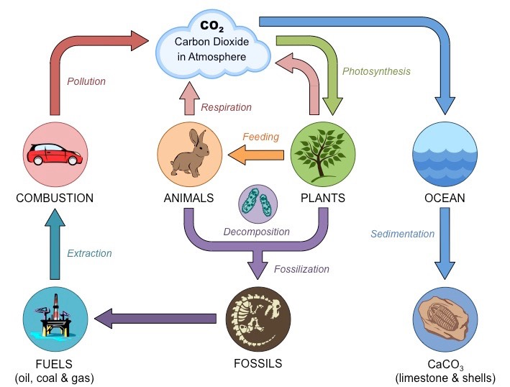

- The carbon cycle is also present in aquatic ecosystems
- In aquatic ecosystems, carbon is present as dissolved carbon dioxide and hydrogen carbonate ions
- Carbon dioxide is produced by respiration and diffuses out of organisms into water or the atmosphere
- When carbon dioxide from the air diffuses into water it forms an acid, which lowers the pH
- The consequences of rising atmospheric carbon dioxide levels include:
  - Acidic water can dissolve organism shells, weakening them, making them more prone to predation
- Factors increasing CO₂ concentration
Methane
- Methanogens are Archaean microorganisms that produce methane (CH₄) as a metabolic by-product in anaerobic conditions
- Anaerobic conditions where methanogens may be found include:
  - Wetlands (swamps and marshes
  - Marine sediments (mud of lake beds)
  - Digestive tract of ruminant animals (Cows, sheep, goats)
- Methanogens produce methane from the by-product of anaerobic digestion, generally with acetic acid and carbon dioxide
$$Acetic acid →Methane and Carbon Dioxide$$
$$Carbon Dioxide+Hydrogen →Methane and Water$$
- When methane is released into the atmosphere as a result of anaerobic reactions, it only persists for ~12 years
- Methane is oxidized to carbon dioxide and water in the atmosphere which is why methane are not very lare
Peat
- Peat: A type of waterlogged soil that contains large amounts of partially decomposed organic matter
- Peat forms when organic matter is not fully decomposed because of acidic and/or anaerobic conditions in waterlogged soils
- Peat is formed in the following steps:
- Dead organisms are covered in water
- The weight of the water forces the air out, creating an anaerobic environment
- Microorganisms that would normally decompose the dead things die off
- Energy-rich compounds are compressed and preserved
- Peat is used as a fossil fuel through burning
  - Burning peat yields a lot of energy, although to harvest peat the wetland environments must be dug up
  - Burning peat also releases carbon dioxide into the environment
- Factors that favor the production of peat include
  - Presence of organic matter
  - Anaerobic conditions
  - Acidic conditions
Fossil Fuels
- Oil (i.e. petroleum) and natural gas form as the result of the decay of marine organisms on the ocean floor
  - Sediments (e.g. clay and mud) are deposited on top of the organic matter, creating anoxic conditions that prevent decomposition
  - As a result of the burial and compaction the organic material becomes heated and hydrocarbons are formed
  - The hydrocarbon form oil and gas, which are forced out of the source rock and accumulate in porous rocks
- The formation of fossil fuels (coal, oil and gas) takes place over millions of years, making them a non-renewable energy source
- Oil, coal, natural gas and other fossil fuels are energy rich and provide lots of usable energy
- Although burning them releases carbon dioxide and other containments into the air
Combustion
- Carbon dioxide is produced by the combustion of biomass and fossilized organic matter
- When organic compounds rich in hydrocarbons are heated in the presence of oxygen, they undergo a combustion reaction
- This reaction produces energy and releases carbon dioxide and water as by-products
- The carbon dioxide is typically released into the atmosphere, increasing the concentration of the gas in the air
Biofuels
- Biofuel: A fuel derived directly from living matter
- Biofuels provide advantages over fossil fuels
  - Habitats don’t have to be disrupted to be mined in
  - The carbon dioxide released are absorbed faster than fossil fuels (a few days vs millions of years), making the cycle time shorter
Limestone
- Limestone is inorganic, the majority of it is made of calcium carbonate or CaCO₃
- Animals such as reef-building corals and mollusca have hard parts that are composed of calcium carbonate and can become fossilized in limestone
- Production of limestone:
- Marine organisms absorb carbon dioxide from their environment
- Carbon dioxide is transformed into calcium carbonate, which is used to make their shells
- The animals die and their shells accumulate on the ocean floor
- Non-porus sedimentary rock layers form on top of the shells
- Heat and pressure turn the shells into limestone
- The formation of limestone is important in biosequestration
  - Biosequestration: The process of removing carbon from the environment and locking it up in a substance for an extended period of time
- When limestone is mined and crushed up for concrete it can released carbon dioxide back into the air which disrupts the biosequestration of the atmospheric carbon
4.4 | Climate Change
U1 | Carbon dioxide and water vapour are the most significant greenhouse gases
U2 | Other gases including methane and nitrogen oxides have less impact
U3 | The impact of a gas depends on its ability to absorb long wave radiation as well as on its concentration in the atmosphere
U4 | The warmed Earth emits longer wavelength radiation (heat)
U5 | Longer wave radiation is absorbed by greenhouse gases that retain the heat in the atmosphere
U6 | Global temperatures and climate patterns are influenced by concentrations of greenhouse gases
U7 | There is a correlation between rising atmospheric concentrations of carbon dioxide since the start of the industrial revolution 200 years ago and average global temperatures
U8 | Recent increases in atmospheric carbon dioxide are largely due to increases in the combustion of fossilized organic matter
A1 | Threats to coral reefs from increasing concentrations of dissolved carbon dioxide
A2 | Correlations between global temperatures and carbon dioxide concentrations on Earth
A3 | Evaluating claims that human activities are not causing climate change
The Atmosphere
- The atmosphere is the collection of gases above Earth’s surface
- The role of the atmosphere is to retain heat at night and prevent fluctuations in temperatures
Greenhouse gases
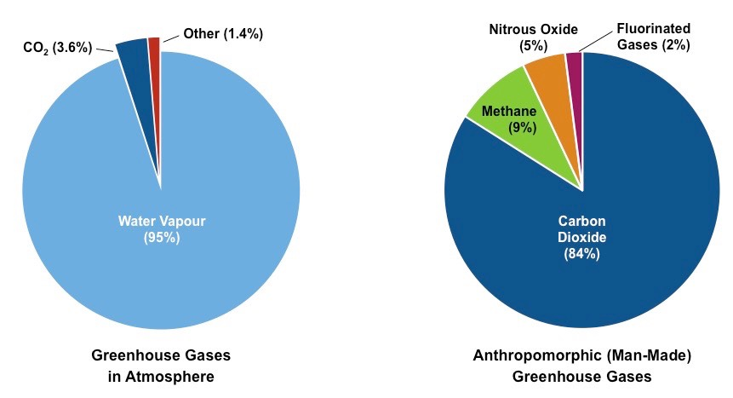
- Greenhouse gases absorb and emit long-wave (infrared) radiation emitted by the Earth’s surface. Therefore trapping and holding heat within the atmosphere
- They collectively make up less than 1% of the Earth’s atmosphere
- The greenhouse gases with the largest warming effect within the atmosphere are water vapour (clouds) and carbon dioxide
- Water vapour is created via evaporation of water bodies and transpiration and is removed via precipitation (rain)
- Carbon dioxide is made by cell respiration and burning fossil fuels
- It is removed via photosynthesis and absorption by oceans
- Other greenhouse gases include methane and nitrogen oxides. These have less impact on the overall warming effect
- Methane is emitted from waterlogged habitats (like marshes) and landfills). It is also a gaseous waste produced by ruminants
- Nitrogen oxides are released naturally by certain bacteria and also is emitted in the exhaust by certain vehicles
Impact of greenhouse gases
- There are two factors which determine how much an impact of a greenhouse gas will have
- The ability to absorb long wave radiation. Gases that have a greater capacity to absorb long-wave radiation will have a greater warming impact (per molecule)
- Concentration within the atmosphere. The greater the concentration of the gas the greater it’s warming impact will be. The concentration of a gas will be determined by both its rate of release and persistence within the atmosphere

The Greenhouse Effect
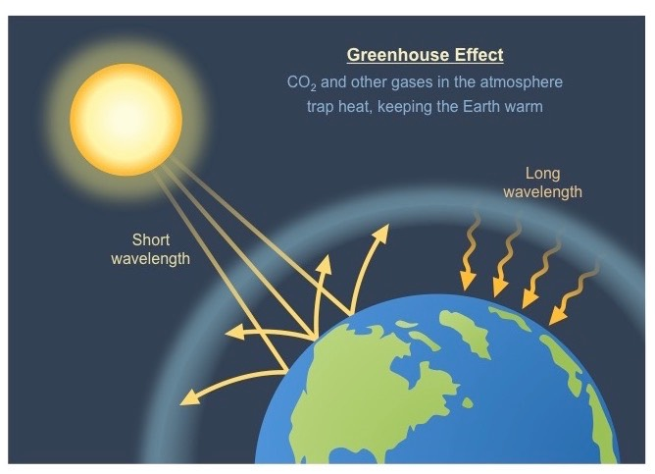
- Greenhouse effect: A planet’s ability to use its atmosphere to retain heat and keep warm even without sunlight
- This ensures the Earth maintains a moderate temperature needed by organisms to maintain life processes
- Without a greenhouse effect, Earth’s temperatures would drop significantly at night in the absence of direct sunlight
- The greenhouse effect works in the following steps:
- Solar energy (short waves) enters the atmosphere
- Solar energy is absorbed by objects and is transformed into heat
- Objects radiate heat back towards the atmosphere
- Heat (long waves) aren’t able to escape the atmosphere
- Heat is trapped inside the atmosphere
CO₂ Concentration
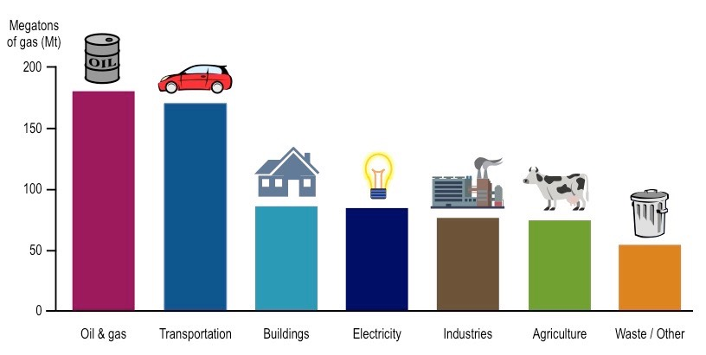
- While greenhouse gases occur naturally, man is increasing greenhouse gas emission via a number of activities including:
- Deforestation: The removal of trees means that less carbon dioxide is removed form the atmosphere via photosynthesis
- Increased farming/agriculture: This involves land clearing for cattle grazing, also ruminant cattle produce methane
- Combustion: This is the main cause of increasing CO₂ concentrations
  - When fossil fuels (e.g. coal, oil, gas) are combusted to release energy, carbon dioxide gas is released as a by-product
  - The increased reliance on fossil fuels following the industrial revolution has resulted in ~38% increase in CO₂ levels
  - There are now efforts to reduce our reliance on fossil fuels by exploiting alternative energy sources (e.g. solar power)
Climate changes
- Greenhouse gases play a major role in climate change. As these gases trap heat, increases in greenhouse gas concentrations should correlate with an increase in global temperatures
- An increase in greenhouse gas concentrations will lead to an enhanced greenhouse effect resulting in
  - More frequent extreme weather conditions
  - Some areas to become more drought affected, while others will be more prone to heavy rainfall
  - Changes to circulating ocean currents
Definitions
Weather – Current conditions in a small area: can change rapidly
Climate – Patterns of temperature and precipitations over large periods of time

Ocean Acidification
- The oceans are a major carbon sink and absorb roughly a third of all human produced CO₂ emissions
- CO₂ solubility is temperature dependent (more soluble when cooler), so less CO₂ will be absorbed as temperatures rise
- When oceans absorb atmospheric CO₂ some of it will remain dissolved in a gaseous state but most will be chemically modified
  - Carbon dioxide combines with water to form carbonic acid
  - H⁺ ions will lower ocean pH
  - A decrease in ocean pH is predicted to threaten the survival of marine organisms that require calcium carbonate
  - Shells and coral exoskeletons are also likely to begin to dissolve when ocean conditions are more acidic
  - Experiments have shown that increasing water acidity correlates with the significant thinning of shells over several weeks
  - This could also lead to the disappearance of coral reefs

