Topic 3: Genetics
3.1 | Genetic modification and biotechnology
U1 | A gene is a heritable factor that consists of a length of DNA and influences a specific characteristic
U2 | A gene occupies a specific position on a chromosome
U3 | The various specific forms of a gene are alleles
U4 | Alleles differ from each other by one or only a few bases
U5 | New alleles are formed by mutation
U6 | The genome is the whole of the genetic information of an organism
U7 | The entire base sequence of human genes was sequenced in the Human Genome Project
A1 | The cause of sickle cell anemia, including a base substitution mutation, a change to the base sequence of mRNA transcribed from it and a change to the sequence of a polypeptide in hemoglobin
A2 | Comparison of the number of genes in humans with other species
S1 | Use of a database to determine differences in the base sequence of a gene in two species
Definitions
Genes – A heritable factor that consists of a specific length of DNA and influences a specific characteristic
Allele – One specific form of a gene, differing from other alleles by one or a few bases only and occupying the same gene locus as other alleles of the same gene
Locus - The position of a gene on a particular chromosome
Genes/Alleles
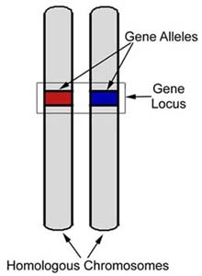
- Alleles are formed by mutations in the nucleotide code. Hence, alleles only differ from each other by one or a few bases
- There can be two or more alleles depending on the gene, for example eye color has a gene for blue eyes, green eyes, or brown eyes. All alleles of the same gene have the same locus
- Humans have 2 copies of each chromosome (except X and Y) so there are two copies of each gene
- Sometimes a person can have two copies of the same allele (homozygous) or two different alleles (heterozygous)
Gene mutation
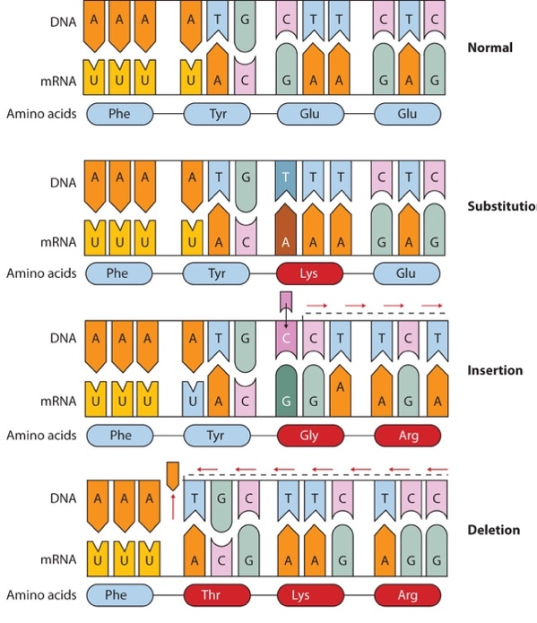
- Gene mutation: A permanent change in the base sequence of DNA
- The sequence of nucleotides in a cell’s DNA is what makes up each gene
- Factors that may increase the mutation rate of a gene: exposure to heat, radiation, or certain chemicals
- Any chemical or physical change that alters the nucleotide sequence in DNA is called a mutation. When a mutation occurs in an egg or sperm cell that then produces a living organism, it will be inherited by the offspring of that organism
- A mutation to one gene can result in a different allele. New alleles can be beneficial to a population where they give organisms a better chance of survival. But most mutations are either harmless or harmful.
- Types of gene mutations: Base substitution, insertion, deletion, frameshift

Sickle Cell Disease
- Sickle-Cell Anemia: A disease that causes red blood cells to form a sickle shape (half moon)
- Sickle cell anemia occurs on chromosome 11 and is caused by a base substitution mutation where adenine is replaced by thymine, changing GAG to GTG
- As a result, glutamic acid is changed into valine. Thus, a negatively charged amino acid is changed to a neutral one. This causes a slightly different structure of the hemoglobin molecule that is less efficient in transporting oxygen
- These sickled blood cells cannot carry as much oxygen as normal red blood cells and due to their abnormal shape and inflexibility can cause clots in blood vessels (capillaries)
- Symptoms include weakness, fatigue, shortness of breath
- However, sickle cell individuals show increased resistance to malaria
Genome
- Genome: The whole of the genetic information of an organism
- The number of genes in an organism’s genome does not indicate how complicated an organism is, for example dogs have a larger genome than a human
- The Human Genome Project was an international research effort to determine the sequence of the human genome and identify the genes that it contains. It was estimated that humans have between 21 000 – 23 000 genes
- The Human Genome Project showed that most of the genome does not code for proteins (originally labeled “junk DNA”)
- Some of these regions consist of areas that can affect gene expression or are highly repetitive sequences called satellite DNA
Patenting human genes
- In 2013, the US Supreme Court had a case in which a biotech company was trying to patent a genetic sequence
- Their argument was that they discovered and recognized what the gene was for. Thus, they should have the right to make industrial use of that knowledge that financially benefits their company
- Another company argued that DNA is naturally occurring and therefore isn’t something that is invented or patentable
3.2 | Chromosomes
U1 | Prokaryotes have one chromosome consisting of a circular DNA molecule
U2 | Some prokaryotes also have plasmids but eukaryotes do not
U3 | Eukaryote chromosomes are linear DNA molecules associated with histone proteins
U4 | In a eukaryote species there are different chromosomes that carry different genes
U5 | Homologous chromosomes carry the same sequence of gene but not necessarily the same alleles of those genes
U6 | Diploid nuclei have pairs of homologous chromosomes
U7 | Haploid nucleic have one chromosome of each pair
U8 | The number of chromosomes is a characteristic feature of members of a species
U9 | A karyogram shows the chromosomes of an organism in homologous pairs of decreasing length
U10 | Sex is determined by sex chromosomes and autosomes are chromosomes that do not determine sex
A1 | Carins’ technique for measuring the length of DNA molecules by autoradiography
A2 | Comparison of genome size in T2 phage, E. Coli, D melanogaster, H. sapiens and P. japonica
A3 | Comparison of diploid chromosome numbers of H. sapiens, P. troglodytes, C., familiaris, O. sativa, P. equorum
A4 | Use of karyograms to deduce sex and diagnose Down syndrome in humans

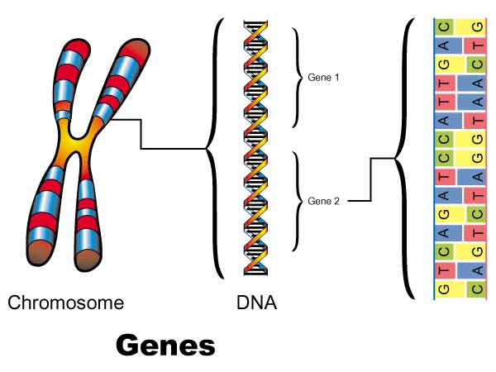
Chromosomes
- The information contained in DNA is arranged in genes. These genes are found on structures called chromosomes. Each chromosome contains many, many genes
- Each specific gene is found at the same locus on the same chromosome in every person
- DNA and chromosomes are arranged differently between prokaryotic and eukaryotic cells through their arrangement and structure
Eukaryotic Chromosomes
- Eukaryotic cells have two sets of chromosome called homologous chromosomes
  - Homologous chromosomes: A pair of chromosomes (one from each parent) that are the same length and contain the same genes in the same location
- There are two sets of chromosomes because each set is inherited from each parent
- However, while homologous chromosomes carry the sequence of genes they may carry different alleles
- An organism’s traits are largely determined by their sets of chromosomes. However, their environment also plays a role in the traits the organism will develop
- In a eukaryotic species there are different chromosomes that carry different genes
- Each chromosome in prophase and metaphase of mitosis consists of two structures, known as sister chromatids. They each contain a DNA molecule that was produced by replication during interphase, so their base sequences are identical. Sister chromatids are held together by a centrosome
- In Eukaryotic chromosomes, the DNA is wrapped around histone proteins forming a nucleosome. The nucleosomes then coil around each other forming a denser structure called a chromosome
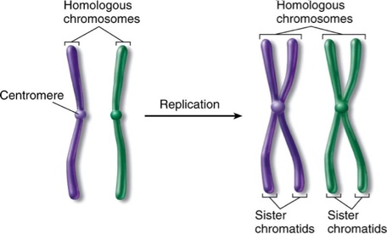
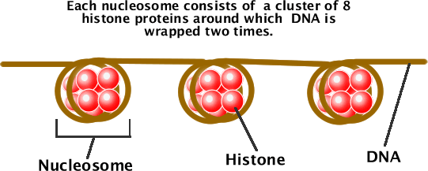

- The first 22 chromosomes in humans are known as autosomes. The 23rd pair is called the sex chromosomes
- Human somatic cells have 46 chromosomes consisting of two sets of 22 homologous chromosomes and a pair of non-homologous sex chromosomes. This is known as 2n, or diploid state
- Human gametes (sex cells) have 23 chromosomes or one complete set of chromosomes. This is n, or haploid state
- The X and Y chromosomes determine gender:
  - The X chromosome is quite large in comparison to the Y chromosome and has a centromere that is located near the center or middle of the chromosome
  - The Y chromosome is relatively small with its centromere located near the end of the chromosome
  - Females have two X chromosomes and males have an XY chromosomes
Diploid Cells | Haploid Cells
Two sets of homologous chromosomes (2n) | One set of chromosomes (n)
Somatic/body cells | Gametes/Sex cells
Produced by mitosis | Produced by meiosis
Pair of homologous chromosomes | One chromosome of each pair
In humans, 2n=46 | In humans n=23
Prokaryotic Chromosomes
- Prokaryotes do not possess a nucleus. Instead genetic material is found free in a region of the cytoplasm called the nucleoid
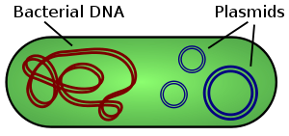
- The genetic material of a prokaryote consists of a single loop chromosome. The DNA of prokaryotic cells are naked, meaning it is not associated with proteins (for additional packing)
- Plasmids are small separate (usually circular) DNA molecules that are sometimes present in prokaryotic cells. Plasmids are not responsible for normal life processes and are often associated with antibiotic resistance
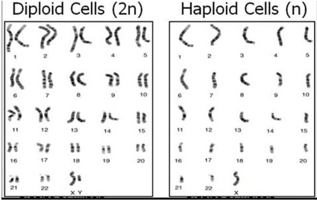
- They can also be transferred from one bacterial cell to another
Eukaryote Chromosomes | Prokaryote Chromosomes
Linear DNA molecule | Circular DNA molecule
Associated with histone proteins | Naked – No associated proteins
No plasmids | Plasmids often present
Two or more different chromosomes | One chromosome only
Karyogram
- Karyogram: A diagram or photograph of the chromosomes present in a nucleus arranged in homologous pairs of descending length
- First chromosomes are exposed to dies, which then allow us to see the size, shape and bands. Then the chromosomes are put in order according to size and position of the centromeres
- There are two techniques to obtain chromosomes for a karyogram:
Amniocentesis
- The fetus is surrounded by a layer of liquid called amniotic fluid. Amniocentesis is a technique in which a sample of amniotic fluid is removed. Amniocentesis is performed by inserting a needle into the amniotic sac to pull some of the amniotic fluid, which contains fetal cells. These fetal cells are then grown on a culture dish. Because these cells are of fetal origin, any chromosomal abnormalities present in the fetus will also be present in the cell
- Amniocentesis cannot be done until the 14th to 16th week of pregnancy
- Cells must be cultured on the dish for two weeks to obtain a sufficient number of cells
Chorionic Villi Sampling
- Chronical villus sampling is a procedure in which a small amount of the placenta is removed. It is performed by inserting a needle into the placenta which contains fetal cells
- It is normally done during the 10th to 12th week, but can be done as early as the 5th week of pregnancy
- The Karyotype analysis can be performed on these cells immediately after sampling
Karyotype
- A karyotype is the number of different chromosomes present in a cell. It can be used to find:
  - Down Syndrome: 3 chromosomes will be found on chromosome 21
  - Gender: XY chromosome is male, XX chromosome is female
Autoradiography
- Autoradiography was created by John Carins to measure the length of DNA molecules. Cairns used autoradiography to visualize the chromosomes whilst uncoiled, allowing for more accurate indications of length. By using tritiated uracil (3H-U), regions of active transcription can be identified within the uncoiled chromosome
3.3 | Meiosis
U1 | One diploid nucleus divides by meiosis to produce four haploid nuclei
U2 | The halving of the chromosomes number allows a sexual life cycle with fusion of gametes
U3 | DNA is replicated before meiosis so that all chromosomes consist of two sister chromatids
U4 | The early stages of meiosis involve pairing of homologous chromosomes and crossing over followed by condensation
U5 | Orientation of pairs of homologous chromosomes prior to separation is random
U6 | Separation of pairs of homologous chromosomes in the first division of meiosis halves the chromosome number
U7 | Separation of pairs of homologous chromosomes in the first division of meiosis halves the chromosome number
U8 | Crossing over and random orientation promotes genetic variation
U9 | Fusion of gametes from different parents promotes genetic variation
A1 | Non-disjunction can cause Down syndrome and other chromosome abnormalities
A2 | Studies showing age of parents influences chances of non-disjunction
A3 | Description of methods used to obtain cells for karyotype analysis
S1 | Drawing diagrams to show the stages of meiosis resulting in the formation of four haploid cells
Meiosis
- Meiosis is a process where a single cell divides twice to produce four cells containing half the original amount of genetic information. These cells are our sex cells (sperm in males, eggs in females)
  - During meiosis, one cell goes through division twice to form four daughter cells
  - These four daughter cells only have half the number of chromosomes of the parent cell. They are haploid
  - Meiosis produces our sex cells or gametes (eggs in females and sperm in males)
- Meiosis can be divided into nine stages. These stages are divided between the first time the cell divides (meiosis I) and the second time it divides (meiosis II)
Meiosis I
Interphase
- G₁ phase: increase in cytoplasm volume, organelle production and protein synthesis (normal growth)
- S phase: DNA replication
  - The DNA in the cell is copied resulting in two identical full sets of chromosomes
- G₂ phase: increase in cytoplasm volume, double the amount of organelle and protein synthesis (prepare for cell division)
Prophase I
- DNA Supercoil: chromatin condenses and becomes sister chromatids, which are visible under the light microscope
- The chromosomes pair up so both copies of each chromosome are together (Chromosome 1 is together, etc)
- The pairs of chromosomes may then exchange bits of DNA in a process called crossing over or recombination
  - The crossing over point is called the chaisma
- Nuclear membrane is broken down
- Centrosomes move to the opposite poles of the cell
- Spindle fibers begin to form
Metaphase I
- Chromatids line up in the equator randomly on either side of the cells the daughter nuclei can get a different mix of chromosomes. This is known as random orientation
- Spindle fibers (microtubules) attach to the centromere of sister chromatids

Anaphase I
- Contraction of the spindle fibers separate the pair of chromosome
- In meiosis I, the sister chromatids stay together. (This is different to what happens in mitosis and meiosis II)
- Chromosomes move to opposite poles of the cell
Telophase I and Cytokinesis
- Chromosomes uncoil to become chromatin
- Spindle fibers break down
- New nuclear membrane reforms at opposite pole
- Chromosome number reduces from 2n (diploid) to n (haploid)
- However, each chromatid still has the replicated sister chromatid still attached (not homologous pairs anymore)
- Cytokinesis then occurs and splits the cell into two separate cells
Meiosis II
Prophase II
- Now there are two daughter cells, each with 23 chromosomes (23 pairs of chromatids)
- DNA Supercoil: chromatin condenses again
- Nuclear membrane is broken down and disappeared
- Centrosomes move to the opposite poles of the cell
- Spindle fibers begin to form
Metaphase II
- Pair of sister chromatids line up in the equator
- Spindle fibers (microtubules) attach to the centromere of sister chromatids
Anaphase II:
- Contraction of the spindle fibers cause the separation of the sister chromatids
- The chromatids are now considered as chromosomes
- Chromosomes move to opposite poles of the cell
Telophase II and cytokinesis
- The chromosomes complete their moves to the opposite poles of the cell
- At each pole of the cell a full set of chromosomes gather together
- A membrane forms around each set of chromosomes to create two new cell nuclei
- This is the last phase of meiosis, however cell division is not complete without another round of cytokinesis
- Once cytokinesis is complete there are four granddaughter cells each with a half set of chromosome
  - In males, these four cells are all sperm cells
  - In females, one of the cells is an egg cell while the other three are polar bodies (small cells that do not develop into eggs

Meiosis I vs II
Meiosis I | Meiosis II
Replication prior to | No replication
Crossing over during prophase I | No crossing over during prophase II
Homologous pairs line up randomly in metaphase I | Chromosomes line up randomly in metaphase II
Homologous pairs are separated into chromosomes in anaphase I | Chromosomes are separated into chromatids during anaphase II

Genetic variation
- Gene variation is a result of subtle differences in the DNA. It results in alleles of a specific gene.
- The advantage of meiotic division and sexual reproduction is that it promotes genetic variation in offspring
- In meiosis, two steps ensure there is genetic variation in the DNA:
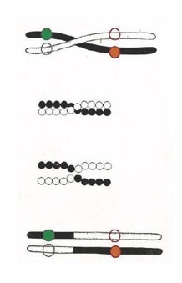
Crossing Over
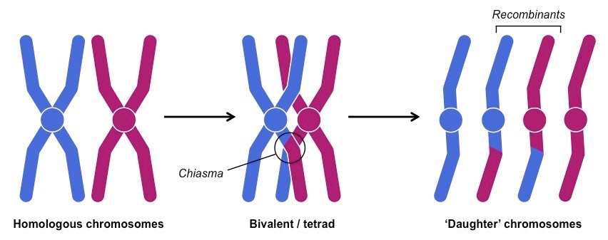
- Crossing over involves the exchange of segments of DNA between homologous chromosomes during prophase I
- The exchange of genetic material occurs between non-sister chromatids at points called chiasmata
- As a consequence of this recombination all four chromatids will be genetically different
Random orientation
- When homologous chromosomes line up in metaphase I their orientation towards the poles is random
- The orientation means that different combinations of maternal/paternal chromosome can be inherited when the bivalents separate in anaphase I
Non-disjunction
- A non-disjunction is an error in meiosis, where the chromosome pairs fail to split during cell division
- It occurs in anaphase I where homologous pairs fail to split, or in anaphase II where the sister chromatids fail to split
- As a result there will be too many or too few chromosomes in the final gamete cell. As a result these gamete cells could have 22 or 24 chromosomes. The resulting zygote will then have 47 or 45 chromosomes
- An example of non-disjunction is Down’s syndrome
- Down syndrome occurs when chromosome 21 fails to separate and one of the gametes ends up with an extra chromosome
- This means there will be an extra chromosome 21, so every cell will have 47 chromosomes
- Down syndrome is also called Trisomy 21.
- Some Down syndrome symptoms include impairment in cognitive ability and physical growth, hearing loss, oversized tongue, shorter limbs and social difficulties
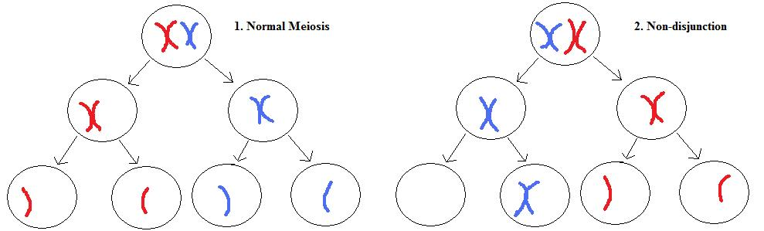

3.4 | Inheritance
U1 | Mendel discovered the principles of inheritance with experiments in which large numbers of pea plants were crossed
U2 | Gametes are haploid so contain only one allele of each gene
U3 | The two alleles of each gene separate into different haploid daughter nuclei during meiosis
U4 | Fusion of gametes results in diploid zygotes with two alleles of each gene that many be the same allele or different alleles
U5 | Dominant alleles mask the effects of recessive alleles but co-dominant alleles have joint effects
U6 | Many genetic diseases in humans are due to recessive alleles of autosomal genes, although some genetic diseases are due to dominant or co-dominant alleles
U7 | Some genetic diseases are sex-linked. The pattern of inheritance is different with sex-linked genes due to their location on sex chromosomes
U8 | Many genetic diseases have been identified in humans but most are very rate
U9 | Radiation and mutagenic chemicals increase the mutation rate and can cause genetic diseases and cancer
A1 | Inheritance of ABO blood groups
A2 | Red-green color blindness and hemophilia as examples of sex-linked inheritance
A4 | Inheritance of cystic fibrosis and Huntington’s disease
S1 | Consequences of radiation after nuclear bombing of Hiroshima and accident at Chernobyle
S2 | Construction of predicted and actual outcomes
S3 | Analysis of data on risks to monarch butterflies of Bt crops
Definitions
Genotype – Symbolic representation of the pair of alleles that an organism has (represented by letters) (AA, Aa, aa)
Phenotype – The characteristic or trait of an organism (Brown eyes or blue eyes, etc)
Dominant allele – A trait that always shows up when the allele is present (Capital letter: T)
Recessive allele – A trait that only shows up when paired with another recessive allele (Lower case letter: t)
Homozygous dominant – Two copies of the same dominant gene (AA)
Homozygous recessive – Two copies of the same recessive gene (aa)
Heterozygous – Two different alleles (one dominant, one recessive) (Aa)
Codominant – Pairs of alleles which are both expressed when present

- The proteome can be larger than the genome (especially in eukaryotes), as there are genes that code for several proteins
Mendel’s Pea Experiment
- Mendel was known as the father of genetics. He performed experiments on a variety of different pea plants
- Through his work he deduced that genes come in pairs and are inherited as distinct units, one from each parent
- Mendel tracked the segregation of parental genes through their appearance in the offspring as dominant or recessive traits
ABO Blood Group
- Although all blood is made of the same basic elements not all blood is alike. There are four major blood groups determined by the presence or absence of two antigens (A and B) on the surface of red blood cells
- Human blood types are an example of both multiple alleles (A, B, O) and co-dominance (A and B are co-dominant)
- Co-dominant alleles such as A and B are written as a superscript (I^{A} and I^{B}). Blood type O is represented by i
- Both I^{A} and I^{B} and are dominant over the allele i
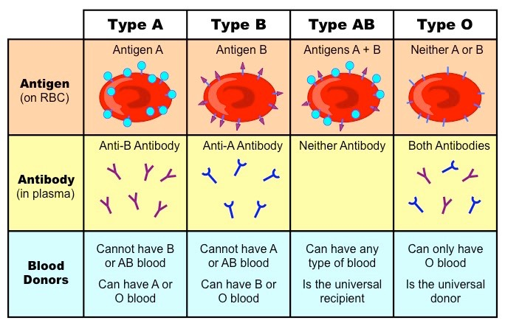

Sex linkage:
- Sex linkage refers to when a gene controlling a characteristic is located on a sex chromosome (X or Y)
- Remember the Y chromosome is shorter than the X chromosome therefore sex-linked conditions are usually X-linked as very few genes exist on the shorter Y chromosome therefore, sex-linked diseases are generally on the X chromosome
- X-linked recessive diseases such as color blindness and hemophilia are more common in males because they only carry one X chromosome, therefore if they inherit the X chromosome with the disease, they will also have the disease
- This also means that males can only pass these alleles onto their daughters as their sons only receive the Y chromosome
Genetic Diseases Summary
Genetic Diseases | Allele Nature | Location of Mutation | Sex-linked | Symptoms
Sickle-cell anemia | Co-dominant | HBB genes on chromosome 11  GAG mutated into GTG | Not | Clots in blood vessels (capillaries because of their abnormal shape  Immune to malaria
Cystic Fibrosis | Recessive | CFTR gene on chromosome 7 | Not | Causes secretion of mucus to become very thick. The thick mucus blocked the airway tubes especially in the lungs.
Huntington’s disease | Dominant | HTT gene on chromosome 4 | Not | Neuron degeneration will lead to brain disorder, affecting the ability to think, talk and move
Red-green color blindness | Recessive | Xq28 gene on X chromosome | Yes | Failure to distinguish between red and blue. Loss of certain frequencies of light
Hemophilia | Recessive | X chromosome | Yes | Clotting response to injury does not work  Patient may bleed to death
Gene Mutation Causes
- Mutations can be spontaneous (caused by copying errors during DNA replication), or induced by exposure to external elements. Factors that can include mutations include:
  - Radiation: UV Radiation from the sun, gamma radiation from radioisotopes, X-rays from medical equipment
  - Chemical: Reactive oxygen species, alkylating agents (found in cigarettes)
  - Biological Agents: Bacteria, viruses
- Agents which increase the rate of genetic mutations are called mutagens
- Mutagens which lead to the formation of cancer are more specifically referred to as carcinogens
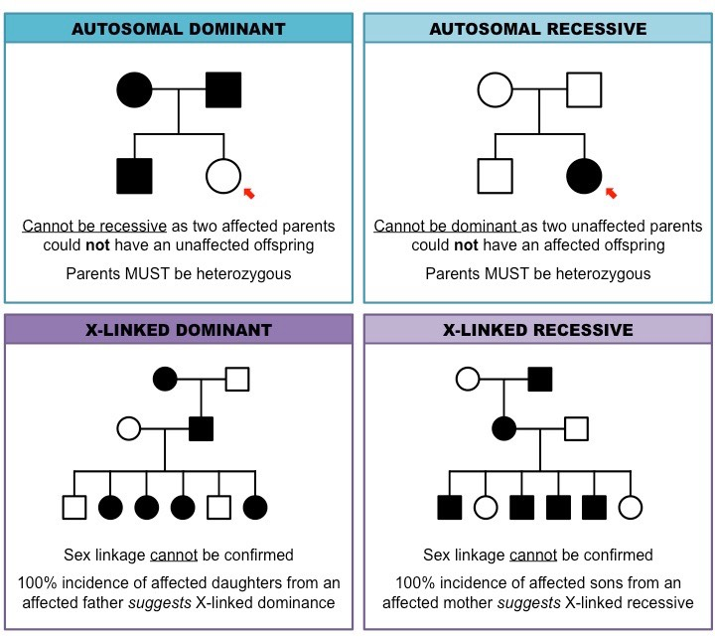
Pedigree Charts
- A pedigree is a chart of the genetic history of a family over several generations
  - Males are represented as squares
  - Females are represented as circles
  - Shaded symbols means an individual is affected by a condition
  - Unshaded symbol means an individual are unaffected
  - A horizontal line between a man and a woman represents mating and resulting children are shown as offshoots to this line
  - Generations are labelled with roman numerals and individuals are numbered according to age (oldest on the left)
- To determine inheritance from pedigree charts:
3.5 | Genetic modification and biotechnology
U1 | Gel electrophoresis is used to separate proteins or fragments of DNA according to size
U2 | PCR can be used to amplify small amounts of DNA
U3 | DNA profiling involves comparison of DNA
U4 | Genetic modification is carried out by gene transfer between species
U5 | Clones are groups of genetically identical organisms, derived from a single original parent ecll
U6 | Many plant species and some animal species have natural methods of cloning
U7 | Animals can be cloned at the embryo stage by breaking up the embryo into more than one group of cells
U8 | Methods have been developed for cloning adult animals using differentiated cells
A1 | Use of DNA profiling in paternity and forensic investigation
A2 | Gene transfer to bacteria using plasmids makes use of restriction endonucleases and DNA ligase
A3 | Assessment of the potential risks and benefits associated with genetic modification of crops
A4 | Production of cloned embryos produced by somatic-cell nuclear transfer
S1 | Design of an experiment to assess one factor affecting the rooting of stem-cuttings
S2 | Analysis of examples of DNA profiles
S3 | Analysis of data on risks to monarch butterflies of Bt crops
Polymerase Chain (PCR)
- Since DNA is a small molecule we need large quantities of it in order to be able to view it. PCR helps increase DNA amount
- Polymerase Chain Reaction (PCR) is a technique used to copy and amplify a small DNA sample
- PCR occurs in a thermal cycler and involves a repeat procedure of 3 steps:
- Denaturation: DNA sample is heated to break hydrogen bonds and therefore separate it into two strands
- Annealing: DNA primers attach to the 3’ ends of the target sequence
- Elongation: A heat-tolerant DNA polymerase binds to the primer and copies the strand
- Once cycle of PCR yields two identical copies of the DNA sequence. A standard reaction of 30 cycles would yield 2³⁰ copies
- Once large quantities of DNA have been created, other laboratory techniques are used to isolate and manipulate the sequences:

Gel Electrophoresis
- Gel electrophoresis can be used to separate the fragments of DNA
- Separate fragments of DNA are moved through an electric field in order to create a DNA profile
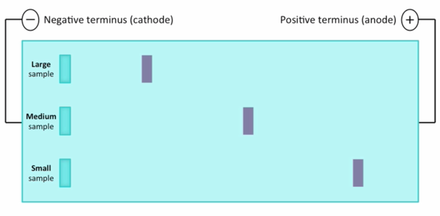
- Enzymes cut DNA into different sized fragments
- The DNA sample is placed at one end of the porous gel
- This side of the gel with the DNA sample is exposed to a negative electrical current
- The DNA fragments move through the gel and stop at different points, creating a band
- The bands are dyed so we can see them
- Two factors determine the movement of DNA through the electrophoresis gel
- Charge: Since DNA is negatively charged the negative electrical charge repels the negative DNA towards the positive end
- Size: The smallest fragment will be the furthers away from the origin while larger fragments get stuck up top
- The results of gel electrophoresis are called a DNA profile or DNA fingerprint
- They are unique to each individual. If there is a perfect match of banding patterns it is identical DNA
DNA Profiling
- DNA profiling is a technique where individuals can be identified and compared via their DNA profiles
- Steps involved in DNA profiling:
- Restriction enzymes are used to break DNA into small fragments
- Fragments are subjected to electrophoresis
- Portions of DNA placed on gel
- Electric field/Voltage applied
- Negatively charged portions of DNA migrate to positive electrode
- DNA portions separated by size/small portions of DNA travel further through the gel
- DNA sequences stained
- Observed under UV light
- Applications of DNA profiling include:
  - Establishing paternity
  - Comparing DNA at a crime scene with potential suspects
  - Released prisoners that are wrongly convicted
  - Identifying people who died last century
  - Establishing relationships in populations to determine migrating patterns of evolutionary relationships
Genetic Modification
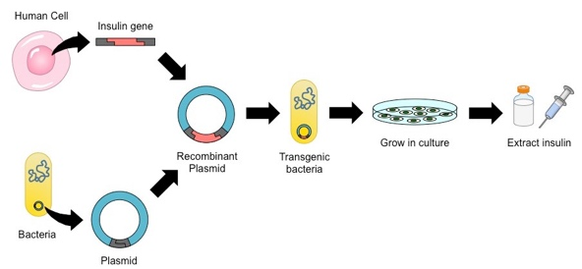
- Gene transfer: Taking a gene from one organism and placing it into another organism (not the same as cloning)
- Because the genetic code is universal it is possible for a gene from one organism to be introduced and function in a different organism
- Certain enzymes can cut pieces of DNA from one organism, and join them into a gap in the DNA of another organism
- This means that the new organism with the inserted genes has the genetic information for one or more new characteristics
- Therefore, we can take genes from one species and insert them into the genome of another species
- The transfer of genes between species is called gene modification and the new organism created is called a transgenic

- The process of gene transfer can be summarized in four key steps:
- Isolation of gene and vector (by PCR)
- Digestion of gene and vector (by restriction endonuclease)
- Ligation of gene and vector (by DNA ligase)
- Selection and expression of transgenic construct
- An example of gene transfer:
- The human gene for insulin production is inserted into an E.coli bacterium
- The bacteria reproduce
- The colony of bacteria produces human insulin, which can be used for diabetics
Genetically Modified Organisms (GMOs)
- GMOs: An organism with a gene that has been artificially inserted into its genome (done by gene modification)
- GMOs can give organisms a desirable property that they don’t naturally posses
Original Plant | Added Gene | New advantage
Corn | From bacterium (Bacillus thuringeiesis) | Corn (now called Bt corn) produces a protein that kills insect larvae
Tomato | From artic fish | Tomato now produces a protein that keeps it from freezing (more cold tolerant)
Rice | Gene that produces beta carotene | Rice now has beta carotene which is used to produce Vitamin a, which is often deficient in developing populations (called golden rice)
- However there are environmental benefits and risks along with health benefits and risks
Environmental benefits | Environmental risks | Health benefits | Health risks
- Pest-resistant crops can be made  - Therefore less spraying of pesticides  - Longer shelf-life therefore less spoilage | - Non-target organisms can be affected  - GMOs reduces biodiversity | - Nutritional value of food improved by increasing nutrient content  - Crops could be produced that lack toxins or alleges | - Proteins from transferred genes could be toxic or cause allergic reactions  - Antibiotic resistance genes used as markers during gene transfer could spread to bacteria
Transgenic Animals
- The principle of transgenic is the same in animals as in plants, if you insert a gene that isn’t normally there the animal will produce things that it doesn’t normally produce
- Example: People with hemophilia can’t produce a blood clotting factor called Factor IX. Scientists have found a way to insert this gene into sheep, and then the sheep make large contents of this factor in their milk which the hemophiliacs then drink
Natural Methods of Cloning
- Clone: Offspring that is an exact copy of its parent
- Organisms that reproduce asexually are always clones. However, there are some plants that normally reproduce sexually that have the ability to clone themselves
- Example: A potato is a plant that can reproduce sexually to make offspring with large amounts of variation. However, you can also just take part of a potato and replant it in the ground to make a new, identical plant. A clone.
Animals Cloned from Embryos
- The first animal clones were produced when an embryo was artificially separated, causing two identical twins to develop
- Remember, embryonic cells contain identical DNA but are undifferentiated, so if they are separated before the cells specialize, two identical organisms will develop
- Reproductive cloning (also called somatic cell transfer). Using an already differentiated cell to make a new individual that is a clone of the original parent
- Reproductive cloning was first done in 1996 when Dolly the sheep was cloned
- A somatic cell from the original sheep was collected and the nucleus (and therefore the DNA was removed)
- A donor egg from another sheep was collected and all of the DNA was removed from the egg
- The DNA from the donor sheep was placed inn the empty egg
- The embryo was placed in the uterus of a surrogate sheep
- The embryo developed and Dolly the shape was born who was an exact copy
Therapeutic cloning
- Sometimes, scientists are more interested in making one type of cell to replaced damaged cells in the body
- This is called therapeutic cloning
- Therapeutic cloning is when scientists still use undifferentiated cells from embryos and then the differentiation in the direction that they want, causing a certain type of cell/tissue to develop
- Benefits:
  - Replaces damaged tissue
  - Reduces the need for an organic transplants
  - Reduced medicine use
- Ethical concerns:
  - Is it ethical to produce a human embryo solely for the purpose of medical research of tissue generation?
  - Is the use of an embryo the same thing as taking a life?
  - Also, the life expectancy of children produced by cloning might be lower than normal
- Benefits of GMO’s:
  - Less pesticides/herbicides, more crop yield, added nutrition
- Potential risks of GMO’s:
  - Unintended/Unnatural consequences to native species, ethical concerns, patenting concerns, no long-term data on safety, killing pollinating insects

