Topic 2: Molecular Biology
2.1 | Molecules to metabolism
U1 | Molecular biology explains living processes in terms of the chemical substances involves
U2 | Carbon atoms can form four covalent bonds allowing a diversity of stable compounds to exist
U3 | Life is based on carbon compounds including carbohydrates, lipids, proteins and nucleic acids
U4 | Metabolism is the web of all the enzyme-catalyzed reactions in a cell or organism
U5 | Anabolism is the synthesis of complex molecules from simpler molecules including the formation of macromolecules from monomers by condensation reactions
U6 | Catabolism is the breakdown of complex molecules into simpler molecules including the hydrolysis of macromolecules into monomers
A1 | Urea as an example of a compound that is produced by living organisms but can also be artificially synthesized
S1 | Drawing molecular diagrams of glucose, ribose, a saturated fatty acid and a generalized amino acid
S2 | Identification of biochemical such as sugars, lipids or amino acids from molecular diagrams
Organic Chemistry
- Organic chemistry: The study of the properties and structures of organic compounds
- Organic compound: A compound that contains carbon and is found in living things
- All organic compounds have carbon backbones, however not all carbon compounds are organic (Ex: CO₂, urea)
Carbon atoms
- Carbon has special properties that allows it to form a wide variety of chemically stable organic compounds:
  - Carbon-carbon bonds are strong and stable due to their covalent bond
  - As a result, carbon can form an almost infinite number of compounds include long carbon chains.
  - No other element can bond like this
- Therefore, carbon forms the basis of organic life due to its ability to form large and complex molecules via covalent bonding
Carbon Compounds
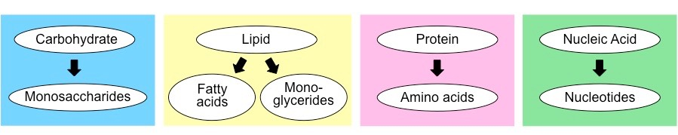
- There are four principle groups of carbon compounds:
  - Carbohydrates (2.3)
  - Lipids (2.3)
  - Proteins (2.4)
  - Nucleic Acids (2.7)
- Complex macromolecules called polymers are commonly made of smaller, recurring sub units called monomers
  - Carbohydrates, nucleic acids and proteins are all polymers comprised of monomers
  - However, lipids do not contain recurring monomers
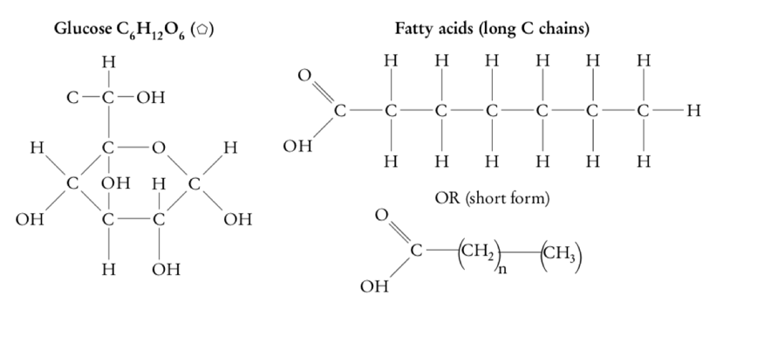
Sketching carbon compounds
- Be able to sketch and recognize:

Metabolism
Definitions
Metabolism – The web of all enzyme-catalyzed reactions in a cell or organism
Anabolism – The synthesis of complex molecules from simpler units, it requires energy
Catabolism – The breakdown of complex molecules into simpler units, it releases energy

- Metabolism is all chemical reactions occurring in an organism
- Metabolic pathways shows a sequence of chemical reactions undergone by a compound or class of compounds in a living organism. Most metabolic pathways consist of chains of reactions (below) but there are also some cycles of reactions
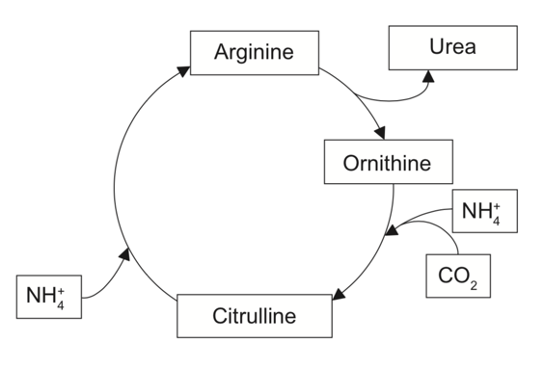

- Metabolic reactions can classified be anabolic or catabolic
- Anabolic reactions include photosynthesis and cellular respiration along with the synthesis of RNA and proteins
- Catabolic reactions include glycolysis
Condensation/Hydrolysis
- Carbon compounds can be formed using condensation, or broken using hydrolysis:
- Condensation makes bond, releases water and is an anabolic reaction
- In condensation, water is released to join 2 molecules together to make a larger, more complex molecule
- Condensation is used to synthesize all important biological macromolecules (carbohydrates, proteins, lipids, nucleic acids) from their simpler monomers
- Hydrolysis breaks bond, requires water, and is a catabolic reaction
- Hydrolysis is used to split polymers into smaller monomers by breaking a bond by using water
Vitalism
- Vitalism was a belief that organic molecules can only be synthesized by living things
- Urea is an organic waste molecule produced by many living things and was a commonly used example by vitalism experts because they proposed that only living things could produce urea and other organic
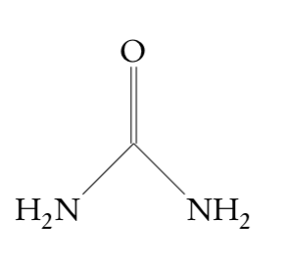
- However, in 1800 urea was produced from inorganic chemicals proving organic molecules don’t have to be synthesized by living things

2.2 | Water
U1 | Water molecules are polar and hydrogen bonds form between them
U2 | Hydrogen bonding and dipolarity explain the cohesive, adhesive, thermal and solvent properties of water
U3 | Substances can be hydrophilic or hydrophobic
A1 | Comparison of the thermal properties of water with those of methane
A2 | Use of water as a coolant in sweat
A3 | Modes of transport of glucose, amino acids, cholesterol, fats oxygen and sodium chloride in blood in relation to their solubility in water
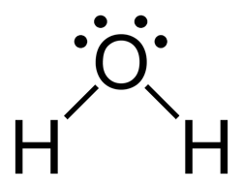
Structure of Water
- Water (H₂O) is composed of two hydrogen atoms covalently bonded to an oxygen atom
- The bond formed between the oxygen and hydrogen are referred to as a polar covalent bond
- This type of bonding involves the sharing of electrons, and in water these electrons are not shared equally hence why this bond is polar
- Water is also a bent molecule because the lone pair of electrons repel more than the bonds resulting in a bent structure
- The oxygen atom is slightly negative (δ⁻) while the hydrogen atoms are slightly positive (δ⁺) therefore the slightly charged regions of the water molecule can attract other polar or charged compounds and gives water special properties
Hydrophilic/Hydrophobic/Amphipathic
- Hydrophobic: Molecules that are attracted to water (water loving), (Example: carbohydrates)
- Hydrophilic: Molecules that hate water (water hating), (Example: Fatty acids, methane)
- Amphipathic: A molecule having both hydrophilic and hydrophobic parts (Example: Phospholipids)
Properties of water molecules
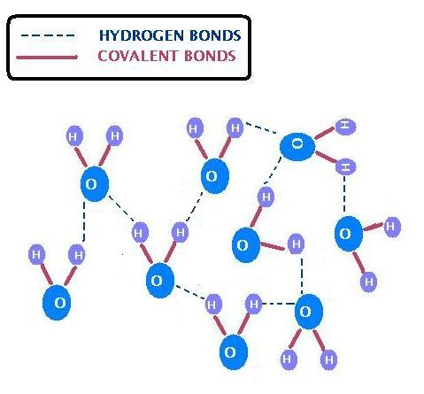
Cohesion
- Cohesion: an attraction between molecules of the same type
- This property occurs in water as a result of its polarity and its ability to form hydrogen bonds
- These hydrogen bonds form between oxygen and hydrogen atoms of different molecules
- Even though hydrogen bonds are weak the large number of bonds present in water can give cohesive forces strength (each water molecule bonds to four others in a tetrahedral arrangement)
- Therefore, water molecules are strongly cohesive (they tend to stick to one another)
- Examples:
  - Surface tension that allows some organisms to rest or move on top of water’s surface
  - Allows water to move as a column (group of water molecules) through the stem of plants
Adhesion
- Adhesion: an attraction between two unlike molecules
- This property occurs between water and other molecules as a result of waters polarity and its ability to form hydrogen bonds
- Again, individual hydrogen bonds are weak, but large number of bonds gives adhesive forces strength
- Therefore, water molecules tend to stick to other molecules that are charged or polar just like cohesion
- Example: Water moves up the stems of plants because in addition to being attracted to itself (cohesion) it is also attracted to the side of the stem (adhesion). Water is so highly attracted to the sides of the stem that it pulls itself up against the force of gravity without any energy input from the plant

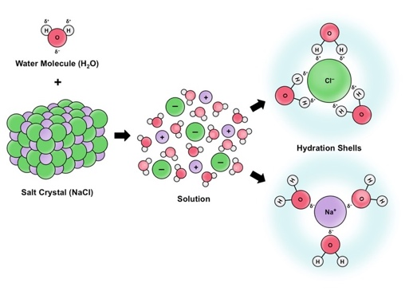
Solvent
- Water can dissolve any substance that contains charged particles (ions) or electronegative atoms (polarity)
- This occurs because the polar attraction of large quantities of water can sufficiently weaken intramolecular forces and result in the dissociation of the atoms
- Example (Plant): The phloem (part of the stem) carries a fluid made of water and lots of dissolved substances through the tissues of a plant such as sugars and minerals
- Example (Animal): Blood carried a lot of dissolved nutrients in the plasma to different tissues in the body such as glucose, amino acids, fibrinogen and hydrogen carbonate ion
Thermal:
- Water has a high specific heat capacity (amount of energy required to raise the temperature)
- This means that water can absorb a lot of energy before becoming too hot (Takes a lot of energy to evaporate)
- It also means that water must lose a lot of energy to drop in temperature
- Example:
  - Cells can withstand a lot of heat energy releases from their metabolic reactions without boiling away
  - Sweat on the skin can absorb a lot of heat energy before it evaporates, cooling an organism
- Water’s high specific heat is also useful for:
  - Aquatic organisms who can’t survive extreme temperature changes
  - Plants have openings in their leaves called stomata to let vaporizing water out in order to cool down the left
- The differences in thermal properties between water and methane arise from differences in polarity between the molecules
  - Water is polar and can form intermolecular hydrogen bonds which increases the amount of energy to break it
  - Methane is non-polar and can only form weak dispersion forces between its molecules
- This means water absorbs more heat before changing state
  - Boiling point of water is greater than methane
  - Melting point of water is greater than methane
  - Latent heat of vaporization of water is greater than methane
2.3 | Carbohydrates and lipids
U1 | Monosaccharide monomers are linked together by condensation reactions to form disaccharides and polysaccharide polymers
U2 | Fatty acids can be saturated, monounsaturated or polyunsaturated
U3 | Unsaturated fatty acids can be cis or trans isomers
U4 | Triglycerides are formed by condensation from three fatty acids and one glycerol
A1 | Structure and function of cellulose and starch in plants and glycogen in humans
A2 | Scientific evidence for health risks of trans fats and saturated fatty acids
A3 | Lipids are more suitable for long-term energy storage in humans than carbohydrates
A4 | Evaluation of evidence and the methods used to obtain the evidence for health claims made about lipids
S1 | Use of molecular visualization software to compare cellulose, starch and glycogen
S2 | Determination of body mass index by calculation or use of a nomogram
Carbohydrates
- Carbohydrate is another term for sugar. Carbohydrates can be classified into three classes depending on their complexity:
  - Monosaccharides: Monomers of polysaccharides, the simplest carbohydrate
  - Disaccharides: A molecule formed by condensation reactions between two monosaccharides
  - Polysaccharides: Polymers with more than 2 molecules linked together in different ways by condensation reactions

- The three most important polysaccharides are:
  - Glycogen: Animal
  - Starch: Plant
  - Cellulose: Plant
- Digestion of polysaccharides involves the hydrolysis (adding water) of the bonds between the bonded monosaccharides
- Enzymes catalyze these reactions in the digestive tract of animals, including humans
- However, humans and most other animals lack the enzyme cellulase so cellulose cannot be digested in animals
Carbohydrate Structures
Type | Name | Formation | Structure | Information
Monosaccharides | Glucose | N/A | 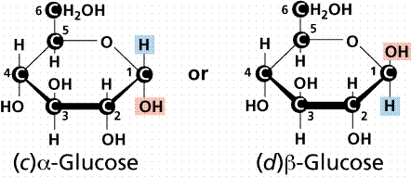 | Energy molecules used in cell respiration
 | Galactose | N/A | 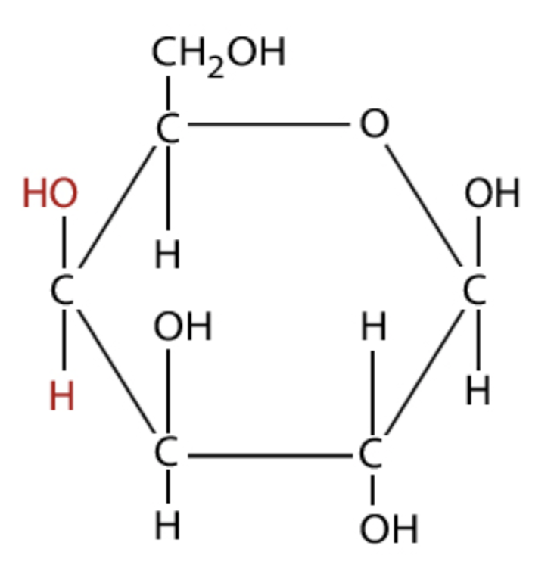 | Nutritive sweetener in foods, less sweet than glucose
 | Fructose | N/A/ | 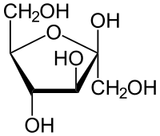 | Fruit sugar
Disaccharides | Maltose | Glucose + Glucose | 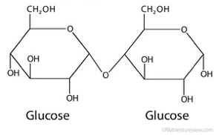 | Source: hydrolyzed starch
 | Lactose | Glucose + Galactose | 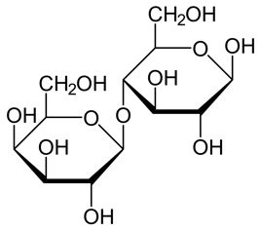 | Source: Milk of mammals
 | Sucrose | Glucose + Fructose | 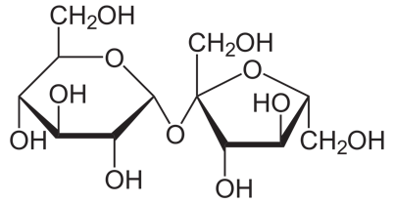 | Source: Plants
Polysaccharides | Starch | Linking alpha glucose together | 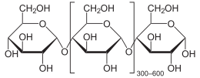 | Storage of extra glucose molecules in plants
 | Glycogen | Linking beta glucose together | 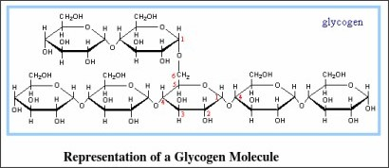 | Storage of extra glucose molecules in animals
 | Cellulose | Linking alpha glucose together | 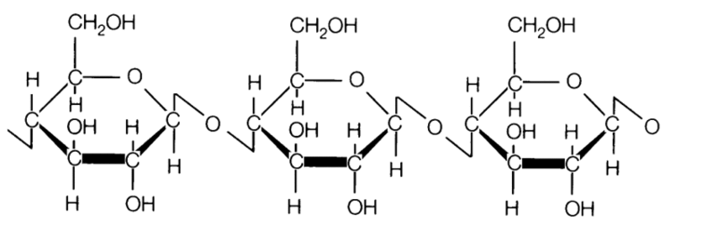 | Used to construct plant cell walls
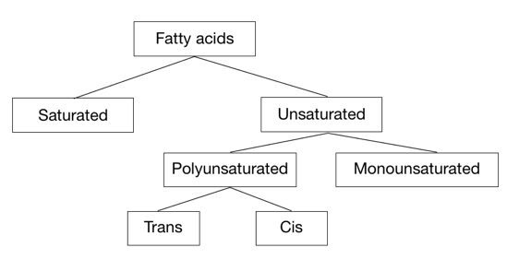
Fatty Acids
- Fatty acids are key components of lipids in plants, animals and microorganisms
- Fatty acids consists of a straight chain of an even number of carbon atoms, with hydrogen atoms
- Fatty acids are a type of lipid
- Fatty acids all have a methyl group (CH₃) on one end and a carboxyl group (COOH) at the other end
- In the middle is a chain of anywhere between 11-23 CH₂ groups
- Fatty acids are not found in a free state in nature. They commonly exist in combination with glycerol in the form of triglyceride. Fatty acids can be classified as follows:
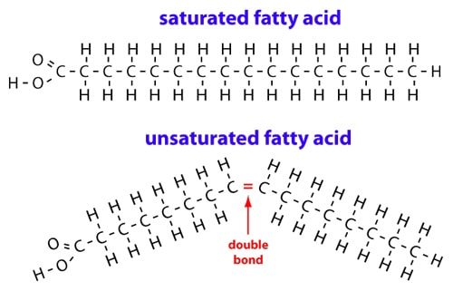
Saturated Fatty Acids
- Saturated fatty acids only have single bonds between carbon atoms therefore have a straight structure
- These fatty acids are saturated because the carbons are carrying as many hydrogen atoms as they can
- Because there are no bends, saturated fatty acids can pack more tightly together, therefore saturated fatty acids are solid at room temperature
Unsaturated Fatty Acids
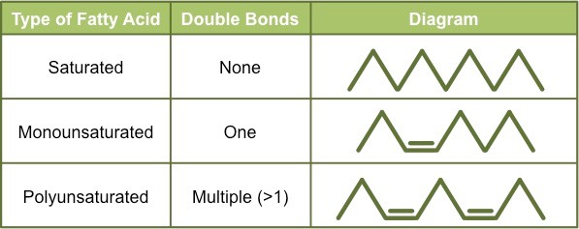
- Monounsaturated fatty acids have at one double bond somewhere in the chain therefore have a bent structure
- Polyunsaturated fats have at least two double bonds in their chain therefore have many bends/kinks in the chain
- Because there are bends the fatty acids can’t pack closely together they are liquid at room temperature
- Two types of polyunsaturated fats
  - Cis = Hydrogens are on the same side of the double bond, and they repel each other so there is a bend in the shape
  - Trans = Hydrogens are on the opposite side of the double bond, so the molecule is straight
- Cis-fatty acids are very common in nature, bent (therefore loosely packed) and healthy
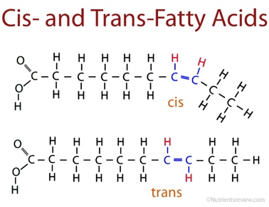
- Trans-fatty acids are rare in nature, straight (therefore closely packed) and not healthy

Lipids
- Lipids are a diverse group of hydrophobic compounds that include molecules like fats, oils, phospholipids and steroids
- Most lipids are hydrocarbons: molecules that include many non polar carbon-carbon or carbon-hydrogen bonds
- Lipids are carbon compounds made by living organisms that are mostly or entirely hydrophobic
- There are three main types of lipids: Triglycerides, Phospholipid and Steroids
Phospholipids (See 1.3)
- Phospholipids are made from a glycerol bonded to two fatty acids and one phosphate group
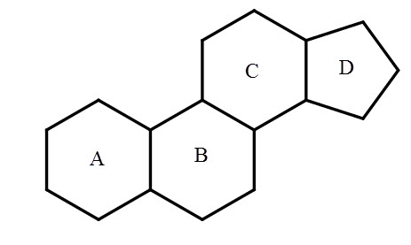
- Phospholipids are only partly hydrophobic and form the basis of membranes
Steroids
- Steroids all have a similar structure of four fused rings in their molecules
- Cholesterol, progesterone, estrogen and testosterone are all steroids
Triglycerides
- Triglycerides are the largest class of lipids and primarily function as a long-term energy storage
- Triglycerides are made from one glycerol bonded to three fatty acids glycerol by condensation reactions
  - Glycerol has three carbon atoms with three hydroxyl groups which bonds to the fatty acids
- Fats and oils are triglycerides:
  - Animals tend to store triglycerides as fats (solid)
  - Plants tend to store triglycerides as oils (liquids)
- Triglycerides can either be saturated or unsaturated depending on the composition of the fatty acid chain
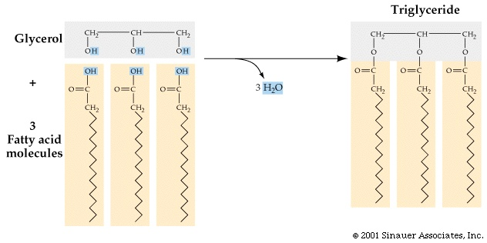

Carbohydrates vs Lipids Energy Storage
Function | Carbohydrate (Glycogen) | Lipid (Triglyceride)
Storage | Short-term energy storage | Long-term energy storage
Osmolality | More effect on osmotic pressure | Less effect on osmotic pressure
Digestion | More readily digested – used for aerobic or anaerobic respiration | Less easily digested – can only be used for aerobic respiration
ATP Yield | Stores half as much ATP per gram | Stores twice as much ATP per gram
Solubility | Water soluble as monomers, easier to transport | Non-water soluble (hydrophobic), more difficult to transport
Example | White bread | Peanuts
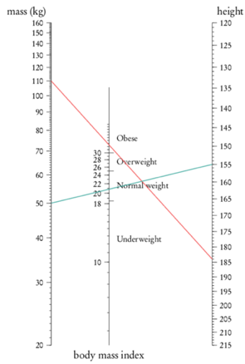
Health problems with lipids
- Lipids can cause high cholesterol which can lead to obesity, diabetes and high blood pressure
- Trans-fats are mostly artificially produced. There is a positive correlation between amounts of trans-fats consumed and rates of coronary heart disease
Body Mass index
- BMI is commonly used as a screening tool to identify potential weight problems
- BMI takes into account your height and weight so in order to calculate BMI: $BMI=\frac{Weight (in kg)}{Height^{2} (in m)}$
- However, BMI calculations should not solely be used as a diagnostic tool and should be used in conjunction with other measurements. Also BMI values are not a valid indicator for pregnant women
- Nomograms can also be used to calculate BMI: By drawing a line connecting weight and height
2.4 | Proteins
U1 | Amino acids are linked together by condensation to form polypeptides
U2 | There are 20 different amino acids in polypeptides synthesized on ribosomes
U3 | Amino acids can be linked together in any sequence giving a huge range of possible polypeptides
U4 | The amino acids can be linked together in any sequence giving a huge range of possible polypeptides
U5 | The amino acid sequence of polypeptides is coded for by genes
U6 | A protein may consist of a single polypeptide or more than one polypeptide linked together
U7 | The amino acid sequence determines the three-dimensional conformation of a protein
U8 | Living organisms synthesize many different proteins with a wide range of functions
U9 | Every individual has a unique proteome
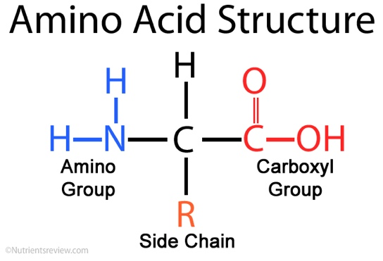
Proteins
- Proteins are polymers built up from small monomer molecules called amino acids
- There are 20 different amino acids that can be used to make polypeptides (proteins)
- Each amino acid has an amino group (NH₂) and a carboxyl group (COOH) along with an R group which differs from each amino acid
- Polypeptides differ from one another in:
  - Their length (number of amino acids)
  - Amino acids that are present
  - Order of the amino acids
- The amino acid sequence is what gives each polypeptide its unique properties
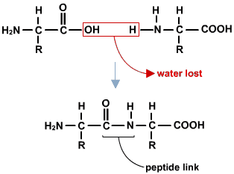
Peptide bonds
- Amino acids are linked together in proteins by a special kind of covalent bond known as a peptide bond or amid link
- Peptide bonds are formed by condensation reactions between the amino group of one amino acid and a carboxyl group of another amino acid
- A water molecule H₂O is also formed
- Polypeptide chains can be broken down via hydrolysis reactions, which requires water to reverse the process
Protein vs Polypeptide
- Polypeptides are composed of a single amino acid chain while proteins are made of amino acids that is in the right shape and ready to carry out its function
Protein function
- There are 4 levels of protein structure. These structures depend on the amino acid sequence and determines the function and shape of a protein
- A change in even one amino acid can affect the overall shape, and therefore the function of the protein
Primary Structure
- The primary structure refers to the sequence of amino acids in the polypeptide chain
- The primary structure is held together by peptide bonds (amide links)
- The sequence of a protein is unique to that protein, and defines the structure and function of the protein
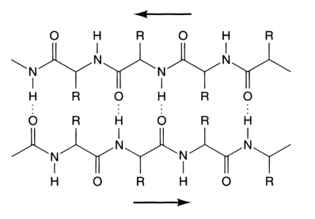
Secondary Structure
- The secondary structure of a protein refers to the folding of the polypeptide as a result of hydrogen bonding held together by hydrogen bonds between amine and carboxylic groups
- Hydrogen bonds provide a level of structural stability (Alpha-helix or beta-pleated sheets)
- Held together by hydrogen bonds
Tertiary Structure
- The tertiary structure of a protein refers to the twisting and folding of the secondary structure to form a specific 3D shape
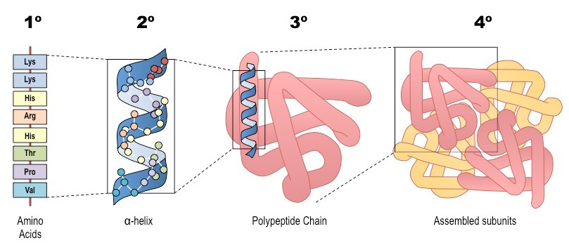
- The tertiary structure of a protein is held together by interactions between the side chains (The R groups)
Quaternary Structure
- The quaternary structure of proteins refers to the interactions between polypeptide chains
Denatured Proteins
- Proteins are highly dependent on their shape. Their shape is determined by the amino acid sequence, the secondary structure, and the tertiary structure. If this structure is altered it may not be able to carry out its original function
- Denaturation: A structural change of a protein that results in the loss of its biological properties
- Denaturation can be caused by pH or temperature:
  - Heat causes vibrations within protein molecules that break intramolecular bonds and cause the conformation to change. Heat denaturation is almost always irreversible
  - Every protein has an ideal or optimum pH at which its conformation is normal. If the pH is increased or decreased the conformation of a protein may initially stay the same, but denaturation will eventually occur when the pH has deviated too far from the optimum. This is because pH changes causes intramolecular bonds to break
Protein Function Examples
- Living organisms synthesize many different proteins with a wide range of cautions:
Function | Example | Description
Structure | Collagen | Used in skin to prevent tearing, in bones to prevent fractures, and ligaments to give tensile strength
 | Spider silk | Used to make webs for catching prey and lifelines on which spiders suspend themselves. It has very high tensile strength and becomes stronger when stretched
Hormones | Insulin | Is carried dissolved in blood and binds specifically and reversibly to insulin receptors in the membranes of body cells, causing the cells to absorb glucose and lower glucose concentration
Immunity | Immunoglobulins | Antibodies that bind to antigens on pathogens
Transport | Hemoglobin | A protein found in red blood cells that is responsible for the transport of oxygen
 | Cytochrome | A group of proteins located in the mitochondria involved in electron transport chain
Sensation | Rhodopsin | A pigment in the photoreceptor cells of the retina that is responsible for the detection of light
Enzymes | Rubisco | An enzyme involved in the light independent stage of photosynthesis

2.5 | Enzymes
U1 | Enzymes have an active site to which specific substrates bind
U2 | Enzyme catalysis involves molecular motion and the collision of substrates with the active site
U3 | Temperature, pH and substrate concentration affect the rate of activity of enzymes
U4 | Enzymes can be denatured
U5 | Immobilized enzymes are widely used in industry
A1 | Methods of production of lactose-free milk and its advantages
S1 | Design of experiments to test the effect of temperature, pH and substrate concentration on the activity of enzymes
S2 | Experimental investigation of a factor affecting enzyme activity
Enzymes
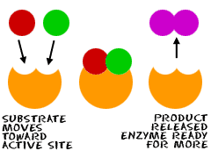
- Enzymes are (globular) proteins that act as biological catalysts, increasing reaction rates of biological processes without being used up in the process
- The molecule that the enzyme binds with is referred to as the substrate
- The substrate binds to a small section of the enzyme called the active site
- The molecule produced at the end of the reaction is referred to as the product
- Once the reaction is complete, the enzyme releases the product and is ready to bind with other substrates
- Enzymes are typically named after the molecules they react with (the substrate) and end with the suffix “-ase”
Induced-Fit Model
- Enzymes are extremely particular, and each enzyme only binds with one particular substrate
- The induced-fit model is based on the lock-and-key model. The lock-and-key model states that the substrate acts as a “key” to the “lock” of the active site
- However, in the induced-fit model, only a single substrate is the precise match for the enzyme. Once the enzyme finds its exact counterpart the chemical reaction can begin
- The induced-fit model is a theory that says the active site will change shape to enfold a substrate molecule
- Instead of the active site and substrate being perfect matches, the substrate induces a change of shape in the enzyme

Factors affecting enzymes
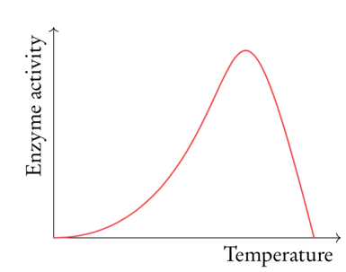
Temperature
- Increasing temperature also increases enzyme activity at around double for every 10°C
- This is because collisions between substrate and active site happen more frequently at higher temperatures due to faster molecular motion
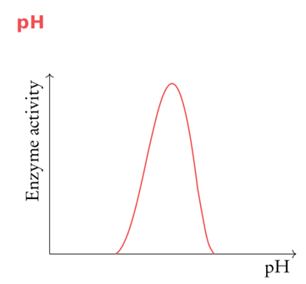
- However, at high temperature the enzymes will become denatured and stop working. This is because the heat causes vibrations inside the enzymes which break bonds needed to maintain the structure of the enzyme
pH levels
- Increasing pH increases enzyme activity to an optimum point. Increasing pH beyond this optimum point will reduce enzyme activity as about a certain pH the alkalinity denatures the enzyme so it can’t catalyze the reaction at all
Concentration
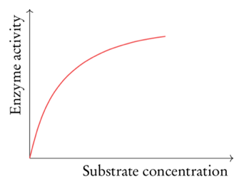
- Increasing substrate concentration increases enzyme activity. This is because random collisions between substrate and active site happens more frequently with higher substrate concentrations
- However, at high substrate concentrations the active site of the enzyme is saturated therefore raising the substrate concentration has little effect on enzyme activity
Immobilized enzymes
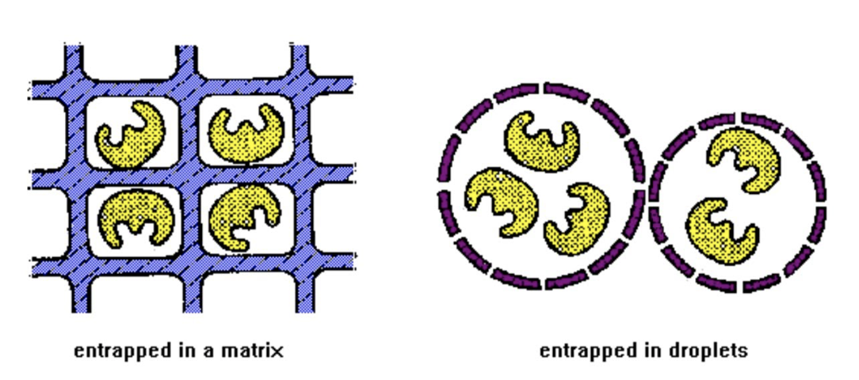
- An immobilized enzyme is an enzyme attached to an inert, insoluble material.
- Enzyme immobilization involves restricting enzyme mobility in a fixed space
- There are several techniques used to immobilize enzymes which depends on the enzymes substrates and products used. Generally, extracting enzymes from cells can be very difficult because they are dissolved in solution
- Advantages and disadvantages of immobilized enzymes include:
Advantages | Disadvantages
- Enzymes can be reused  - Enzymes are more stable and less likely to denature because they are binded to a surface  - There will be no enzyme left in the product as enzymes are immobilized. Thus, purification is not necessary | - Requires extra time, equipment and work  - May be a reaction in reaction rates if enzymes cannot mix freely with the substrate  - Immobilized enzymes cannot be used if one of the substrate is insoluble
- Immobilized enzymes are used in a wide variety of industrial practices such as: biofuels, medicine, biotechnology, food production, textiles, paper
- However, immobilized enzymes are especially useful in the production of lactose-free milk
- The enzyme lactase breaks down lactose, which is found in milk into glucose and galactose. However, some people don’t possess lactase hence they can’t break down lactose. Because their body can’t break down lactose it builds up in their digestive system where bacteria feeds on it causing digestive problems
- Immobilized lactase can be used to produce lactose free milk. Normal milk is poured down a column containing the immobilized lactase enzymes which break down the lactose. After the milk has passed through this system it will only contain glucose and galactose so lactose intolerant people can drink
- Advantages of Lactose-Free Dairy products
  - As a source of dairy for lactose-intolerant individuals
  - As a means of increasing sweetness in the absence of artificial sweeteners
  - To reduce crystallization of ice creams
2.6 | Structure of DNA and RNA
U1 | The nucleic acids DNA and RNA are polymers of nucleotides
U2 | DNA differs from RNA in the number of strands present, the base composition and the type of pentose
U3 | DNA is a double helix made of two antiparallel strands of nucleotides linked by hydrogen bonding between complementary base pairs
A1 | Crick and Watson’s elucidation of the structure of DNA using model making
S1 | Drawing simple diagrams of the structure of single nucleotides of DNA and RNA, using circles, pentagons and rectangles to represent phosphates, pentoses and bases
Structure of nucleotides
- DNA and RNA are two types of nucleic acid. They are both polymers of sub-units called nucleotides
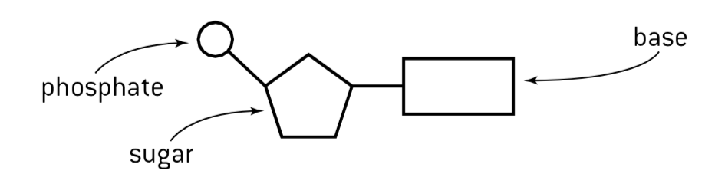
- Each nucleotide consists of three parts:
- A pentose group (A five-carbon sugar)
- Phosphate Group (PO₄⁻³)
- A nitrogenous base
- There are two differences between DNA and RNA nucleotides
- The type of pentose is ribose in RNA but deoxyribose in DNA
- In both DNA and RNA there are four possible bases. There of these are the same. However the fourth base is thymine in DNA but uracil in RNA
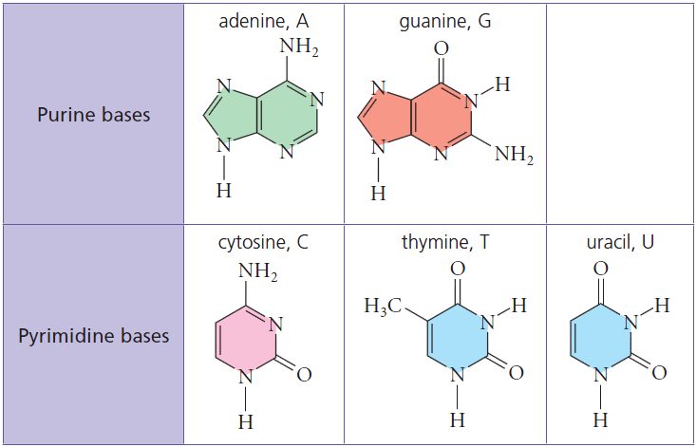

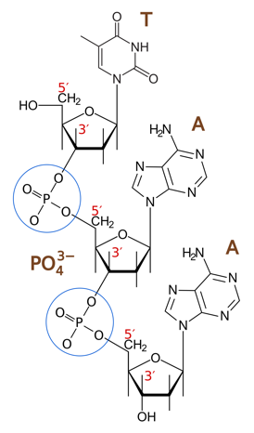
DNA/RNA Structure
- Nucleic acids are composed of nucleotide monomers which are linked into a single strand via condensation reactions
- The phosphate group of one nucleotide attaches to different sugar molecules at C₃ and C₅ forming a covalent bond (phosphodiester links) between sugar molecules (See right)
- The double helix of the DNA is stabilized by hydrogen bonds between complementary pairs of bases
  - Adenine pairs with Thymine via two hydrogen bonds
  - Guanine pairs with Cytosine via three hydrogen bonds
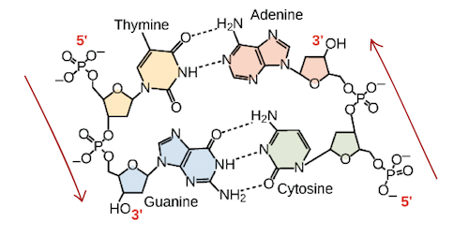
- In order for the bases to be facing each other and be able to pair the strands must be running in opposite directions. Therefore, the two strands of DNA are described as being antiparallel

- Chargaff's rules state that, as a result of how the DNA bases pair, the amount of adenine and thymine are equal, and the amount of cytosine and guanine are equal
- RNA differs from DNA in that it has:
  - Ribose sugar instead of deoxyribose (Remember, these are both monosaccharides)
  - Uracil instead of thymine
  - A single stranded structure instead of a double stranded structure
Watson and Crick
- Watson and Crick were able to assemble a DNA that showed that:
  - DNA strands are antiparallel and form a double helix
  - DNA strands pair via complementary base pairing
- However, their first model showed that DNA had a triple helix
2.7 | DNA replication, transcription and translation
U1 | The replication of DNA is semi-conservative and depends on complementary base pairing
U2 | Helicase unwinds the double helix and separates the two strands by breaking hydrogen bonds
U3 | DNA polymerase links nucleotides together to form a new strand, using the pre-existing strand as a template
U4 | Transcription is the synthesis of mRNA copied from the DNA base sequences by RNA polymerase
U5 | Translation is the synthesis of polypeptides on ribosomes
U6 | The amino acid sequence of polypeptides is determined by mRNA according to the genetic code
U7 | Codons of three bases on mRNA correspond to one amino acid in a polypeptide
U8 | Translation depends on complementary base pairing between codons on mRNA and anticodons on tRNA
A1 | Use of Taq DNA polymerase to produce multiple copies of DNA rapidly by the polymerase chain reaction (PCR)
A2 | Production of human insulin in bacteria as an example if the universality of the genetic code allowing gene transfer between species
S1 | Use a table of the genetic code to deduce which codon(s) corresponds to which amino acid
S2 | Analysis of Meselson and Stahl’s results to obtain support for the theory of semi-conservative replication of DNA
S3 | Use a table of mRNA codons and their corresponding amino acids to deduce the sequence of amino acids coded by a short mRNA strand of known base sequence
S4 | Deducing the DNA base sequence for the mRNA strand
DNA Replication
- The purpose of DNA replication is to produce two identical copies of a DNA molecule. This is essential for cell growth or repair of damaged tissues. DNA replication ensures that each new cell receives its own copy of the DNA
- During DNA replication DNA molecules containing nucleotides from the original molecule are produced.
- DNA is replicated using two key enzymes:
DNA Helicase
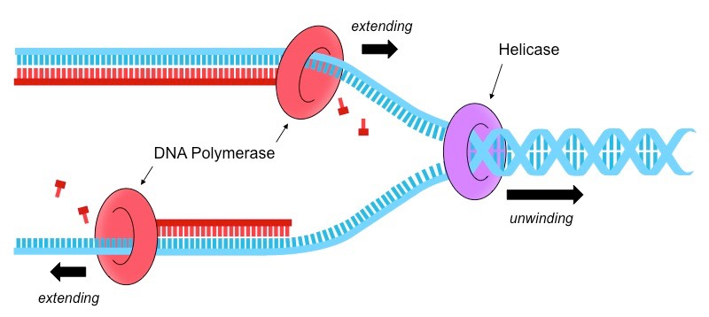
- DNA helicase separates the two polynucleotide strands of DNA by breaking the hydrogen bonds between complementary base pairs
- ATP is needed by helicase to both move along the DNA molecule and to break the hydrogen bond
- The two separated strands become parent/template strands for the replication process
- There are now a bunch of free nucleotides present in the nucleus

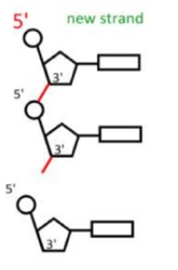
DNA Polymerase
- DNA polymerase links nucleotides together to form a new strand, using the pre-existing strand as a template
- DNA polymerase moves in a 5’ to 3’ direction
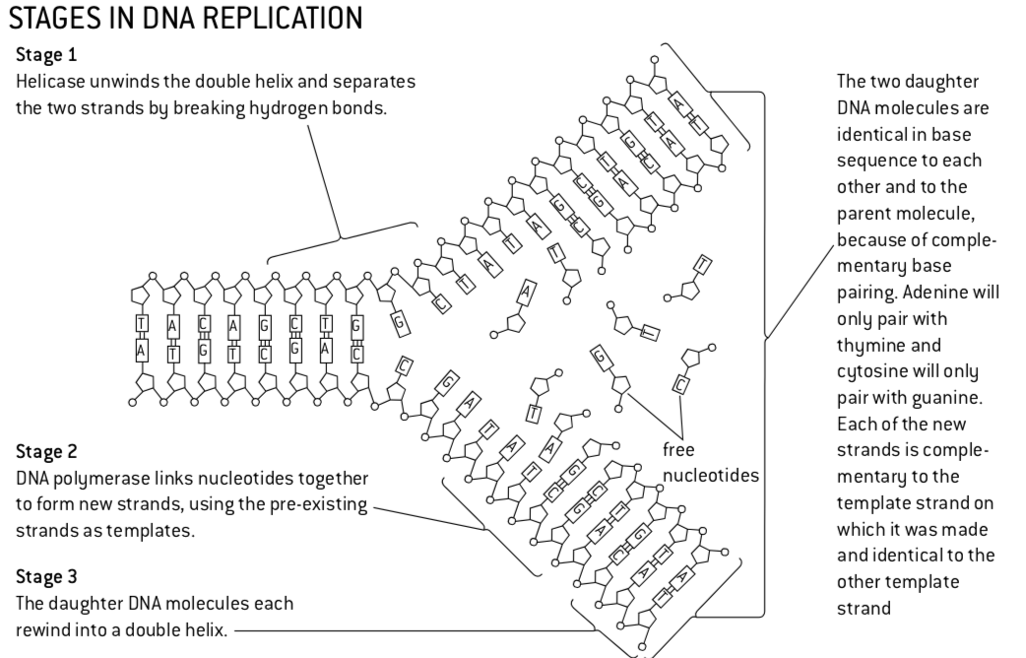
- There are very few mistakes because A can only bond with T and G with C, therefore it ensures that the new strand is complementary to the parent strand, and therefore identical to the other original parent strand

DNA is semi-conservative
- DNA replication is said to be semi-conservative, because each strand contains one original and one new strand
- The original DNA strands are split into two and each half is used as a template to make the complementary strand (the other half). The complementary strands are made using free nucleotides that are floating around the nucleus.
- This was proven by the Meselson-Stahl experiment in 1958. Meselson and Stahl used radioactive isotopes of nitrogen
- Nitrogen is a key component of DNA and can exist as a heavier ¹⁵N or a lighter ¹⁴N. DNA samples were then separated via centrifugation to determine the composition of DNA in the replicated molecules
- After one division DNA molecules were found to contain a mix of either nitrogen isotopes disproving the conservative model.
- After two divisions, some molecules of DNA were found to consist solely of ¹⁴N
- Prior to this experiment, three hypotheses had been proposed for the method of replication of DNA
  - Conservative model: An entirely new molecule is synthesized from a DNA template (which remains unaltered)
  - Semi conservative model: Each new molecule consists of one newly synthesized strand and one template strand
  - Dispersive mode: New molecules are made of segments of new and old DNA
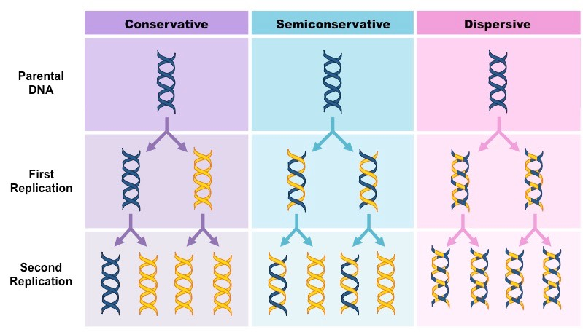

Types of RNA
- Three main types of RNA:
  - mRNA (messenger RNA): Serves as a temporary copy of DNA and carries the DNA codes from the nucleus to the ribosome
  - rRNA (ribosomal RNA): Makes up the ribosome
  - tRNA (transfer RNA): Carries a specific amino acid to the ribosome and adds it to the growing polypeptide chain
Transcription
- Transcription is the synthesis of mRNA copied from the DNA base sequences by RNA polymerase
- This process occurs in the nucleus and results in a molecule of mRNA
- However, transcription is not used for long-term storage (temporary copy) and can freely exist only in the nucleus
- The two nucleotides are temporarily separated in transcription opposed to translation where they would be permanently separated
- Transcription uses an enzyme called RNA polymerase and a number of necessary proteins called transcription factors:
- RNA polymerase separates the DNA strands and synthesizes a complementary RNA copy from one of the DNA strands
- When the DNA strands are separated, ribonucleotide triphosphates align opposite their exposed complementary base partner
- RNA polymerase removes the additional phosphate groups and uses the energy from this cleavage the covalently join the nucleotide to the growing sequence
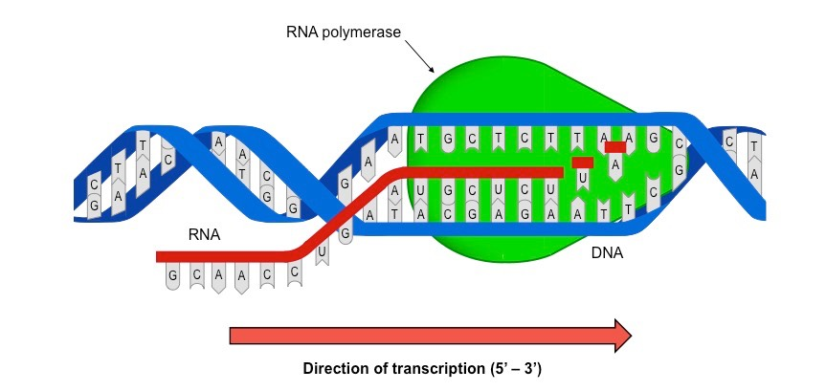
- Once the RNA sequence has been synthesizes, RNA polymerase detaches from the DNA Molecule and the double helix reforms

- The strand that is transcribed is called the antisense strand and is complementary to the RNA sequence
- The strand that is not transcribed is called the sense strand and is identical to the RNA sequence (with T instead of U)
Translation
- Translation is the process of converting a sequence of mRNA nucleotides to a sequence of amino acids
- This process occurs in the cytoplasm and results in a polypeptide chain (protein)
- During translation, an mRNA sequence is read using the genetic code which is a set of rules that defines how an mRNA sequence is to be translated into the 20-letter code of amino acids, which are the building blocks of proteins
- These amino acids are coded by a three-letter combination (codons) each of which corresponds with a specific amino acid or stop signal.
  - Groups of three letters on DNA are called triplets
  - Groups of three letters on mRNA are called codons
  - Groups of three letters on tRNA has anticodons
- Translation occurs in a structure called the ribosome, which is a factory for the synthesis of proteins. The ribosome has a small and large subunit

- Translation of an mRNA molecule by the ribosome occurs in the following stages:
- mRNA binds to a ribosome
- A tRNA molecule with an anticodon that is complementary to the codon on mRNA binds to the mRNA
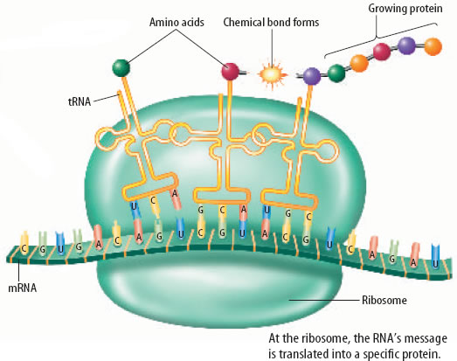
- Another tRNA with an anticodon complementary to the second mRNA codon attaches to the mRNA molecule at the ribosome
- An enzyme joins the two amino acids on the tRNA molecules together via a condensation reaction
- The bond is broken between the tRNA molecule and the amino acid that was just added to the polypeptide chain
- The tRNA molecule is released
- The ribosome moves down to the next mRNA codon
- This process is repeated many times to form the amino acid chain
Genetic code
- The genetic code is often said to be universal. This is because the same triplets make the same codons which are translated into the same amino acid in every single organism on earth.
- Thus, the universality of the genetic code makes it possible to insert genes from one species into another species
Polymerase Chain Reaction
- Polymerase chain reaction (PCR) is used to amplify small samples of DNA. It is useful when only a small amount of DNA is available for testing (Example: Crime scene, samples of blood, hair)
- PCR occurs in a thermal cycle and involves a repeat procedure of 3 steps:
- Denaturation: DNA strands are separated using heat (to break hydrogen bonds)
- Annealing: DNA primers attach to opposite ends of the target sequence
- Elongation: A heat tolerant DNA polymerase (Taq) copies the strand
- One cycle of PCR yields two identical copies of the DNA sequence
- Taq polymerase is a form of polymerase found in heat-resistant bacteria called Thermus aquaticus
- By using this enzyme, hydrogen bonds can be broken without denaturing the polymerase enzyme
2.8 | Cell respiration
U1 | Cell respiration is the controlled release of energy from organic compounds to produce ATP
U2 | ATP from cell respiration is immediately available as a source of energy in the cell
U3 | Anaerobic cell respiration gives a small yield of ATP from glucose
U4 | Aerobic cell respiration requires oxygen and gives a large yield of ATP from glucose
A1 | Use of anaerobic cell respiration in yeasts to produce ethanol and carbon dioxide in baking
A2 | Lactate production in humans when anaerobic respiration is used to maximize the power of muscle contractions
S1 | Analysis of results from experiments involving measurement of respiration rates in germinating seeds of invertebrates using a respirometer
Cell Respiration
- Most processes in living cells require energy in the form of ATP
- ATP (adenosine triphosphate) is a high energy molecule that functions as an immediate source of power for cell processes
- Uses of ATP include:
  - Synthesis of macromolecules. This include DNA, RNA and proteins
  - Active transport
  - All movements in the cell, such as muscle contraction, endocytosis, exocytosis, etc
- We continuously need this energy because once ATP is used we lose all energy through heat
- Every cell produces its own ATP by a process called cell respiration. Carbon compounds such as glucose or fat are carefully broken down and the energy released by doing this is used to make ATP
- Cell respiration: The controlled release of energy from organic compounds to produce ATP
- Cell respiration breaks down ATP into ADP+P into ATP by using glucose
- C₆H₁₂O₆ + 6O₂ => 6CO₂ + 6H₂O + ATP(energy)
- Respiration takes place in all living cells all the time it can be classified as followed:
 | Oxygen | Substrate | Yield of ATP per glucose | Products
Anaerobic Respiration | Not present | Glucose only | Small | Humans: Lactate  Yeast: CO₂ and ethanol
Aerobic Respiration | Present | Glucose or lipids | Large (~36 ATP) | CO₂ and water

- Both products of anaerobic respiration in yeast are used in industries
Carbon dioxide and the baking industry
- Yeast is used in baking bread. It is mixed into the dough before baking
- The yeast rapidly uses up all oxygen present in the dough and then produces ethanol and carbon dioxide by anaerobic cell respiration. The carbon dioxide forms bubbles making the dough rise
- It increases the volume of the bread and makes it less dense. When the dough is based most of the ethanol evaporates and the carbon dioxide bubbles give the bread a light texture
Ethanol and the brewing and biofuel industries
- Yeast can be used to produce ethanol by fermentation. The yeast is cultured in a liquid containing sugar and other nutrients, but not oxygen so its respires anaerobically
- The ethanol concentration of the fluid around the yeast cells can rise to approximately 15% by volume, before it becomes toxic to the yeast and the fermentation ends. Most of the carbon dioxide bubbles out into the atmosphere
- Beer, wine and other alcoholic drinks are brewed in this way
- Ethanol is also produced by fermentation for use as a fuel
Glycolysis
- All cellular respiration pathways begin with glycolysis
- Glycolysis literally translates into sugar breaking. It is the first step of cellular respiration and takes place in the cytoplasm (NOT in the mitochondria)
- Glycolysis is an anaerobic process:
- Starts with glucose (6 carbons)
- An enzyme modifies to make it unstable
- A series of reactions splits the glucose into 2 molecules of pyruvate (3 carbons each)
- The energy from the bond that are broken in this process are used to generate 2 ATP molecules
- To make the glucose unstable 2 ATP molecules are needed. The breaking of glucose generates 4 ATP molecules
- So, we say that 2 ATP molecules are spent, 4 are generated, and that results in a net gain of 2 ATP molecules
Fermentation
- After glycolysis, if there is no oxygen present organisms will undergo fermentation
- Fermentation: The breakdown of organic molecules for ATP production anaerobically
- Fermentation also takes place in the cytoplasm as it is anaerobic

Alcoholic Fermentation | Lactic Acid Fermentation
Example Organism: Yeast  - Starts with pyruvate  - Ends with alcohol and carbon dioxide  Real World Application: Yeast fermentation is sued to produce bread, beer and wine | Example Organisms: Bacteria, Animals  - Starts with pyruvate  - Ends with lactic acid  Real World Application: Production of sour cream, yogurt, cheese, and muscle soreness after exercise in animals
Aerobic Respiration
- If there is oxygen present organisms will undergo aerobic respiration in the mitochondria:
- Pyruvate (from glycolysis) and oxygen enter the mitochondria
- The pyruvate is completely broken down during reactions called the Krebs cycle and electron transport chain
- Water, carbon dioxide and ATP are generated (along with heat)
- This produces 36ATP
2.9 | Photosynthesis
U1 | Photosynthesis is the production of carbon compounds in cells using light energy
U2 | Visible light has a range of wavelengths with violet the shortest wavelength and red the longest
U3 | Chlorophyll absorbs red and blue light most effectively and reflects green light more than other colors
U4 | Oxygen is produced in photosynthesis from the photolysis of water
U5 | Energy is needed to produce carbohydrates and other carbon compounds from carbon dioxide
U6 | Temperature, light intensity and carbon dioxide concentration are possible limiting factors on the rate photosynthesis
A1 | Changes to the Earth’s atmosphere, oceans and rock deposition due to photosynthesis
S1 | Drawing an absorption spectrum for chlorophyll and an action spectrum for photosynthesis
S2 | Design of experiments to investigate the effect of limiting factors on photosynthesis
S3 | Separation of photosynthetic pigments by chromatograph
Photosynthesis
- Photosynthesis: The synthesis of energy rich molecules (like glucose) from carbon dioxide and water using light energy
- Photosynthesis is the process by which cells synthesize organic compounds (e.g. glucose) from inorganic molecules (CO₂ and H₂O) in the presence of sunlight
- Photosynthesis Equation: 6CO₂ + 6H₂O → C₆H₁₂O₆ + 6O₂
- This process requires a photosynthetic pigment (chlorophyll) and can only occur in certain organisms
- Photosynthesis is a two step process:
- The light dependent reactions convert light energy from the Sun into chemical energy (ATP)
- The light independent reactions use the chemical energy to synthesize organic compounds (e.g. carbohydrates)

Characteristics | Light dependent | Light independent | Overall
Description | Converts light energy from the sun into chemical energy | Uses chemical energy to synthesize organic compounds
Location | Thylakoid | Stroma | Chloroplast
Starts with | H₂O, ADP, NADP | CO₂, ATP, NADPA
Ends with | O₂, ATP, NADPH | C₆H₁₂O₆, ADP, NADP | C₆H₁₂O₆ + O₂
Energy conversion | Light into chemical | Chemical into chemical | Light into chemical
Factors that affect photosynthesis
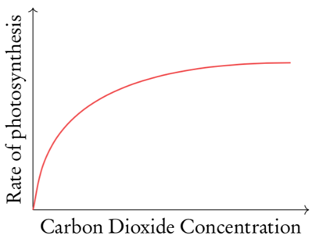
CO₂ Levels
- Rate limiting step in the Calvin cycle -> Carbon cannot be fixed to inorganic compounds and thus gluocose production slows down
- Increasing CO₂ concentration increases the rate of photosynthesis, until the photosynthetic enzymes involved in the cycle reach their saturation point and can no longer increase reaction rates
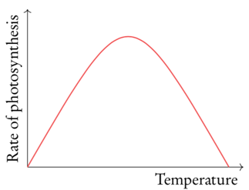
Temperature
- At low temperatures the enzymes involved in photosynthesis reactions work very slowly. The rate of reaction increases steadily as temperature increases until reaching an optimum point when all enzymes are working at a high rate
- When the temperature surpasses this optimal point enzymes can be denatured once again decreasing photosynthetic rate
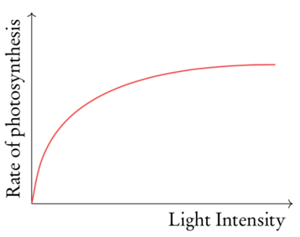
Light intensity
- At low light intensities, rate of photosynthesis is limited. Photolysis which requires the absorption of light waves slow down, and thus so does oxygen and ATP production
- Indirectly limits the light independent reactions as ATP is necessary for carbon fixation to occur
- The graph levels off once all the enzymes and reactions are occurring at the highest speed possible
Chlorophyll
- Chlorophyll is a green pigment found in photosynthetic organisms that is responsible from light absorption
  - Pigment: The natural coloring matter of animal or plant tissue
- Chlorophyll is found in thylakoid membranes
- Plants are green because their main pigment, chlorophyll, absorbs all colors of light except green
  - Chlorophyll absorbs light most strongly in the blue portion of the visible spectrum, followed by the red portion
  - Chlorophyll reflects light most strongly in the green portion of the visible spectrum
- Therefore green is the least useful of light for photosynthesis
- However, only the thylakoids are green because that’s where the chlorophyll is
Measuring rate of photosynthesis
- Photosynthesis can be measured directly via the uptake of CO₂ or production of O₂ or indirectly via a change in biomass

Measuring CO₂ uptake
- Carbon dioxide uptake can be measured by placing leaf tissue in an enclosed space with water
- Water free of dissolved carbon dioxide can initially be produced by oiling and cooling water
- Carbon dioxide interacts with the water molecules, producing bicarbonate and hydrogen ions, which changes the pH
- Increased uptake of CO₂ by the plant will lower the concentration in solution and increase the alkalinity
- Alternatively, carbon dioxide levels may be monitored via a data logger
Measuring O₂ uptake
- Oxygen production can be measured by submerging a plant in an enclosed water filled space attached to a sealed gas syringe
- Any oxygen gas produced will bubble out of solution and can be measured by a change in meniscus level on the syringe
- Alternatively, oxygen production could be measured by the time taken for submerged leaf discs to surface
- Oxygen levels can also be measured with a data logger if the appropriate probe is available
Measuring Biomass (Indirect)
- Glucose production can be indirectly measured by a change in the plant’s biomass (weight)
- This requires the plant tissue to be completely dehydrated prior to weighing to ensure the change in biomass represents organic matter and not water content
- An alternative method for measuring glucose production is to determine the change in starch levels (glucose is stored as starch)
- Starch can be identified via iodine staining (turns starch solution purple) and quantitated using a colorimeter
Electromagnetic spectrum
- The electromagnetic spectrum is the range of all possible frequencies of electromagnetic radiation
- The shorter the wavelength the greater the energy and vice versa
- Photosynthesis with other wavelengths should be possible, as long as it contains energy
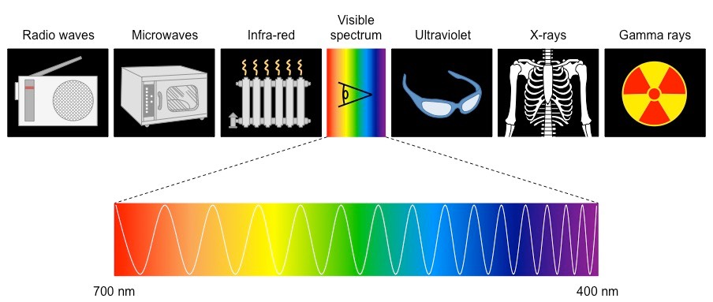

Photolysis
- Photolysis: When photons (light) are used to split (lysis). The reason for this reaction is because some plants need some e- and H+ during photosynthesis, thus they split water and produce oxygen as a waste product
- Photolysis occurs in the thylakoid
- The equation: 2H2O -> 4e- + 4H+ + o2
- ATP is also produced as a product
- Oxygen is produced as a waste product of photosynthesis
Absorption/Action Spectrum
- The absorption spectrum indicates the wavelengths of light absorbed by each pigment
- The action spectrum indicates the overall rate of photosynthesis at each wavelength of light
- As you can see from the absorption spectrum green is reflected while blue and red are absorbed the most, with blue having a shortest wavelength

