Topic 2: Atomic Structure
2.1 | The nuclear atom
2.1.1 | Atoms contain a positively charged dense nucleus composed of protons and neutrons (nucleons)
2.1.2 | Negatively charged electrons occupy the space outside the nucleus
2.1.3 | The mass spectrometer is used to determine the relative atomic mass of an element from its isotopic composition
2.1.4 | Use of the nuclear symbol notation ${}_{Z}^{A}X$ to deduce the number of protons, neutrons and electrons in atoms and ions
2.1.5 | Calculations involving non-integer relative atomic masses and abundance of isotopes from given data, including mass spectra
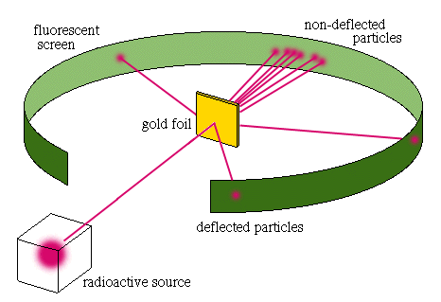
Rutherford’s experiment
- Rutherford’s experiment revealed that atoms have a nucleus
- In his experiment, he shot alpha particles straight towards a sheet of gold foil. Around this foil was a florescent screen that would flash when alpha particles hit the screen
- It was predicted that these alpha particles would go straight through the gold foil and not get deflected
- However, a small percentage of particles were deflected through angles much larger than 90 degrees. Some particles even were scattered back
- This showed that:
  - The atom was mostly empty space instead of a solid (plum pudding model)
  - This also showed that atoms had a nucleus, as alpha particles would sometimes get deflected backwards when they would hit the nucleus
Sub-Atomic Structure
- Atoms are made up of a nucleus containing a positively charged protons and neutral neutrons, with negatively charged electrons moving around the nucleus in shells
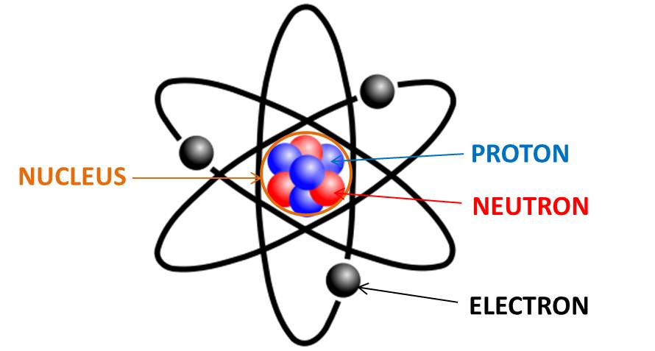
- Electrons are assumed to be massless
Sub-atomic particle | relative mass | relative charge
proton | 1 | +1
neutron | 1 | 0
electron | $$\frac{1}{1836}$$ | -1

Definitions
Mass number (A) – Sum of the number of protons and neutrons in the nucleus
Atomic number (Z) – The number of protons in the nucleus. Since atoms are electrically neutral, the number of protons is also equal to the number of electrons
Isotope – Atoms of the same element with the same number of protons, but with a different number of neutrons

- Some isotopes may be heavier than other elements despite having a smaller proton count because the element may have a greater proportion of heavier isotopes

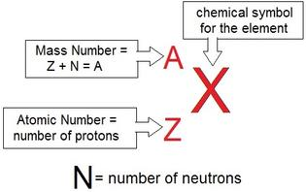
Nuclear Notation
- Nuclear notation shows the mass number, atomic number and symbol to represent a particular isotope. To find:
  - Atomic Number: Number of protons
  - Mass Number: Number of protons and neutrons
  - Number of electrons = atomic number – charge
Properties of isotopes
- Chemical properties depend on the outer shell of electrons. Since isotopes still have the same number of electrons, these properties will remain the same
- Physical properties depend on their nuclei. Since the number of neutrons changes, properties such as density, rate of diffusion, melting and boiling change. The mass will also change
Uses of radioisotopes
- Many isotopes are radioactive because the nuclei are more prone to breaking down spontaneously. Radiation is emitted when this happens. Radioisotopes can occur naturally or be man-made
- Uses of radioisotopes include:
Carbon-14
- Carbon-14 is used to estimate the age of organisms. This process is called radiocarbon dating
- Surprisingly, these isotopes are very penetrating and can be used to treat cancerous cells
Cobalt-60
- Cobalt-60 is a powerful gamma emitter, making it useful for the treatment of cancer
- It has also been used in recent times to stop the immune response to transplanted organs in the body
- It is also used in levelling devices and to sterlize foods and spices
Iodine-131/Iodine 125
- Iodine-131 releases both gamma and beta radiation
- It can be used to treat thyroid cancer, and detect if the thyroid is functioning correctly
- The thyroid will take up the iodine and then the radiation will kill part of it
- Iodine 125 is a gamma emitter and can treat prostate cancer and brain tumors. It is also taken up by the thyroid gland
Mass Spectrometry
- A mass spectrometer is an instrument that can be used to measure the individual masses of atoms
- A mass spectrometer separates individual isotopes from a sample of atoms and determines the mass of each isotope
- The operation of the mass spectrometer can be broken down into four stages:
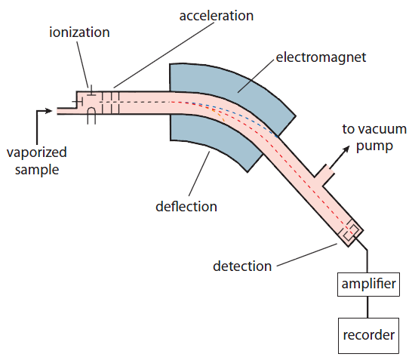
- Vaporization: The sample is heated and vaporized, and passed through into an evacuated tube
- This separates the particles
- Ionization: The atoms/molecules are then bombarded by a stream of high energy electrons, knocking electrons off the particles, resulting in ions with a 1+ charge
- Acceleration: The positively charged ions are then accelerated along the tube by means of the attraction to negatively charged plates. The ions pass through the slits, which control the direction and velocity of their motion
- Deflection: The ions are then passed into a very strong magnetic field, deflecting the ions in a curved path
- Detection: The ions are detected electronically by a device that measures the location and the number of particles

- The deflection or path of an ion in a mass spectrometer depends on:
  - Absolute mass of the ion
  - Charge of the ion
  - Strength of magnetic field
  - Velocity (speed) of ions
- This information is presented as a mass spectrum. In a mass spectrum showing the number of isotopes of an element:
  - The number of peaks indicates the number of isotopes
  - The position of each peak in the horizontal axis indicates the relative isotopic mass
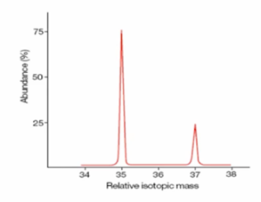
  - The relative heights of the peaks correspond to the relative abundance of the isotopes

Calculating atomic mass
- As the relative atomic mass of an element is the weighted average of the relative masses of the isotopes of an element we can calculate relative atomic mass using the following formula:
$$A_{r}=\frac{\left(relative isotopic mass_{1}×\%abundance_{1}\right)+\left(relative isotopic mass_{2}×\%abundance_{2}\right)+…}{100}$$
Problem solving
Chlorine has two isotopes. ³⁵Cl and ³⁷Cl. Cl has a relative atomic mass of 35.5. What are the abundances?
Let x represent the abundance of ³⁵Cl.
$35.5= \frac{x ×35+\left(100-x\right)×37}{100}$ $35.5 ×100 =35x+3700-37x$
$2x=150$ $x=75\%$ So the abundance of ³⁵Cl is 75% and the latter is 25% abundant.

2.2 | Electron configuration
2.2.1 | Emission spectra are produced when photons are emitted from atoms as excited electrons return to a lower energy level
2.2.2 | The line emission spectrum of hydrogen provides evidence for the existence of electrons in discrete energy levels, which converge at higher energies
2.2.3 | The main energy level or shell is given an integer number, n, and can hold a maximum number of electrons, 2n²
2.2.4 | A more detailed model of the atom describes the division of the main energy level into s, p, d and f sub-levels of successively higher energies
2.2.5 | Sub-levels contain a fixed number of orbitals, regions of space where there is a high probability of finding an electron
2.2.6 | Each orbital has a defined energy state for a given electronic configuration and chemical environment and can hold two electrons of opposite spin
2.2.7 | Description of the relationship between color, wavelength, frequency and energy across the electromagnetic spectrum
2.2.8 | Distinction between a continuous spectrum and a line spectrum
2.2.9 | Description of the emission spectrum of the hydrogen atom, including the relationships between the lines and energy transitions to the first, second and third energy levels
2.2.10 | Recognition of the shapes of an s atomic orbital and the p_{x}, p_{x}, and p_{z} atomic orbitals
2.2.11 | Applications of the Aufbau principle, Hund’s rule and the Pauli exclusion principle to write electron configurations for atoms and ions up to Z = 36
Bohr’s Model
- Bohr used the term energy levels to describe orbitals of differing energy
- The Bohr Model supports four main ideas:
- Electrons orbit the nucleus in ring like paths around the nucleus at fixed energy levels. The higher the energy level the farther away the electron is from the nucleus and the higher the energy
- Orbits further from the nucleus exist at higher energy levels
- Bohr said that electrons are quantized, meaning electrons can only occur in one energy level or another but nothing in between. The ground state is the energy level an electron normally occupies
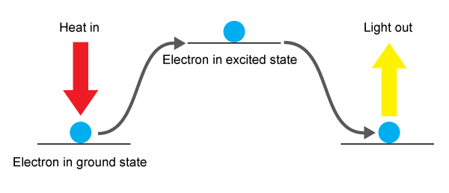
- Electrons can only move from one orbital to another orbital at one time. When electrons absorb energy they move up to a higher energy level. This is called the excited state. When the electron returns to a lower energy level they emit energy. These emissions are not always visible to the naked eye
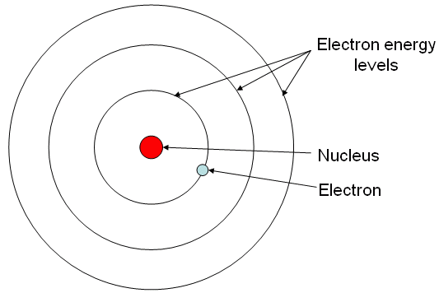

- One weakness of Bohr’s model was that he could not offer a reason why only certain energy levels were allowed
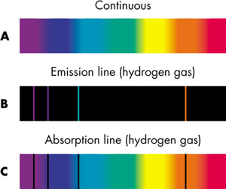
Emission spectrums
- Emission spectra are produced when photons are emitted from atoms as excited electrons return to a lower energy level
- Each electron transition from a higher energy level to a lower energy level corresponds to radiation with a specific frequency or wavelength
- Emission (line) spectrums are produced by excited atoms as they fall back to a lower energy level and only contain specific colors (wavelengths, frequencies) of visible light
- There are also several other types of spectrums:
  - Line spectrum: Only sharp, discrete colors
  - Continuous spectrum: All colors
- Note: The line emission spectrum of hydrogen provides evidence for the existence of electrons in discrete energy levels
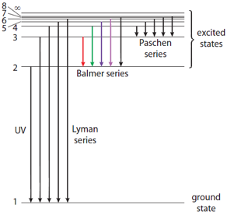
- The energy of the lines on the emission spectrum of hydrogen corresponds to the difference in energies between energy levels
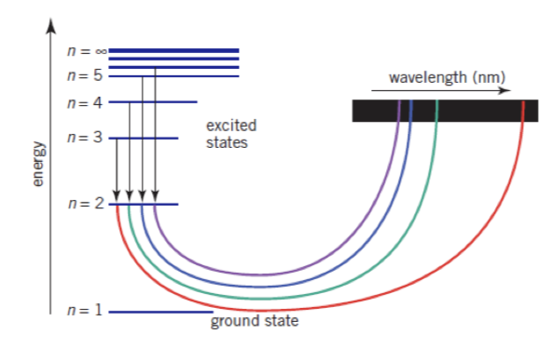

- Every element has its own unique emission (line spectrum). Hence, an element can be identified from its emission spectrum
- For instance, the helium emission spectrum is different from hydrogen because of the differences in the energy levels
- The Balmer series is the name given to a series of spectral emission lines of the hydrogen atom that result from electron transitions from higher levels down to the energy level where n=2
- Ultraviolet light is produced when electrons drop to the first energy level (Lyman series)
- Infrared is produced when electrons drop to the third energy level (Paschen series)
Electromagnetic Spectrum
- All electromagnetic waves travel at the same speed, but can be distinguished by their wavelengths
  - A wavelength is the distance between two successive crests
- A smaller wavelengths has a higher frequency, so possess more energy
- A larger wavelength has a lower frequency, so posses less energy
- To sum, as energy increases so does the frequency. So red light has lower energy than violet light which is why UV light is so damaging to the skin, since high energy is more dangerous than low energy
- The electromagnetic spectrum shows the range of all possible frequencies of electromagnetic radiation
- The order of the spectrum is radio, microwave infrared, visible, ultraviolet, x-ray and gamma ray
  - An easy way to remember is Rabbits Mate In Very Unusual eXpensive Gardens

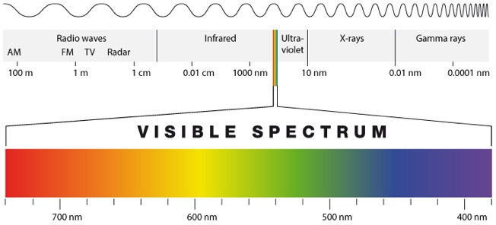

Orbitals
- Orbital: A region of space in which the probability of finding an electron is greater than or equal to 95%
- This is because the Heisenberg Uncertainty Principle states it is impossible to define the exact position of an electron
- Each orbital can hold a maximum of two electrons with opposite spin
- Orbitals can be represented as boxes with electrons depicted with arrows. Often an up-arrow and a down-arrow are used to show that the electrons are different. The “spin” is shown by the direction the arrow is pointing
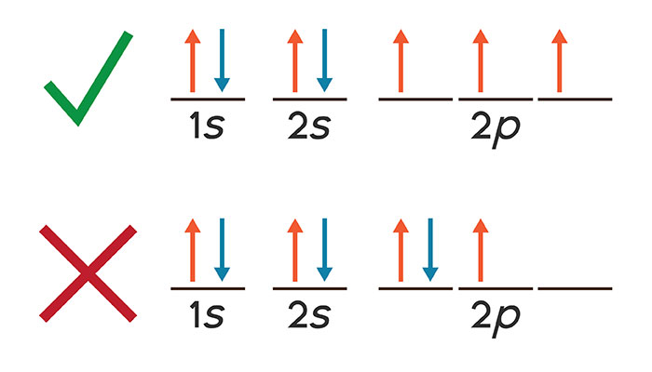
- Three rules control how electrons fill atomic orbitals:
  - Pauli’s Exclusion Principle: No more than two electrons can occupy any one orbital and if two electrons are in the same orbital they must spin in opposite
  - Aufbau Principle: Electrons are placed into orbitals of lowest energy first
  - Hund’s Third Rule: Orbitals of the same sub-level are filled singly first, then doubly. If more than one orbital in a sub-level is available, electrons occupy different orbitals with parallel spins

S/P/D/F Sub-levels
- Each main energy level is divided into several sub-levels
- Sub-levels contain a fixed number of orbitals, regions of space where there is a high probability of finding an electron
  - Sub-level: A group of orbitals with particular properties like shape and angular momentum
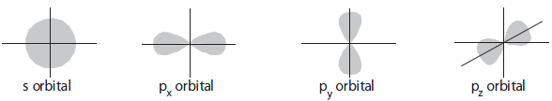
- Orbitals can take up to 4 different shapes
  - s-orbitals take a spherical shape
  - p-orbitals resemble a “dumbbell” shape
- The sub-levels s, p, d and f contain the following number of orbitals respectively where every orbital can hold up to two electrons maximum
  - s: 1 orbital, 2 electrons
  - p: 3 orbitals, 6 electrons
  - d: 5 orbitals: 10 electrons
  - f: 7 orbitals, 14 electrons
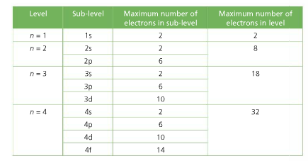
- Each main energy level can hold a max of 2n² electrons

Writing electron configurations/arrangement
- To write an electron configuration:
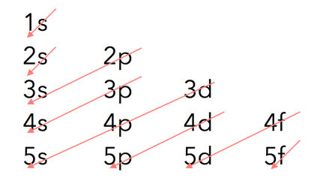
- Determine the total number of electrons
- Fill the lowest energy subshells first and then proceed to higher energy levels until all electrons are used. The easiest way is to use the chart on the left
- S-orbital can hold 2 electrons, each p-orbital can hold 6, each d-orbital can hold 10 and each f-orbital can hold 14
- Note: The 4s orbital is filled first before 3d, but is removed first before 3d
- To write a condensed electron configuration:
- Write the symbol in square brackets ([X]) for the nearest, smaller noble gas (The square brackets represent the electron configuration for the noble gas)
- Write the electron configuration following the noble gas configuration
- The electronic configurations of the transition elements copper and chromium do not follow the expected patterns
  - Chromium has the electron configuration: [Ar] 3d⁵ 4s¹
  - Copper has the electron configuration: [Ar] 3d¹⁰ 4s¹
- Electron arrangement is the number of electrons per each main energy level (i.e., Level 1, 2, 3, 4 and 5)
12.1 | Electrons in atoms
12.1.1 | In an emission spectrum, the limit of convergence at higher frequency corresponds to the first ionization energy
12.1.2 | Trends in first ionization energy across periods account for the existence of main energy levels and syb-levels in atoms
12.1.3 | Successive ionization energy data for an element give information that shows relations to electron configuration
12.1.4 | Solving problems using $E=hv$
12.1.5 | Calculation of the value of the first ionization energy from spectral data which gives the wave length of frequency of the convergence limit
12.1.6 | Deduction of the group of an element from its successive ionization energy data
12.1.7 | Explanation of the trends and discontinuities in first ionization energy across a period
Definitions
First ionization energy – The minimum amount of energy required to remove one mole of electrons from one mole of gaseous atoms. The formula for first ionization energy is: $X_{(g)}→X_{(g)}^{+}+e^{-}$

- In an emission spectrum, the limit of convergence at higher frequency corresponds to the first ionization energy

First ionization energy factors
- Factors that influence ionization energy:
Size of the nuclear charge
- As the atomic number (number of protons) increases, the nuclear charge increases
- The larger the positive charge, the greater the attractive electrostatic force between the nucleus and all the electrons
- So, a larger amount of energy is needed to overcome these attractive forces and remove an electron
- As the proton number increases, ionization energy increases: First ionization energy increases across each period
Distance of outer electrons from the nucleus
- The force of electrostatic attraction between positive and negative charges decreases rapidly as the distance between them increases
- Hence electrons in shells (main energy levels) further away from the nucleus, are more weakly attracted to the nucleus than those closer to the nucleus
- The further the outer electron shell is from the nucleus, the lower the ionization energy
- Thus, ionization energies tend to decrease down a group of the periodic table
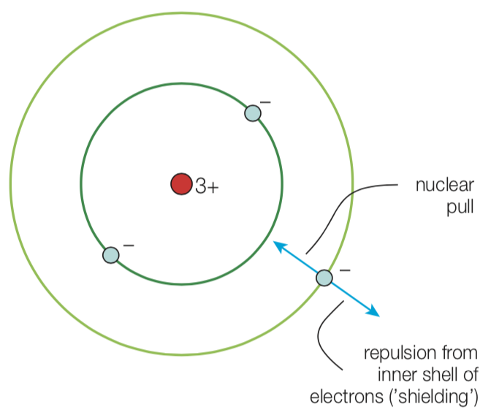
Shielding effect
- Since all electrons are negatively charged, they repel each other
- Electrons in full inner shells repel electrons in outer shells
- The full inner shells of electrons prevent the full nuclear charge being experienced by the outer electrons. This is known as shielding
- The greater the shielding of outer electrons by the inner electron shells, the lower the electrostatic attractive forces between the nucleus and the outer electrons
- The ionization energy is lower as the number of full electron shells between the outer electrons and the nucleus increases
First ionization energy trends
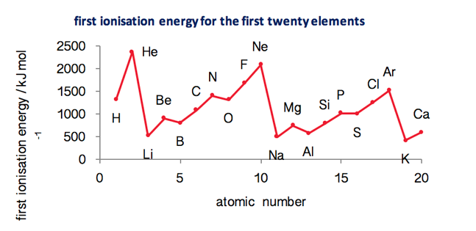
- The general trend is that first ionization energies increase from left to right across a period
- The increase in nuclear charge across a period causes an increase in the attraction between the outer electrons and the nucleus makes the electrons more difficult to remove
- However, 1st IE sometimes drops between elements in periods, (Be to B). This is because Beryllium has the electronic structure 1s² 2s² and the boron atom has the electronic structure 1s² 2s² 2p¹.
- 1st IE will decrease as the electron is being removed from the s-orbital in Be whereas for B it is being removed from the p-orbital which has a slightly higher energy and this counteracts the increase in effective nuclear charge
  - The greater the nuclear charge on the atom the harder it is to remove an electron
  - Sub-levels are more stable when they are empty, half-full or full
  - Electrons prefer to be unpaired if possible as pairing of electrons creates repulsion
Successive ionization energies
- Additional evidence of electron configuration in atoms comes from looking at patterns of successive ionization energies
- The second and third ionization energies are described as:
  - ${X^{+}}_{(g)}→X_{(g)}^{2+}+e^{-}$
  - ${X^{2+}}_{(g)}→X_{(g)}^{3+}+e^{-}$
- Successive ionization energies increase for all atoms because as more electrons are removed the remaining electrons experience an increasing effective nuclear charge and are held closer to the nucleus and hence more tightly
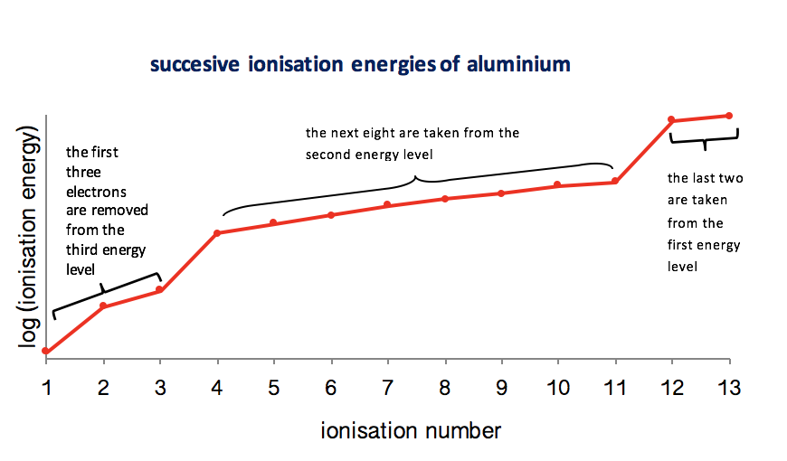
- The large increases (jumps) in ionization energy correspond to a change to a new inner shell, closer to the nucleus, with the electrons held more strongly

Lines of convergence
- The separate lines in a series become closer together as their wavelength decreases (as their frequency and energy increases). At these high energies the lines form a continuum
- The start of the continuum, beyond which separate lines cannot be distinguished is called the convergence limit
- We can use the ionization energy data to determine the wavelength of frequency of convergence
- This can be calculated by:
  - $c=vλ$
  - $E=hv$
- Where:
  - Planck’s constant = $6.63 × {10}^{-34} Js$
  - Speed of light = $3.00 × {10}^{8} {ms}^{-1}$

