Topic 1: Algebra |  |  |  |  |  |  |  |  |  |  |  | Sequences and Series
A sequence is a set of terms which follow a rule (pattern) |  |  |  |  |  |  |  |  |  | $$u_{1},u_{2},u_{3},…,u_{n-1},u_{n}$$
Arithmetic Progression: Terms differ by a common difference, $d$ |  |  |  |  |  |  |  |  |  |  | $$u_{1}+u_{2}+u_{3}+…+u_{n-1}+u_{n}$$
$$d=u_{n}-u_{n-1}$$ |  |  |  | $$c-b=b-a$$ |  |  |  |  |  |  | $$u_{1}=a$$ |  | $$u_{2}=a+d$$ |  |  | $$u_{3}=a+2d$$ |  |  |  |  | $$u_{n}=a+\left(n-1\right)d$$
Sum of arithmetic progression |  |  |  |  |  |  | $$S_{n}=\frac{n}{2}(u_{1}+u_{n})$$ |  |  |  |  |  |  |  | $$S_{n}=\frac{n}{2}(2a+\left(n-1\right)+d)$$
Geometric Progression: Terms differ by a common ratio, $r$ |  |  |  |  |  |  |  |  |  |  |  | $$u_{1}× u_{2}× u_{3}×…× u_{n-1}× u_{n}$$
$$r=\frac{u_{n+1}}{u_{n}}$$ |  | $$\frac{b}{a}=\frac{a}{c}$$ |  |  |  |  | $$u_{1}=a$$ |  |  |  |  | $$u_{2}=ar$$ |  |  | $$u_{3}=ar^{2}$$ |  |  |  | $$u_{n}=ar^{n-1}$$
Sum of geometric progression |  |  |  |  | $$S_{n}=\frac{u_{1}(1-r^{n})}{1-r}$$ |  |  |  |  |  |  | Sum of infinite geometric progression |  |  |  |  |  | $$S_{n}=\frac{u_{1}}{1-r}$$
Topic 1: Algebra |  |  |  |  |  |  |  |  |  |  |  | Exponents and Logarithms
Exponent (Index) Laws: |  |  |  |  |  |  |  |  |  |  |  | Logarithm Laws: $b=a^{x}⟺x=\log_{a}{b}$
$$a^{n}×a^{m}=a^{n+m}$$ |  |  |  |  |  | $$a^{n}÷a^{m}=\frac{a^{n}}{a^{m}}=a^{n-m}$$ |  |  |  |  |  | $$\log_{a}{x+\log_{a}{x=\log_{a}{xy}}}$$ |  |  |  |  | $$\log_{a}{x+\log_{a}{x=\log_{a}{\frac{x}{y}}}}$$
$$a^{\frac{m}{n}}=\sqrt[n]{a^{m}} or {\left(\sqrt[n]{a}\right)}^{m}$$ |  |  |  |  |  | $$a^{1}=a$$ |  | $$a^{0}=1$$ |  |  |  | $$\log_{a}{x^{n}={nlog}_{a}{x}}$$ |  |  |  |  | $$\log_{a}{1=0}$$ |  |  |  |  | $$\log_{a}{a=1}$$
$${\left(a^{x}\right)}^{y}=a^{xy}$$ | $${\left(ab\right)}^{x}=a^{x}b^{x}$$ |  |  |  |  | $$a^{x}=a^{y}$$ |  |  | $$a^{-x}=\frac{1}{a^{x}}$$ |  |  | $$\log_{a}{a^{r}=r}$$ |  | $$a^{\log_{a}{x}}=x$$ |  |  | $$\log_{a}{x=\log_{a}{y}}$$  $$x=y$$ |  |  |  |  | $$\log_{e}{x=\ln{x}}$$
 |  |  |  |  |  | $$x=y$$ |  |  |  |  |  | $$\log_{a}{(0)=undefined}$$ |  |  |  |  |  |  |  |  |  | $$\log{(-x)=0}$$
Graphs of exponential functions and $e^{x}$ |  |  | 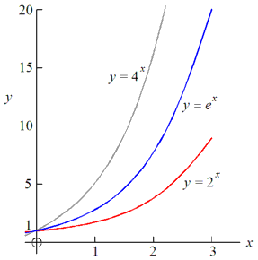 |  |  |  |  |  |  |  |  | Change of Base Formula |  |  |  |  |  |  |  | $$\log_{a}{b=\frac{1}{\log_{b}{a}}}$$
 |  |  |  |  |  |  |  |  |  |  |  | $$x=\frac{\log_{c}{b}}{\log_{c}{a}}=\frac{\ln{b}}{\ln{a}}$$
No stationary points |  |  |  |  |  |  |  |  |  |  |  | Graphs of logarithms
Always positive |  |  |  |  |  |  |  |  |  |  |  | 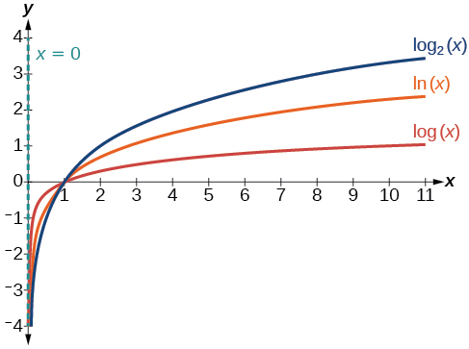
Always increasing
y-axis is HA
No VA
One-to-one

Topic 1: Algebra |  |  |  | Induction
1. Test |  | Let $n=1$ |  |  |  |  | Ensure$LHS=RHS$
2. Assume |  | Assume true for $n=k$ |  |  |  |  | Substitute $k$ for$n$ in statement
3. Prove |  | Let$n=k+1$ |  |  |  |  | Substitute part of $n=k+1$ with$n=k$
4. Explain |  | Since statement is true for $n=k$, then it is also true for $n=k+1$  The proposition is true for$n=1$ and
Topic 1: Algebra |  |  |  | Complex Numbers
There are two types of complex numbers |  |  |  | $$i^{2}=-1$$ |  | $$i^{3}=-i$$ |  |  | $$i^{4}=1$$ |  | $$i^{5}=i$$
polar form | mod-arg form |  |  | Modulus ($r$): The distance from the origin |  |  |  |  | $$r=\left|z\right|=\sqrt{a^{2}+b^{2}}$$
$$z=a+bi$$ | $$z=r(cosθ+isinθ)=r(cisθ)$$ |  |  | Argument ($θ$): the angle is subtended from the real axis |  |  |  |  | $$θ=\tan^{-1}{\frac{b}{a}}$$
Topic 1: Algebra |  |  |  | Permutations and Combinations
$×:$AND |  |  | $+ :$ OR |  |  |  |  | $- :$EXCLUDING
Permutations (pick):  To pick $r$ objects out of $n$ distinct objects is: |  | $${{}_{ }^{n}P}_{r}^{ }=\frac{n!}{\left(n-r\right)!}$$ |  | Combinations (choose):  To choose $r$ objects out of $n$ distinct objects (order not important) is: |  |  |  |  | $${{}_{ }^{n}C}_{r}^{ }=\frac{n!}{r!\left(n-r\right)!}=\left({n \atop r}\right)$$
Topic 1: Algebra |  |  |  | Sum and Product of Roots
Formula of Quadratic:$x^{2}-\left(α+β\right)x+αβ$ or $x^{2}-S_{N}x+P_{N}$
For a quadratic equation: |  | $$S_{N}=α+β=-\frac{b}{a}$$ |  | For a polynomial: | $$S_{N}=α+β=-\frac{a_{n-1}}{a_{n}}=-\frac{second}{first}$$
 |  | $$P_{N}=αβ=\frac{c}{a}$$ |  |  | $$P_{N}=αβ=\frac{{(-1)}^{n}a_{n}}{a_{n}}=\frac{last}{first}$$ |  |  |  |  | Odd number: Negative  Even number: Positive

