Topic 9: Redox processes
9.1 | Oxidation and reduction
9.1.1 | Oxidation and reduction can be considered in terms of oxygen gain/hydrogen loss, electron transfer or change in oxidation number
9.1.2 | An oxidizing agent is reduced and a reducing agent is oxidized
9.1.3 | Variable oxidation numbers exist for transition metals and for most main-group non-metals
9.1.4 | The activity series rank metals according to the ease with which they undergo oxidation
9.1.5 | The Winkler Method can be used to measure biochemical oxygen demand (BOD), used as a measure of the degree of pollution in a water sample
9.1.6 | Deduction of the oxidation states of an atom in an ion or a compound
9.1.7 | Deduction of the name of a transition metal compound from a given formula, applying oxidation numbers represented by Roman numerals
9.1.8 | Identification of the species oxidized and reduced and the oxidizing and reducing agents, in redox reactions
9.1.9 | Deduction of redox reactions using half-equations in acidic or neutral solutions
9.1.10 | Deduction of the feasibility of a redox reaction from the activity series or reaction data
9.1.11 | Solution of a range of redox titration problems
9.1.12 | Application of the Winkler Method to calculate BOD
Oxidation | Reduction
Loss of electrons | Gain of electrons
Loss of hydrogen | Gain of hydrogen
Gain of hydrogen | Loss of oxygen
Oxidation and Reduction
- In oxidation and reduction reactions (also called redox reactions), electrons move between atoms
- Oxidation involves the loss of electrons. The more a substance is oxidized, the more positive it gets
- Reduction involves the gain of electrons. The more a substance is reduced the more negative it gets
- Remember: OIL RIG (Oxidation is loss, reduction is gain)
Oxidant and reductant
Definitions
Oxidant – A substance that readily oxidizes other substances
Reductant – A substance that readily reduces other substances

Oxidizing agent | Reducing agent
Gains electrons | Loses electrons
Oxidizes another reactant | Reduces another reactant
Is reduced during the reaction | Is oxidized during the reaction
- An oxidizing agent makes oxidation happen. In order to make oxidation happen, the agent must take the electron from the substance
- So, oxidizing agents are reduced
- Common oxidizing agents include halogens, ozone, maganate (VII) ions and hydrogen peroxide
- A reducing agent makes reduction happen. In order to make reduction happen, the agent must give an electron to the substance
- So, reducing agents are oxidized
- Common reducing agents include hydrogen, carbon, carbon monoxide and sulfur dioxide
Oxidation state
- The oxidation state (also known as oxidation number) is the total number of electrons that an atom either gains or loses to form a chemical bond with another atom
- Oxidation numbers are represented by a roman number. Example: Cu₂O: Copper (I) oxide, FeCl₂: Iron (II) chloride
- Oxidation states can be used to identify which species have been oxidized and which have been reduced
  - An increase in oxidation number means oxidation (so reducing agent) (Loss of electrons, becomes more positive)
  - A decrease in oxidation number means reduction (so oxidizing agent) (Gain of electrons, becomes more negative)
- Oxidation states are written as NUMBER and then SIGN
- To assign oxidation states to atoms in a molecule or compound we follow some very specific rules:
Sum of oxidation state for a neutral compound: 0 | Sum of oxidation state for a polyatomic ion: Ion charge
Element by itself: 0 | Group 1/2/3: Always +1/+2/+3
Monatomic ion: Ion charge | D-Block elements have variable oxidation states
Halogens: Usually -1 (+1 with oxygen) | Hydrogen: +1 (-1 with metals)
Oxygen: -2 (-1 in peroxide) | Florine: Always -1

Question: Deduce the oxidation state of Cr in K₂Cr₂O₇
$K:+1 \left(2×+1\right)=+2$ $O:-2 \left(7×-2\right)=-14$
No charge on compound so equals 0: $+2-14+2x=0=+6$
Therefore $Cr:+6$
Redox Half Equations
- In a redox reaction, one substance always becomes reduced while the other one oxidized
- To balance redox equations, we write out the half-equations for the oxidation and reduction reactions
- Redox reactions can take place in neutral, acidic or basic solutions
  - In acidic solutions, follow the steps below
  - In neutral solution, balance the reaction as if it were in acidic solution
  - In basic solution, instead of adding H⁺ ions add OH⁻ ions
- In order to write a balanced redox reaction we must: write the two half equations first and then add them together to get an overall equation (OHe)
- Write the unbalanced redox equation
- Separate the reaction into its two half equations (Identify species that is reduced and that is being oxidized)
- Balance all atoms other than O and H
- Balance the O atoms by adding water (on the opposite side)
- Balance the H atoms by adding H⁺ ions
- Balance the charges on both sides of the equation by adding electrons to the more positive sides
Question: Write the redox half equations for the following reaction
$$Mn{O_{4}}^{-}+{Fe}^{2+}→{Mn}^{2+}+{Fe}^{3+}$$
- Equation 1: $Mn{O_{4}}^{-}→{Mn}^{2+}$ Equation 2: ${Fe}^{2+}→{Fe}^{3+}$
- Balanced; Equation 1: $Mn{O_{4}}^{-}→{Mn}^{2+}$ Equation 2: ${Fe}^{2+}→{Fe}^{3+}$
- O; Equation 1: $Mn{O_{4}}^{-}→{Mn}^{2+}+4H_{2}O$ Equation 2: ${Fe}^{2+}→{Fe}^{3+}$
- H; Equation 1: $Mn{O_{4}}^{-}+8H^{+}→{Mn}^{2+}+{4H}_{2}O$ Equation 2: ${Fe}^{2+}→{Fe}^{3+}$
- e⁻: Equation 1: $5e^{-}+Mn{O_{4}}^{-}+8H^{+}→{Mn}^{2+}+{4H}_{2}O$ Equation 2: ${(Fe}^{2+}→{Fe}^{3+}+e^{-})×5$
- $Mn{O_{4}}^{-}+5{Fe}^{2+}+2H^{+}→{Mn}^{2+}+5{Fe}^{3+}+H_{2}O$
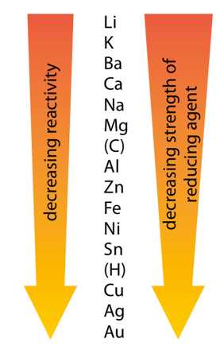
The activity series
- The activities series is a chart of metals listed in order of declining relative reactivity and their strength as reducing agents
  - Metals at the top of the activity series are more reactive and stronger reducing agents (more readily oxidized)
  - Metals at the bottom of the activity series are less reactive and weaker reducing agents (less readily oxidized)
- It is used to determine the products of single displacement reactions. The greater the difference in reactivity of two metals, the more rapidly the reaction would occur. However, the metal acting as the reducing agent must occur higher in the reactivity series that the one being reduced.
- A metal can only displace another in a compound if it is higher in the activity series (more reactive)
- Almost always the most reactive non-metal ends up as an ion. For instance, since Fe is higher in the activity series it ends up as ${Fe}^{2+}$
$${Fe+Pb}^{2+}→{Fe}^{2+}+Pb$$
- The activity series can also be used to determine whether a reaction will occur or not as more reactive elements will replace less reactive elements in a compound.
Redox titration
- Redox titration: Titration of a reducing agent by an oxidizing agent or titration of an oxidizing agent by a reducing agent
- Redox titration is used to determine the concentration of an analyte containing either an oxidizing or a reducing agent
- This analytical technique can be used to find the amount of iron in a sample
- In redox titration Fe²⁺ is oxidized to Fe³⁺ by an oxidizing agent:
$${Fe}^{2+}→{Fe}^{3+}+e^{-}$$
The oxidizing agent is usually acidified potassium manganate (VII) or potassium dichromate (VI)
- Steps of redox titration:
- Calculate the amount, in moles, of MnO₄⁻ (or other oxidizing agents) required to react with the Fe²⁺, using $n=CV$
- Use the molar ratio to determine the amount (in mol) of Fe²⁺ ions in the solution
- Calculate the mass of iron in the tablet using the equation $m=nM$
- Calculate the percentage by mass of iron in the tablet
The Winkler Method
- Biochemical oxygen demand: The amount of oxygen used by the aerobic microorganisms in water to decompose the organic matter in water over a fixed period of time
- This is because high levels of oxygen can mean low levels of pollution as there will be more aerobic microorganisms respiring
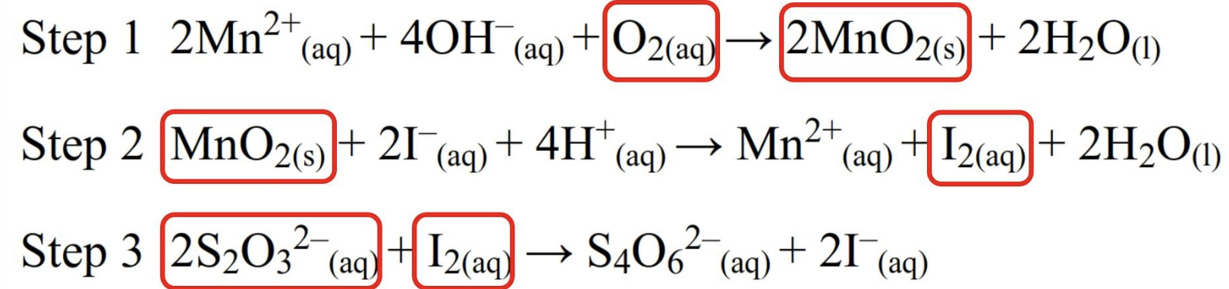
- The Winkler method is used to measure the concentration of dissolved oxygen in a sample of water
- The equations involved are:

- Just remember ratio of O₂ to S₂O₃²⁻ is 1:4 as one mole of O₂ reacts with 4 mols of S₂O₃²⁻

9.2 | Electrochemical cells
9.2.1 | Voltaic cells convert energy from spontaneous, exothermic chemical processes to electrical energy
9.2.2 | Oxidation occurs at the anode (negative electrode) and reduction occurs at the cathode (positive electrode) in a voltaic cell
9.2.3 | Electrolytic cells convert electrical energy to chemical energy, by bringing about non-spontaneous processes
9.2.4 | Oxidation occurs at the anode (positive electrode) and reduction occurs at the cathode (negative electrode) in an electrolytic cell
9.2.5 | Construction and annotation of both types of electrochemical cells
9.2.6 | Explanation of how a redox reaction is used to produce electricity in a voltaic cell and how current is conducted in an electrolytic cell
9.2.7 | Distinction between electron and ion flow in both electrochemical cells
9.2.8 | Performance of laboratory experiments involving a typical voltaic cell using two metal-ion half-cells
9.2.9 | Deduction of the products of the electrolysis of a molten salt
Voltaic cells
- Voltaic cells convert energy from spontaneous, exothermic chemical processes to electrical energy
  - i.e. voltaic cells create electricity using a chemical reaction
  - Note these reactions should happen on their own as they are spontaneous
- Voltaic cells consist of two half cells. In a half-cell, a metal electrode is placed in an aqueous solution of its ions
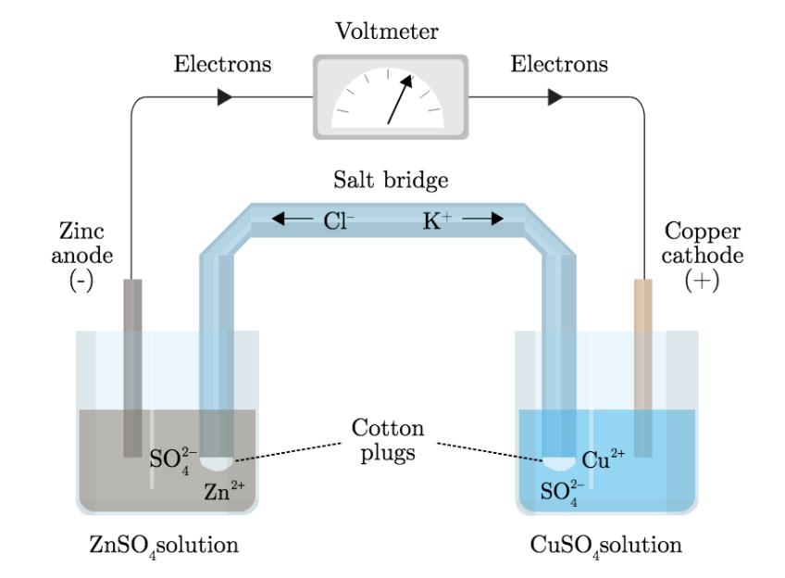
- Two half cells are connected to form a voltaic cell, allowing electrons to flow during the redox reaction and produce electrical energy. The half-cells are joined by a wire to transfer electrons and a salt bridge to transfer ions.
- The Daniel’s cell contains a copper electrode in a copper solution and a zinc electrode in a zinc solution. The reaction can be written as:
$${Cu}^{2+}+Zn→Cu+{Zn}^{2+}$$
- The metal higher in the activity series is oxidized and the metal lower in the activity series is reduced. Therefore:
  - Oxidation occurs at the anode (negative electrode) in a voltaic cell (negative because Zn has a weak pull for electrons, so it loses electrons which makes the solution negative)
  - Reduction occurs at the cathode (positive electrode) in a voltaic cell (positive because Cu has a stronger pull for electrons, so it gains electrons which makes the solution positive)
- Remember: An Ox, Red Cat (Anode Oxidation, Reduction Cathode)
- Current is conducted by electron flow in wires and movement of ions in salt bridge
- Electricity is produced because electrons flow from the oxidized substance, where electrons are being lost, to the reduced substance, where electrons are being gained (as electrons are electricity)
- The salt bridge completes the circuit and neutralizes any buildup of charge by the following ion movement:
  - Anions in the salt bridge move from the anode to the cathode
  - Cations move in the salt bridge move from the cathode to the anode
Cell diagram
- A cell diagram is a shorthand notation to represent the redox reactions of an electrical cell
- For the cell above, the cell diagram is as follows:
$$\left.Zn\left|{Zn}^{2+}\right.\right\|{Cu}^{2+}\left|Cu\right.$$
- A single vertical line is used to separate different states of matter on the same side
- A double vertical line represents a salt bridge between the half-cells
- The anode (where oxidation occurs) is placed on the left side of the ||
- The cathode (where reduction occurs) is placed on the right side of the ||
Electrolytic cells
- Electrolytic cells convert electrical energy to chemical energy, by bringing about non-spontaneous processes. The electrical energy from a battery can force a non-spontaneous reaction to happen
  - The power source should be a battery or a DC power source
  - The electrodes are placed in the electrolyte, connected to the power source by electrical wires
  - The electrodes cannot touch each other.
- The electrical energy supplied by the power source induces a flow of electrons from the anode to the cathode
- However, unlike in voltaic cells, the power source causes the polarity of the electrodes to change
  - The positive pole of the external power source makes the anode of the electrolytic cell positive
  - Now the anode is the positive electrode and the cathode is the negative electrode
- When the current reaches the electrolyte, the electrical energy is carried by ions, which migrate to the electrodes. The redox reactions taking place at the electrodes take the ions of out solution and allow it to continue
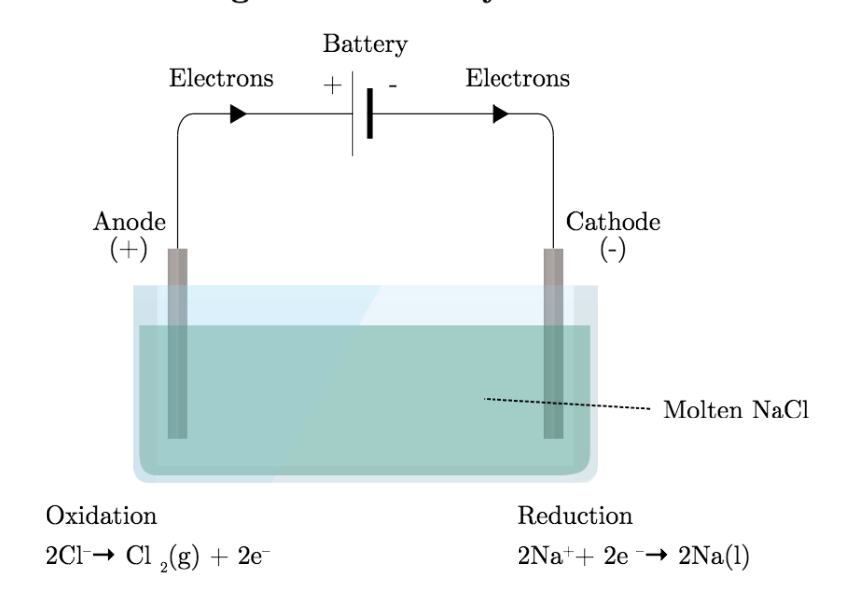

- Unlike voltaic cells, the electrodes must be made from an inert, heat resistant material like graphite or platnium
- The flow of energy in an electrolytic cell has two forms. From the anode to the cathode, the electrons pass along a conductive wire in the form of electrical energy. Therefore, the current is conducted by the movement of electrons in the external part of the circuit
- However, electrical energy cannot move through the electrolyte, so the current moves in a different form. At the cathode, electrons are accepted by the positive ions. The flow of current in the electrolyte is facilitated by ions, or chemical energy- the positive ions flow towards the cathode and the negative ions flow towards the anode
- In the electrolysis of molten sodium chloride, sodium metal and chlorine gas are formed
- In order to find the products of the electrolysis of a molten salt:
- Write down what chemicals are being used
- Create two half equations of each chemical
- Determine towards which electrode the different ions will flow. The cations are attracted to the cathode and the anions are attracted to the anode
- Combine the two half reactions and check that the complete reaction is balanced
Voltaic Cell vs Electrolytic Cell
Voltaic cell | Electrolytic cell
Chemical energy is converted to electrical energy | Electrical energy is converted to chemical energy
Reaction is exothermic | Reaction is endothermic
A spontaneous reaction produces an electric current | An electric current drives a non-spontaneous reaction
Current is conducted by electron flow in wires and movement of ions in salt bridge | Current is conducted by electron flow in wires and movement of ions in electrolyte
Anode is negative  Cathode is positive | Anode is positive  Cathode is negative

19.1 | Electrochemical cells
9.1.1 | A voltaic cell generates an electromotive force (EMF) resulting in the movement of electrons from the anode (negative electrode) to the cathode (positive electrode) via the external circuit. The EMF is termed the cell potential ($E°$)
9.1.2 | The standard hydrogen electrode (SHE) consists of an inert platinum electrode in contact with 1 mol dm⁻³ hydrogen ion and hydrogen gas at 100kPa and 298K. The standard electrode potential ($E°$) is the potential (voltage) of the reduction half-equation under standard conditions measured relative to the SHE. Solute concentration is 1 mol dm⁻³ or 100 kPa for gases. $E°$ of the SHE is 0V
9.1.3 | When aqueous solutions are electrolyzed, water can be oxidized to oxygen at the anode and reduced to hydrogen at the cathode
9.1.4 | $∆G°=-nFE°$. When $E°$ is positive,$∆G°$ is negative indicative of a spontaneous process. When $E°$ is negative, $∆G°$is positive indicative of a non-spontaneous process. When $E°$ is 0, then $∆G°$ is 0
9.1.5 | Current, duration of electrolysis and charge on the ion affect the amount of product formed at the electrodes during electrolysis
9.1.6 | Electroplating involves the electrolytic coating of an object with a metallic thin layer
9.1.7 | Calculation of cell potentials using standard electrode potentials
9.1.8 | Prediction of whether a reaction is spontaneous or not using $E°$ values
9.1.9 | Determination of standard free-energy changes ($∆G°$) using standard electrode potentials
9.1.10 | Explanation of the products formed during the electrolysis of aqueous solutions
9.1.11 | Perform lab experiments that could include single replacement reactions in aqueous solutions
9.1.12 | Determination of the relative amounts of product formed during electrolytic processes
9.1.13 | Explanation of the process of electroplating
Standard electrode potential
- The direction electrons move between the anode and cathode are determined by the difference in potential energy. Electrons will more from areas of higher potential energy to areas of lower potential energy
- In a voltaic cell the potential difference is called the cell potential (also sometimes called EMF: electromotive force)
- This is denoted as:$E_{cell}$
- The cell potential is different for each voltaic cell, as its value depends on the concentration of the reactants and products along with the temperature and pressure
- For standard cell potential, the temperature of the reaction is assumed to be 25°C, the concentration of the reactants and products is 1M, and reaction occurs at 1atm pressure
- The standard cell potential is denoted ${E^{θ}}_{cell}$ and can be written as oxidation potential + reduction potential. For voltaic cell:
$${E^{θ}}_{cell}={E^{θ}}_{reduction}±{E^{θ}}_{oxidation}$$
- The $E^{θ}$ values are intensive quantities, therefore they are not multiplied by the coefficients of the equation
- If $E_{cell}$ is negative then reaction is non-spontaneous and will not happen in a voltaic cell
Question: Calculate E°cell for the following redox reaction under standard conditions
$$2Al+3{Sn}^{2+}→2{Al}^{3+}+3Sn$$
First, calculate ${E^{θ}}_{reduction}$ and ${E^{θ}}_{oxidation}$ (remember to take out common coefficients)
Oxidation: $2\left(Al→{Al}^{3+}\right)$ ${{- E}^{θ}}_{oxidation}={E^{θ}}_{reduction}=+1.66V$
Reduction: $3\left({Sn}^{2+}→Sn\right)$ ${E^{θ}}_{reduction}=-0.137V$
Therefore, ${E^{θ}}_{cell}={E^{θ}}_{reduction}-{E^{θ}}_{oxidation}=-0.137V+(+1.66V)$

Cell potential and Gibbs free energy
- For a spontaneous reaction, ${E^{θ}}_{cell}$ must be positive and ${∆G}^{θ}$ must be negative
- However, when ${E^{θ}}_{cell}$ is negative and ${∆G}^{θ}$ is positive the reaction will be non-spontaneous, and the reverse reaction is spontaneous
- If the reaction is non-spontaneous then a voltaic cell will not work with those metals
$$E^{θ}$$ | $${∆G}^{θ}$$ | Spontaneity
positive | negative | spontaneous reaction
negative | positive | non-spontaneous reaction
zero | zero | reaction is at equilibrium

- Merging electrochemistry with thermodynamics gives this formula:
$${{∆G}^{θ}}_{cell}=-nF{E^{θ}}_{cell}$$
n=moles of electrons transferred in the reaction
F= Faraday constant (96500 C mol⁻¹)
Standard hydrogen electrode (SHE)
- The SHE is a hydrogen half-cell comprising a solution of ﻿﻿1 mol dm^{–3} H⁺ ions at 298 K, hydrogen gas at 100 kPa and 298 K and a platinum electrode. It is linked to a second half-cell through an external circuit. The reaction occurring is:
  - The standard hydrogen electrode is used as a reference to measure the electrode potential of other half-cells
- The value of the standard electrode potential ($E^{θ}$) is zero, which forms the bases one needs to calculate cell potentials using different electrodes or different concentrations
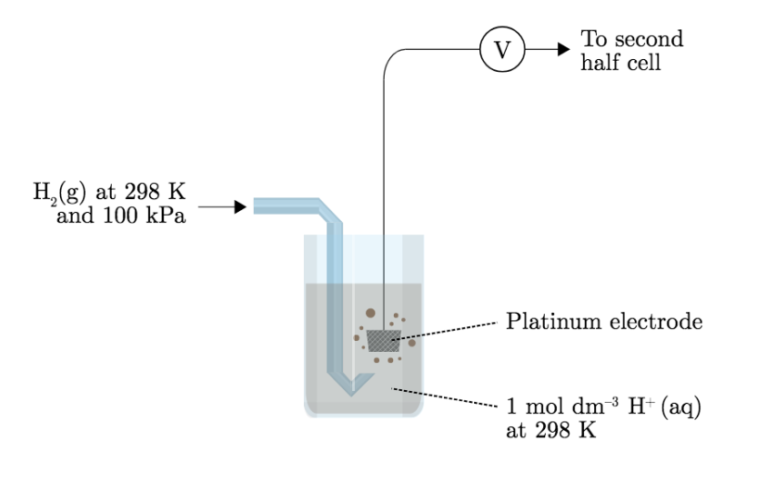
- The standard hydrogen electrode is set up as:
  - A wire attached to a piece of platinum (or covered in platinum)
  - The wire is immersed in a 1.0M strong acid solution (Generally HCL)
  - A glass tube around the wire (electrode)
  - H₂ gas is bubbled in at a pressure of one atmosphere and a temperature of 25°C through the glass tube into the solution
  - This gives 0.0V
  - However, when the SHE is attached to another half-cell this will give the ${E^{θ}}_{cell}$ of the other half cell
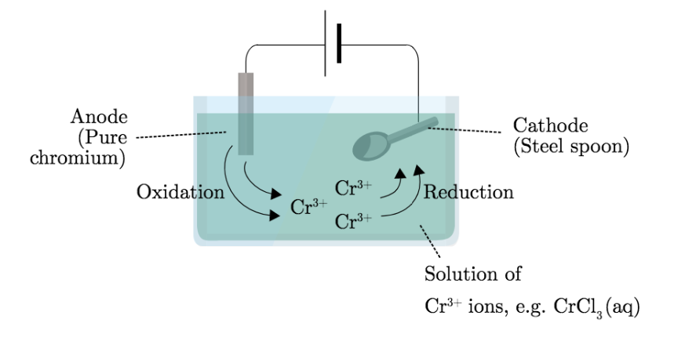
Electroplating
- Electroplating involves the electrolytic coating of an object with a thin metallic layer
- The purpose of electroplating includes:
  - Appearance
  - Protection
- The electroplating process:
  - Both an anode and a cathode (the metal to be coated) are immersed in an electrolytic bath that is composed of a solution of salts, including the metal to be plated
  - A direct current of electricity is passed through the solution, effecting the transfer of metal ions onto the cathodic surface, plating the metal onto the item

Electrolysis of Water
- Pure water is a very poor conductor of electricity and cannot undergo significant electrolysis without adding an electrolyte
  - NaOH is added to increase its conductivity
- Factors that affect the amount of product formed at the electrodes during electrolysis are:
  - Time of electrolysis: The longer the electrolysis is performed, the greater the quantity of products formed. This is a directly proportional relationship
  - Current: The higher the current, the greater the quantity of product formed. This is a directly proportional relationship
  - Charge of the ions: The smaller the charge on the ion, the greater the number of moles of product formed. Thi sis an inversely proportional relationship
Products of Electrolysis
- To deduce the products of electrolysis:
  - Write down what chemicals you have in your set up. Normally inert electrodes are used, so the chemicals in question are the cations and anions of the molten salt itself
  - Determine towards which electrode the different ions will flow. The cations are attracted to the negative electrode and will migrate towards it. Likewise, the anions will migrate to the positive electrode (the anode)
  - At the surface of the negative cathode, the positive ions are reduced as they gain electrons from it. Likewise, at the positive anode the anions are oxidized as they lose electrons to the positive surface
  - If it is not directly obvious, use section 24 of the ﻿﻿IB data booklet to find the most powerful half reactions that can take place.
  - Combine the two half reactions and check that the complete reaction is balanced. Note that there must be an equal number of electrons in both half equations.

