Topic 6: Kinetics
6.1 | Collision theory and rates of reactions
6.1.1 | Species react as a result of collisions of sufficient energy and proper orientation
6.1.2 | The rate of reaction is expressed as the change in concentration of a particular reactant/product per unit time
6.1.3 | Concentration changes in a reaction can be followed indirectly by monitoring changes in mass, volume and color
6.1.4 | Activation energy (E_{a}) is the minimum energy that colliding molecules need in order to have successful collisions leading to a reaction
6.1.5 | By decreasing E_{a} a catalyst increases the rate of a chemical reaction, without itself being permanently chemically changed
6.1.6 | Descriptions of the kinetic theory in terms of the movement of particles whose average kinetic energy is proportional to temperature in Kelvin
6.1.7 | Analysis of graphical and numerical data from rate experiments
6.1.8 | Explanation of the effects of temperature, pressure/concentration and particle size on rate of reaction
6.1.9 | Construction of Maxwell-Boltzmann energy distribution curves to account for the probability of successful collisions and factors affecting these, including the effect of a catalyst
6.1.10 | Investigation of rates of reaction experimentally and evaluation of the results
6.1.11 | Sketching and explanation of energy profiles with and without catalysts
Collision Theory
- For a reaction between two particles to occur three conditions must be met
  - The particles must collide
  - They must collide with the appropriate geometry or orientation
  - They must collide with sufficient energy to bring about the reaction
- The minimum amount of energy required is known as the activation energy
Factor | Effect of increasing factor | Explanation
Surface Area  Particle Size | Decreases rate | The greater the particle size, the smaller the exposed surface area. Reactions require collisions for reactions to occur, so if the surface area is smaller, fewer collisions will occur per unit time
Temperature | Increases rate | As the temperature increases, the particles will move faster so there will be more collisions per second. However, the main reason why an increase in temperature increases the rate is that more of the colliding particles will possess the necessary activation energy resulting in more successful collisions. Generally, an increase of 10°C doubles the rate of a chemical reaction
Concentration | Increases rate | Increasing the concentration increases the frequency of collisions which increases the frequency of successful collisions too, thus increasing the rate.
Pressure | Increases rate | Higher pressure compresses the gas, effectively increasing the concentration, so increasing the frequency of collisions and therefore the rate too.
Rate of reaction
- Chemical kinetics is the study of the factors affecting the rate of a chemical reaction
- The rate of a chemical reaction can be defined as the change in concentration of the products/reactants per unit time or Increase/decrease in concentration of product/reacts per unit time

- Concentration changes in a reaction can be indirectly monitored by monitoring :
  - Change in volume of a gas, mass, concentration through titration, gas pressure or electrical conductivity
  - Calorimetry and light absorbance
- The results obtained is usually then plotted in a graph of concentration against time
- The rate at any point in time is the gradient of the graph at that time
- Thus, find the gradient at $t$ by using $Rate of Reaction=\frac{∆concentration}{∆time}$
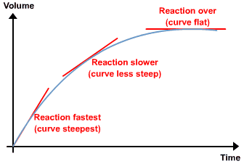

- The rate of reaction (gradient) will generally be the steepest at the start of the curve
  - This is because a high concentration of reactant particles, therefore a high frequency of successful collisions
- The rate of reaction (gradient) decreases over time as time as the concentration of reactant particles decreases, thus the frequency of successful collisions also decreases
- Hence, the rate of reaction can also be defined as:
The Rate of Disappearance of Reactants | The Rate of Formation of Products
$$Rate=-\frac{∆[R]}{∆T}$$  Since Rate of Disappearance of Reactants is decreases over time, the negative sign counteracts this effect | $$Rate=\frac{∆[P]}{∆T}$$  This is the rate of which the products are formed

- Where $∆[R]$ means the change in the concentration of $R$, and $∆[P]$ means the change in the concentration of $P$
- The units for rate of reactions are $mol {dm}^{-3} s^{-1}$
Maxwell-Boltzmann distribution curve
- The Maxwell-Boltzmann curve shows the distribution of kinetic energy for a reaction
- Only a small proportion of particles at a given temperature will have sufficient kinetic energy to overcome its E_{a}
- Activation energy (E_{a}): The minimum amount of energy required for a reaction to occur
- As temperature increases, the area under the curve does not change as the total number of particles remains constant.
- Instead more particles have a very high velocity resulting in an increase in the average kinetic energy which leads to a broadening of the curve, however still has same activation energy
- Adding a catalyst reduces the activation energy, more particles have enough energy to react
  - If a species is both on the reactant and product side of the overall equation, it is probably a catalyst
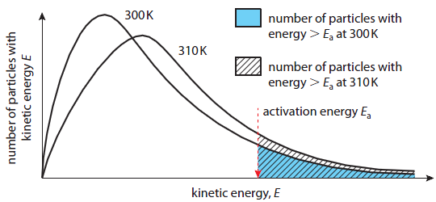
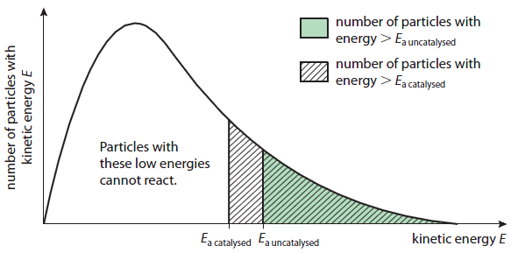

16.1 | Rate expression and reaction mechanism
16.1.1 | Reactions may occur by more than one step and the slowest step determines the rate of reaction
16.1.2 | The molecularity of an elementary step is the number of reactant particles taking part in that step
16.1.3 | The order of a reaction can be either integer or fractional in nature. The order of a reaction can describe, with respect to a reactant, the number of particles taking part in the rate-determining step
16.1.4 | Rate equations can only be determined experimentally
16.1.5 | The value of the rate constant (k) is affected by temperature and its units are determined from the overall order of the reaction
16.1.6 | Catalysts alter a reaction mechanism, introducing a step with lower activation energy
16.1.7 | Deduction of the rate expression for an equation from experimental data and solving problems involving the rate expression
16.1.8 | Sketching, identifying, and analyzing graphical representations for zero, first and second order reactions
16.1.9 | Evaluation of proposed reaction mechanisms to be consistent with kinetic and stoichiometric data
Rate Expression
- The rate of reaction between two reactants, A and B, can be followed experimentally
- The mathematical relationship of reaction rate with reactant concentration can be expressed as a rate expression
For the following hypothetical reaction: $aA+bB→cC$
The Rate Law can be expressed as: $rate=k{[A]}^{x}{[B]}^{y}$
- The proportionality constant, $k$, is known as the rate constant
- The rate constant is different for each reaction and is changed by temperature
- The overall order of a reaction is: $order=x+y$
- For example, take: $rate=k\left[A\right]{\left[B\right]}^{2}.$This reaction is third-order overall, first-order in A, and second order in B
- However, the order of a reaction and the rate expression can only be determined experimentally. They cannot be decuded from the balance equation
- Generally, reaction orders can be classified as zero-order, first-order, second-order and third-order:
Order: | Zero order | First order | Second order | Third order
Description | The rate does not depend on concentration | The rate is directly proportional to concentration  If concentration doubles, rate doubles | The rate is proportional to the square of the concentration  If the concentration doubles, rate quadruples | If the concentration doubles, the rate increases eight times
Rate Expression | Rate = k | Rate = k[A] | Rate = k[A]² or  Rate = k[A][B] | Rate = k[A]³ or  Rate = k[A][B]² or  Rate = k[A][B][C]
Units of Rate | $$=mol {dm}^{-3} s^{-1}$$ | $$=\frac{mol {dm}^{-3} s^{-1}}{mol {dm}^{-3}}$$  $$= s^{-1}$$ | $$=\frac{mol {dm}^{-3} s^{-1}}{{\left(mol {dm}^{-3}\right)}^{2}}$$  $$={mol}^{-1}{dm}^{3}s^{-1}$$ | $$=\frac{mol {dm}^{-3} s^{-1}}{{\left(mol {dm}^{-3}\right)}^{3}}$$  $$={mol}^{-2}{dm}^{6}s^{-1}$$

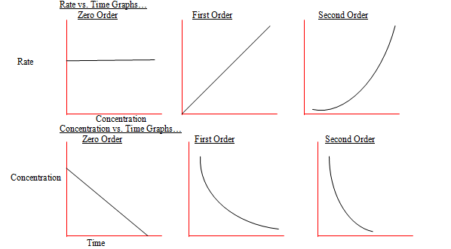
- When graphed, reactions orders will be graphed as:

16.2 | Activation energy
16.2.1 | The Arrhenius equation uses the temperature dependence of the rate constant to determine the activation energy
16.2.2 | A graph of 1/T against ln(k) is a linear plot with gradient –E_{a}/R and intercept, lnA
16.2.3 | The frequency factor (or pre-exponential factor) (A) takes into account the frequency of collisions with proper orientations
16.2.4 | Analyzing graphical representation of the Arrhenius equation in its linear form $lnk=Ae^{\frac{-E_{a}}{RT}}+lnA$
16.2.5 | Using the Arrhenius equation$k=Ae^{\frac{-E_{a}}{RT}}$
16.2.6 | Describing the relationships between temperature and rate constant; frequency factor and complexity of molecules colliding
16.2.7 | Determining and evaluating values of activation energy and frequency factors from data
Reaction Mechanisms
- Many reactions do not go in one step. This is particularly true when there are more than two reactant molecules as the chances of a successful collision between three or more particles is extremely small. Where there is more than one step then each step will proceed at its own rate. No matter how fast the other steps are the overall rate of reaction will depend only upon the rate of the slowest step
- The step with the highest activation energy will act as the rate determining step, which acts as a limit on the rate of reaction
Arrhenius equation
- The rate constant for a reaction is only constant if the temperature remains constant. As the temperature increases the reactants possess more energy and the rate constant increases
- The relationship between rate constant and absolute temperature is given by the Arrhenius equation:
$k=Ae^{-\frac{Ea}{RT}}$
k: rate constant/A: Arrhenius constant/E_{a}: Activation energy/R: Gas constant/T: Temperature
- A graph of the Arrhenius equation allows us to calculate the activation energy of a reaction. We used the integrated version of the equation to simply the graph into a linear expression ($y=mx+c$)
$$lnk=-\frac{E_{a}}{R}\frac{1}{T}+lnA$$
- The equation can be used to determine both the frequency factor and the activation energy for a reaction

