Topic 4: Bonding
4.1 | Ionic bonding and structure
4.1.1 | Positive ions (cations) form by metals losing valence electrons
4.1.2 | Negative ions (anions) form by non-metals gaining electrons
4.1.3 | The number of electrons lost or gained is determined by the electron configuration of the atom
4.1.4 | The ionic bond is due to electrostatic attraction between oppositely charged ions
4.1.5 | Under normal conditions, ionic compounds are usually solids with lattice structures
4.1.6 | Deduction of the formula and name of an ionic compound from its component ions, including polyatomic ions
4.1.7 | Explanation of the physical properties of ionic compounds (volatility, electrical conductivity and solubility) in terms of their structure
Ions
- Atoms have a neutral charge as their negative electrons and positive protons balance out
- However, ions are formed when atoms gain or lose electrons
- The charge is changed by adding or removing electrons from an atom
- Cations are atoms that lose electrons and therefore have a positive net charge
- Therefore, positive ions are called cations
- Anions are atoms that gain electrons and therefore have a negative net charge
- Therefore, negative ions are called anions
Ionic Bonding
- Ionic bonds form as a result of the electrostatic attraction between oppositely charged ions
  - An electrostatic attraction is the attraction of oppositely charged of particles/objects
- This bond only occurs between metals and non-metals
- The metal will have a positive charge, while the non-metal will have a negative charge
- The opposite charges create an electrostatic attraction between the ions, causing them to form a neutral lattice
- The charge of the ions will cancel each other out
Formation of an ionic compound
- When metals react with non-metals electrons are transferred from the metal to the non-metal forming an ion
- Ionic compounds are balanced as the negative and positive charges balance each other out
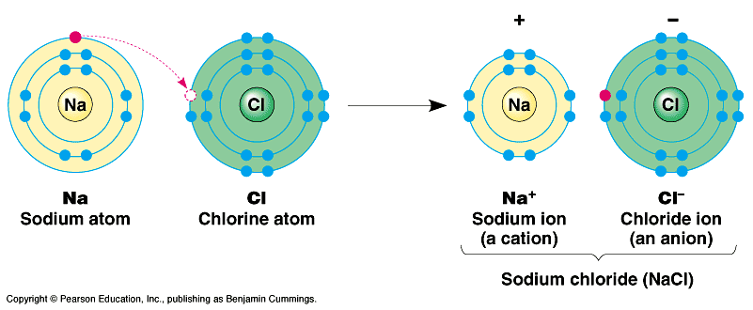
- The formation of an ionic compound can be represented using electron shell diagrams
- Example: When sodium and chlorine react together to form sodium chloride the electron that a sodium atom loses to form a stable sodium ion is gained by a chlorine atom to for a stable chlorine ion
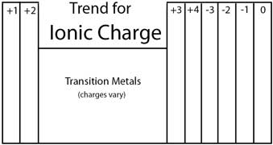
Chemical Charge
- Remember, noble gas configuration is the most stable so most elements will try to reach it by either losing or gaining electrons
- To find the ionic charge of an element the periodic table can be used:
- Group 1, 2, 3 elements form ions with charges of 1+, 2+ and 3+ respectively
- Group 15, 16, 17 elements form ions with charges of 3-, 2-, 1- respectively
- Elements in group 14 can lose 4 electrons but can also gain 4 electrons

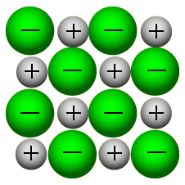
Physical Properties of Ionic Compounds
- The electrostatic force of attraction between oppositely charged ions arrange in a 3D structure called a lattice
- This is possible because the ions are held together by their opposite charges, and each ion will be surrounded by 6 other different ions
- For the most stable arrangement positively charged ions are packed as closely as possible to the negative charged ions, while ions of the same charge are as far apart as possible. This maximizes electrostatic attraction between the ions, while minimizing repulsion
- Under normal conditions, ionic compounds are usually solids with lattice structures
- The lattice structure of an ionic compound can be used to explain their physical properties
Volatility
- Volatility: The tendency of a substance to vaporize
- Ionic compounds have ionic bonds which are very strong meaning that a lot of energy is needed to break its bonds. Thus at room temperature there isn’t enough energy to break the lattice.
- Example: If you leave salt in a room for 100 years it will be the same, it won’t turn into a gas because it’s non-volatile
- Therefore ionic compounds can be described as having a low volatility or being non-volatile
High melting temperatures
- As mentioned before ionic bonds are very strong and a lot of energy is needed to break its bond
- Hence ionic compounds have high melting temperatures
- Therefore Ionic compounds are solid at room temperature
- Melting point: Solid -> Liquid
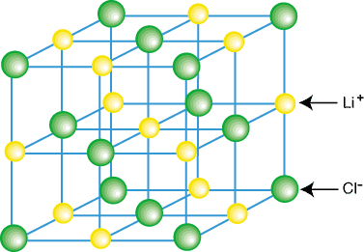
- Boiling point: Liquid -> Gas
Electric conductivity
- When ionic compounds are solid the ions are not free to move as there are held in fixed positions so the ionic compound cannot conduct electricity when solid
- When ionic compounds melt however, the ions are free to move as they are no longer held in the crystal, therefore melted ionic compounds can conduct electricity
Solubility
- Water is a covalent polar compound (has positive and negative poles) therefore can break molecules off the lattice structure
- Therefore, the ions from the lattice structure can be separated by polar water molecules
- So, ionic compounds are soluble in polar solvents
- However not all ionic compounds are soluble
4.2 | Covalent bonding
4.2.1 | A covalent bond is formed by the electrostatic attraction between a shared pair of electrons and the positively charged nuclei
4.2.2 | Single, double and triple covalent bonds involve one, two and three shared pairs of electrons respectively
4.2.3 | Bond length decreases and bond strength increases as the number of shared electrons increases
4.2.4 | Bond polarity results from the difference in electronegativities of the bonded atoms
4.2.5 | Deduction of the polar nature of a covalent bond from electronegativity values

Covalent bonds
- A covalent bond is formed by the electrostatic attraction between a shared pair of electrons and the positively charged nuclei. This type of bonding occurs between two atoms of the same elements or close elements on the periodic table.
- Covalent bonds generally occur between non-metals only
- If atoms have similar electronegativities (the same affinity for electrons), they are likely to form a covalent bond
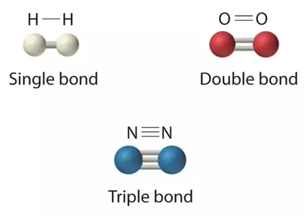
- This is because both atoms have the same affinity for electrons and neither has a tendency to donate them, therefore they must share electrons in order to achieve octet configuration and become more stable
Double/Triple Covalent Bond
- A double covalent bond is formed when two atoms shared 2 electron pairs (4 electrons)
- A triple covalent bond is formed when two atoms share 3 electron pairs (6 electrons)
Bond Length/Strength
- Bond length: A measure of the distance between the two bonded nuclei
- Bond strength: A measure of the energy required to break the bond. Described in terms of bond enthalpy
- Bond length decreases as the number of electron pair increases because there will be a greater attractive force between the two nuclei
- Bond strength increases as the number of electron pair increases as more energy is required to break them
Non-polar covalent bond
- When electronegativities are not equal, electrons are not shared equally and a partial ionic charge develops
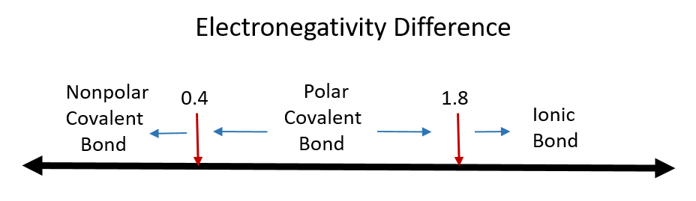
- To find the most ionic bond compare the electronegative differences of each bond against the Pauling Scale
- The greater the electronegative difference the more ionic the bond is
- Bonds that are partially ionic are called polar covalent bonds, this also means the most polar bonds with have the highest electronegative value
- Non-polar covalent bonds have equal sharing of bond electrons
4.3 | Covalent structures
4.3.1 | Lewis (electron dot) structures show all the valence electrons in a covalently bonded species
4.3.2 | The “octet rule” refers to the tendency of atoms to gain a valence shell with a total of 8 electrons
4.3.3 | Some atoms, like Be and B, might form stable compounds with incomplete octets of electrons
4.3.4 | Resonance structures occur when there is more than one possible position for a double bond in a molecule
4.3.5 | Shapes of species are determined by the repulsion of electron pairs according to VSEPR theory
4.3.6 | Carbon and silicon form giant covalent/network covalent structures
4.3.7 | Explanation of the physical properties of ionic compounds (volatility, electrical conductivity and solubility) in terms of their structure
4.3.8 | Deduction of Lewis (electron dot) structure of molecules and ions showing all valence electrons for up to four electron pairs on each atom
4.3.9 | The use of VSEPR theory to predict the electron domain geometry and the molecular geometry for species with two, three and four electron domains
4.3.10 | Prediction of bond angles from molecular geometry and presence of non-bonding pairs of electrons
4.3.11 | Prediction of molecular polarity from bond polarity and molecular geometry
4.3.12 | Deduction of resonance structures, examples include but are not limited to C₆H₆, CO₃²⁻ and O₃
4.3.13 | Explanation of the properties of giant covalent compounds in terms of their structures

Covalent Compounds
- A covalent compound is formed when two or more non-metal atoms bond by sharing valence electrons
  - Non-metals are types of elements that lack metallic characteristics
- This bonding occurs primarily between non-metals however it can also be observed between non-metals and metals
- The number of covalent bonds that will form depends directly on the number of electrons it needs to fill its valence shell
- The “octet rule” refers to the tendency of atoms to gain a valence shell with a total of 8 electrons
- Electron shell diagrams, known as Lewis or electron dot structures, can be constructed for covalently bonded molecules
- All valence electrons are drawn, as these are the electrons that can take part in bonding
Lewis Structure
- Lewis Structure: A diagram of molecules or other covalent species in which the outer shell (valence) electrons of the atom are represented dots or crosses and the sharing of electrons to form a covalent bond is shown. To draw Lewis Diagrams:
- Count all the valence electrons
- Determine the central atom (the least electron negative which is the furthest away from Florine)
- Draw single bonds to the central atom
- Put all remaining valence electrons on atoms as lone pairs
- Turn lone pairs into double or triple bonds to give every atom an octet
See resonance structure in 14.1
- Boron and beryllium are exceptions to the octet rule
- Atoms of elements in period 3 and below may expand their octet by using d-orbital’s in their valence shell
Electron domain
- Electron domain: Describes the number of electrons in the valence shell. They may be occupied by lone pairs, single, double or triple bonds
- Molecular geometry: Explains the 3D shape of a molecule. That is the position of the electrons in the outer shell where they experience the maximum repulsion
- The number of electron domains determines the shape of the covalent molecule each covalent molecule shape is a result of electron repulsion. Each pair of electrons will be repelled from others as far as possible in three dimensions as each negative charge center carrier a negative charge
- Electron repulsion decreases in the following order:
lone pair – lone pair > lone pair – bonding pair > bonding pair – bonding pair
- The arrangement of atoms in space is the molecular geometry
VSEPR Diagram
- We can predict molecular geometry using the VSEPR model (Exceptions to VSEPR in 14.1)
- Sketch the Lewis structure of the ion or molecule
- Find the number of bonding pairs and non-bonding pairs surrounding the central molecule (double bonds and triple bonds count as a bonding pair)
- Use the table below to calculate the shape
- Some are some important exceptions to the octet rule
- Two conditions must apply if a molecule is to be a dipole (polar)
  - It must have polar bonds
  - The partial charges must be distributed asymmetrically across the molecule (the molecule must not be symmetrical)
- A molecule that contains polar covalent bonds will form a dipole
- A polar molecule must have dipoles distributed so overall there is a positive and negative end of the molecule

Electron domains |  | Geometric Arrangement | Bonding pairs | Lone pairs | angle
2 |  | linear | 2 | 0 | 180°
3 | trigonal planar |  | 3 | 0 | 120° | 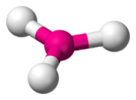
 | Bent |  | 2 | 1 | <120° | 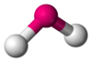
4 |  | tetrahedral | 4 | 0 | 109.5° | 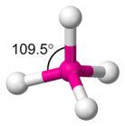
 |  | Trigonal pyramidal | 3 | 1 | <109.5° | 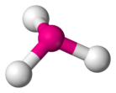
 |  | Bent | 2 | 2 | <109.5°
5 |  | trigonal bipyramid | 5 | 0 | trigonal bipyramid  90°  120° | 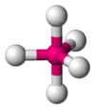
 |  |  | 4 | 1 | see saw  90°  < 120° | 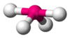
 |  |  | 3 | 2 | T-shaped  90° | 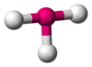
6 |  | octahedral  90° | 6 | 0 | 90° | 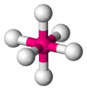
 |  | square pyramidal  90° | 5 | 1 | 90° | 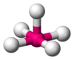
 |  | square planar  90° | 4 | 2 | 90° | 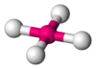
Covalent structures
- Covalent compounds have two types of structures: simple covalent and giant covalent (network covalent) structures
Simple covalent structures
- These contain only a few atoms held together by strong covalent bonds such as carbon dioxide where one atom of carbon is covalently bonded with two atoms or oxygen
- Molecular covalent substances have low boiling points and are usually liquids and gases, due to the weak intermolecular forces (not intramolecular)
- These structures are also non-conductive. This is because they do not have any free electrons or an overall electric charge
Giant covalent structures
- Giant covalent structures contain a lot of non-metal atoms, each joined to adjacent atoms by covalent bonds
- Example: Silicon and carbon form giant covalent structures
- The atoms are usually arranged into giant regular lattices, which are extremely strong structures because of the many bonds involved (such as graphite or diamond)
- Giant covalent structures have very high melting points because a lot of strong covalent bonds must be broken
- Giant covalent structures also vary in conductivity, as some contain free electrons while some do not
Allotropes of carbon
- Carbon can be found in three forms. All of these forms contain carbon only but vary in their structure
- They are called allotropes of carbon
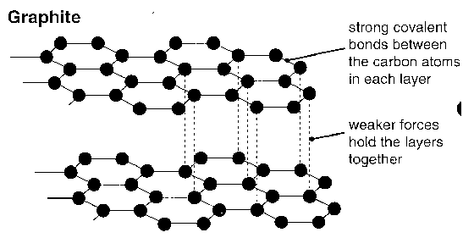
Graphite
- Graphite has a hexagonal layer structure, and although it has covalent bonds between the carbon atoms, it has weak Van Der Waals forces between the layers themselves, allowing the bonds to be shattered easily and the layers to slide over each other easily
  - The covalent bonds within the layers are very strong
  - The dispersion forces between the layers are weak
- The structure of graphite is described as a covalent layer lattice
- Graphite has good conductivity as there are delocalized electrons between the hexagonal layers and electrons are free to move parallel
Diamond
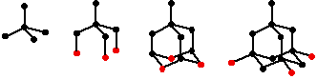
- In diamond, each carbon atom is joined to four other carbon atoms, forming a giant covalent structure
- Diamond has a tetrahedral structure held together with strong covalent bonds
- There are no weak links to these lattices
- As a result, diamond is very hard and has a high melting point
- Diamond has bad conductivity as there are no delocalized electrons as the outer shell electrons are used for covalent bonds
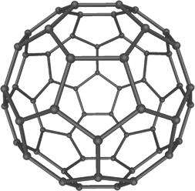
C₆₀ Fullerenes
- 60 carbon atoms form a sphere in which each atom is covalently bonded to three others
- Fullerene is a semiconductor that is very strong and light. It is used in the medical field for the transportation of medicines in the body.
- Structure: Spheres made of atoms arranged in hexagons (not a lattice)
Silicon
- Silicon is a member of group four of the periodic table and so is able to form 4 covalent bonds with other silicone atoms to form network covalent structure
4.4 | Intermolecular forces
4.4.1 | Intermolecular forces include London (dispersion) forces, dipole-dipole forces and hydrogen bonding
4.4.2 | The relative strengths of these interactions are London (dispersion) forces < dipole-dipole forces < hydrogen bonds
4.4.3 | Deduction of the types of intermolecular force present in substances, based on their structure and chemical formula
4.4.4 | Explanation of the physical properties of covalent compounds (volatility, electrical conductivity and solubility) in terms of their structure and intermolecular forces
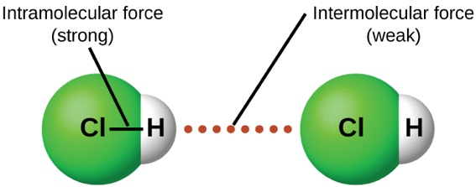
Intermolecular forces
- Intermolecular forces are the forces that exist between molecules
- Intramolecular forces are the forces that exist between atoms (ionic and covalent)
- There are three main types of intermolecular forces:
London Dispersion Forces
- The London dispersion force is the weakest intermolecular force
- The London dispersion force is a temporary attractive force that results when the electrons in two adjacent atoms occupy positions that make the atoms form temporary dipoles. This force is sometimes called an induced dipole-induced dipole attraction
- London dispersion forces are the attractive forces that cause non-polar substances to condense to liquids and to freeze into solids when the temperature is lowered sufficiently
Dipole-Dipole
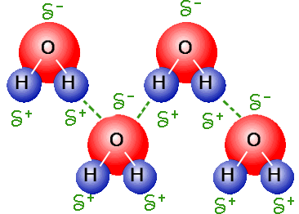
- A dipole is a molecule that has both positive and negative regions
- A dipole-dipole force is when the positive side of a polar molecular attracts the negative side of another polar molecule
- The strength of this attraction will depend on the distance and orientation of the dipoles
- The molecules need to be very close to each other like a liquid in order to work
Hydrogen Bonds
- Hydrogen bond is an attraction between a slightly positive hydrogen on one molecule and a slightly negative atom on another molecule
- Hydrogen bonds are a type of dipole-dipole force
- The most electronegative elements are all found in the top right corner of the periodic table
- The large electronegativity difference between hydrogen atoms and fluorine, oxygen and nitrogen causes hydrogen bonds to be the strongest of all intermolecular forces
- The relative strength of intermolecular bonding is:
  - London Dispersion Forces < dipole-dipole forces < hydrogen bonds
4.5 | Metallic bonding
4.5.1 | A metallic bond is the electrostatic attraction between a lattice of positive ions and delocalized electrons
4.5.2 | The strength of a metallic bond depends on the charge of the ions and the radius of the metal ion
4.5.3 | Alloys usually contain more than one metal and have enhanced properties
4.5.4 | Explanation of electrical conductivity and malleability in metals
4.5.5 | Explanation of trends in melting points of metals
4.5.6 | Explanation of the properties of alloys in terms of non-directional bonding

Metallic bonding
- A metallic bond is the electrostatic attraction between a lattice of positive ions and delocalized electrons
- The strength of a metallic bond depends on the charge of the ions and the result of the metal ion
- Metals conduct electricity because they have mobile delocalized electrons. When a potential is applied to a piece of metal, the mobile electrons move through the metallic structure and carry an electric current.
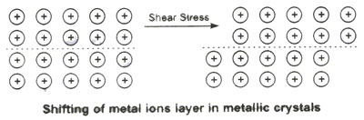
- Metals are malleable and ductile
- This is because the layers of metals can slide over each other when metals are bent, hammered or stretched without breaking the metallic bond
- Characteristics of metals are:
  - They are good conductors of heat and electricity because of the delocalized electrons in their structures
  - Have highest conductivity when they are aqueous or melted and the lowest conductivity when they are gases
  - Shiny, the delocalized electrons in the metallic structure reflect light
- Since metals have low electronegativity values, they can lose electrons easily to form positive ions
- Since non-metals have high electronegativity values they can gain electrons to form negative ions
Alloys
- Different metals are often melted together, mixed and then allowed to cool
- The resultant solid is called an alloy
- Alloys usually contain more than one metal and have enhanced properties
- The properties of a metal can be significantly altered by adding small amounts of another substance, usually another metal
- The production of alloys is possible because of the non-directional nature of the delocalized electrons, and the fact that the lattice can accommodate ions of different sizes
- Alloys are usually more stronger than regular metals. This is because if different atoms are present, the regular network of positive ions will be disturbed
- The atoms of a different size make it harder for layers of positive ions to slide over each other and thus prevent bending or denting of the metal.
Types of Bond comparison
Type of bonding | Ionic | Metallic | Simple Covalent | Giant Covalent
Melting point | Very high  Requires a large amount of energy to break bond | Medium to high  Depends on size and charge of ions | Low  Weak bond between molecules | Very high  Requires a large amount of energy to break all covalent bonds
Volatility | Low  Solid at room temperature due to high boiling point. Difficult to vaporize | Usually low  Solid at room temperature, high boiling point  (Mercury is a liquid) | High  Easy to break the weak intermolecular forces between molecules | Low  Usually solids at room temperature and high boiling points
Electrical conductivity | Conduct electricity when in liquid state  Ions are free to move and are not held in a lattice | All conduct electricity in solid state  Delocalized electrons allow electrical current to be conducted | Polar molecules form ions when they dissolve | Delocalized electrons in graphite  Others do not have free particles or electrons
Solubility | Some will dissolve in a polar solvent  The attraction to the solvent must be greater than the attraction to other ions | Some metals react with water to make alkaline solutions | Polar molecules dissolve in polar substances, non-polar molecules dissolve in non-polar substances | Do not dissolve in any solvents

14.1 | Further aspects of covalent bonding and structure
14.1.1 | Covalent bonds result from the overlap of atomic orbitals. A sigma bond is formed by the direct head-on/end-to-end overlap of atomic orbitals, resulting in electron density concentrated between the nuclei of the bonding atoms. A pi bond is formed by the sideways overlap of atomic orbitals, resulting in electron density above and below the plane of the nuclei of the bonding atoms
14.1.2 | Formal charge (FC) can be used to decide which Lewis (electron dot) structure is preferred from several. The FC is the charge an atom would have if all atoms in the molecule had the same electronegativity. FC = (Number of valence electrons) – ½ (Number of bonding electrons) – (Number of non-bonding electrons). The Lewis (electron dot) structure with the atoms having FC values closest to zero is preferred
14.1.3 | Exceptions to the octet rule include some species having incomplete octets and expanded octets
14.1.4 | Delocalization involves electrons that are shared by/between all atoms in a molecule or ion as opposed to being localized between a pair of atoms
14.1.5 | Resonance involves using two or more Lewis (electron dot) structures to represent a particular molecule or ion. A resonance structure is one of two or more alternative Lewis (electron dot) structures for a molecule or ion that cannot be described fully with one Lewis (electron dot) structure alone
14.1.6 | Prediction whether sigma (σ) or pi (π) bonds are formed from the linear combination of atomic orbitals.
14.1.7 | Deduction of the Lewis (electron dot) structures of molecules and ions showing all valence electrons for up to six electron pairs on each atom
14.1.8 | Application of FC to ascertain which Lewis (electron dot) structure is preferred from different Lewis (electron dot) structures
14.1.9 | Deduction using VSEPR theory of the electron domain geometry and molecular geometry with five and six electron domains and associated bond angles
14.1.10 | Explanation of the wavelength of light required to dissociate oxygen and ozone
14.1.11 | Description of the mechanism of the catalysis of ozone depletion when  catalyzed by CFCs and NOx.
Overlapping Orbitals
- Covalent bonds are formed from the overlap of atomic orbitals
  - Two orbital’s from different atoms, each containing one unpaired electron, can merge in the region of space between the two atoms
- This overlapping of two orbitals creates a bonding orbital between the two atoms
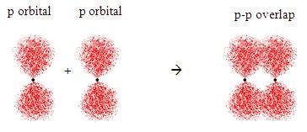
- π-bonds are formed by the sideway overlap of orbitals resulting in electron density above and below the plane of the nuclei of the bonding atom
- A sigma bond is formed by the direct head-on/end-to-end overlap of orbitals resulting in electron density concentrated between the nuclei of the bonding atoms
- Double bonds consist of one sigma bond and one pi bond
- Triple bonds consist of one sigma and two pi bonds

Resonance Structure
- Electrons have no fixed position in molecules but can be found in certain spaces (orbitals)
- Resonance structures do not change the relative positions of the atoms, but instead the electron locations
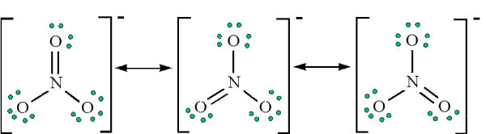
- Instead of being combined to one location electrons have a tendency to be shared between more than one bonding position, and therefore are said to be delocalized
- Delocalization involves electrons that are shared by/between more than one pair in a molecule or ion as opposed to being localized between a pair of atoms
(There is more than one location for a pair of electrons)
- The electrons from the double bond have delocalized and spread themselves equally between both possible bonding positions
Formal Charge (FC)
- Therefore, when drawing Lewis (electron dot diagrams) it is often possible to come up with multiple possible structures
- Formal charge allows us to calculate which of these structure is the most stable. To calculate formal charge:
$$FC=V-\left(\frac{1}{2}B+L\right)$$
- Where:
  - V=Valence electrons, B=# of bonding electrons, L= # of lone pair electrons
- The most stable structure is the molecule that:
  - Formal charge value closest to 0
  - The negative charges located on the most electronegative atom

14.2 | Hybridization
14.1.1 | A hybrid orbital results from the mixing of different types of atomic orbitals on the same atoms
14.1.2 | Explanation of the formation of sp³, sp² and sp hybrid orbitals in methane, ethane and ethyne
14.1.3 | Identification and explanation of the relationships between Lewis (electron dot) structures, electron domains, molecular geometries and types of hybridization
Hybridization
- A hybrid orbital results because of the mixing of different types of atomic orbitals on the same atom
- We write hybridization as a mix of the two combined levels
- To find hybridization, we can look at the Lewis structure
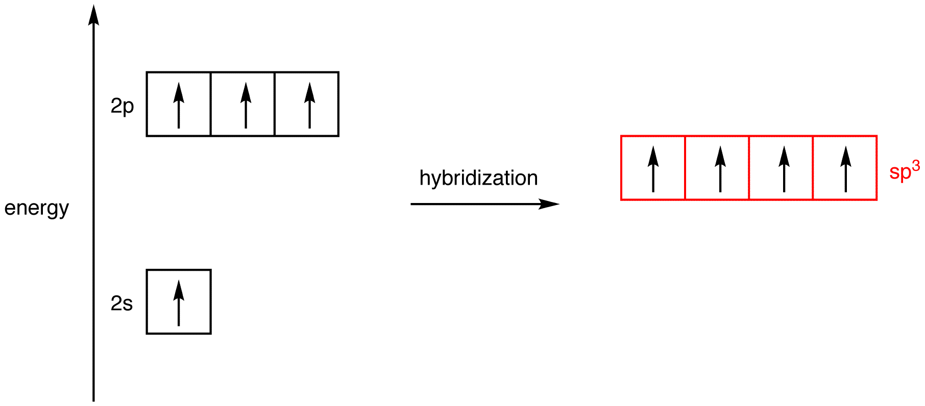

- Generally speaking:
  - If there are four electron domains around the central atom, the hybridization will be sp₃
  - If there are three electron domains, the hybridization will be sp₂
  - If there are two electron domains the hybridization will be sp

