Topic 3: Periodicity
3.1 | Periodic Table
3.1.1 | The periodic table is arranged into four blocks associated with the four sub-levels – s, p, d, and f
3.1.2 | The periodic table consists of groups (vertical columns) and periods (horizontal rows)
3.1.3 | The period number (n) is the outer energy level that is occupied by electrons
3.1.4 | The number of the principal energy level and the number of the valence electrons in an atom can be deduced from its position on the periodic table
3.1.5 | The periodic table shows the position of metals, non-metals and metalloids
3.1.6 | Deduction of the electron configuration of an atom from the element’s position on the periodic table, and vice versa
Periodic Table Arrangement
- The periodic table is arranged into 4 blocks associated with their last orbital: s, p, d and f
- Elements in the periodic table are arranged by increasing atomic number
- Group: A vertical column of elements
  - Group number is the same as the number of valence electrons
- Period: A horizontal row of elements
  - Period number is the same number of shells in the atom
  - All shells except the outer shell will be full
- There is a division between metals and non-metals. Metals are on the left and non-metals are on the right
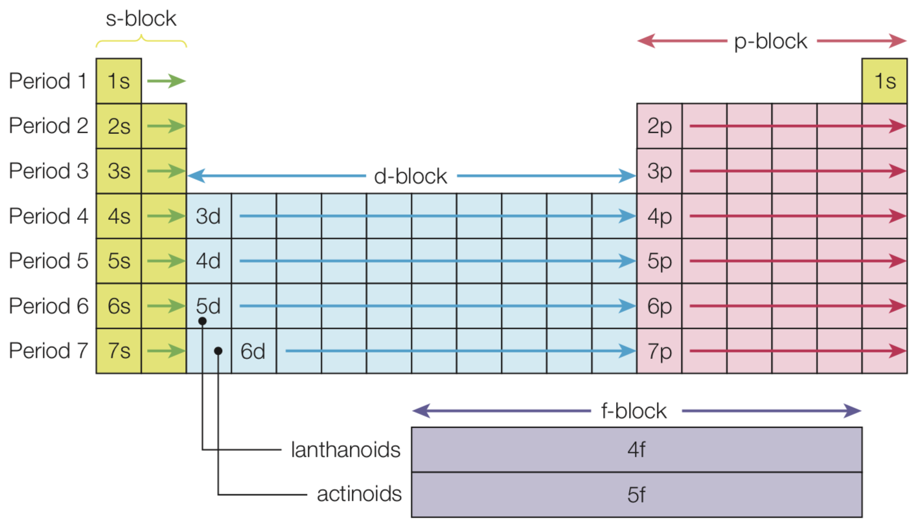
- The farther sub-level occupied is found by the location of the element (which block it is in):
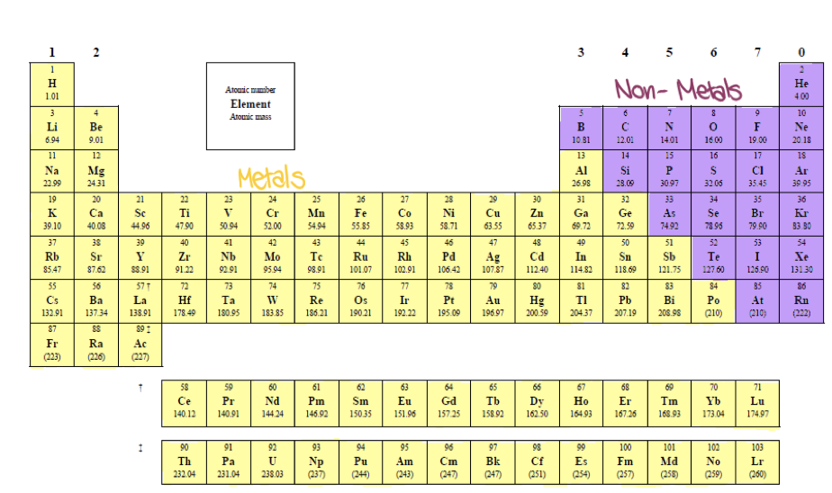

- The location of the following families of the periodic table must be known: alkali metals, alkali earth metals, halogens, noble gases, transition metals, lanthanides and actinoids
3.2 | Periodic trends
3.2.1 | Vertical and horizontal trends in the periodic table exist for atomic radius, ionic radius
3.2.2 | Trends in metallic and non-metallic behavior are due to the trends above
3.2.3 | Oxides change from basic through amphoteric to acidic across a period
3.2.4 | Prediction and explanation of the metallic and non-metallic behavior of an element based on its position in the periodic table
3.2.5 | Discussion of the similarities and differences in the properties of elements in the same group, with reference to alkali metals and halogens

Definitions
Atomic Radius – The distance from the nucleus to the outermost electron
Ionic Radius – The distance from the nucleus to the outermost electrons in an ion
First ionization energy – The energy required to remove one mole of electrons from one mole of gaseous atoms. This is shown by: $X_{(g)}→X_{(g)}^{+}+e^{-}$
Electron affinity – The energy released when one mole of an electron is added to one mole gaseous atoms. This is shown by: $X_{(g)}+e^{-}→X_{(g)}^{-}$
Electronegativity – A measure of the attraction an atom has for a shared pair of electrons in a covalent bond

Trends in the Periodic Table
- Periodicity refers to repeating trends or patterns of physical and chemical properties in elements
Atomic Radius
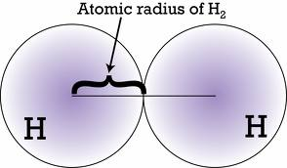
- Atomic radius increases down a group as the number of electron shells increases
- Atomic radius decreases across a period
  - This is because electrons are added to the same main energy level (n=3) the nuclear charge also increases
  - The attraction between the nucleus and the outer electrons increases resulting in a smaller radius
Ionic Radius
- Ionic radius of positive ions decrease across a period as the number of protons in the nucleus increases but the number of electrons remain the same
- Ionic radius of negative ions decrease across a period as the number of protons in the nucleus increases but the number of electrons remains the same
Ionization energy
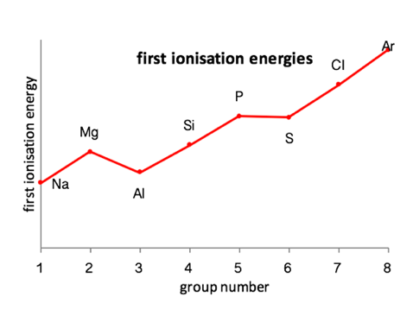
- Ionization energy increases across a period
- The increase in nuclear charge across a period causes an increase in the attraction between the outer electrons and the nucleus makes the electrons more difficult to remove
- Ionization energy decreases down a group
- The electron being removed is from the energy level furthest from the nucleus so it gets easier to remove valence electrons as atomic radius increases down a group
  - Valence Electrons: The outermost electrons of an atom
Electron affinity
- Generally, metals have a low EA and non-metals have a higher EA
- The greater the distance between the nucleus and the outer energy level, the weaker the electrostatic attraction and the less energy is released when an electron is added to the atom
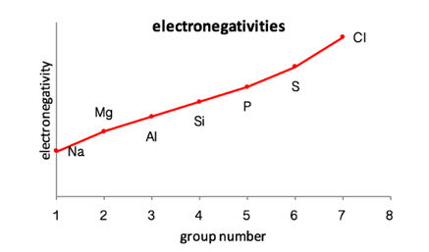
Electronegativity
- Metals have low electronegativities because they lose electrons easily
- Non-metals have high electronegativities as they gain electrons to complete their outer shell
- Generally, electronegativity tends to increase across a period and decrease down a group

Melting points
- Melting points generally increase across a period until group 14, then they decrease
- This depends on the type of bonding (covalent, ionic or metallic), structure (ionic lattice, molecular covalent, giant covalent, or metallic structures), and strength of metallic bond
Metallic Character
- Metallic character: How easily an atom can lose electrons
- Metallic character is displayed by metals, which are all on the left-hand side of the periodic table including alkali metals, alkalie earth metals, tarnsition metals the lanthanide and actinides, and the basic metals
- Metallic character increases down a group
- Metallic character decreases across a period
Trends Across: Group 1 – The Alkali Metals
- Atomic/Ionic radius increases down the group as there are more electron shells
- First ionization energy decreases down the group as the valence electron is further from the nucleus so its easier to remove
- Electronegativity decreases because of increased distance and shielding
- Melting points decrease as atoms become larger and therefore metallic bonds becomes weaker
- Reactivity increases down the group as the valence electron is easier to lose, due to shielding
Trends Across: Group 7 – Halogens
- Same trends as alkali metals except melting points increase as Van der Waal forces becomes greater with more electrons
- Reactivity decreases down group as with each consecutive element the outer shell gets further from the nucleus. So the attraction between the nucleus and electrons gets weaker, so an electron is less easily gained.
Trends Across: period 3
- In period 3, sodium, magnesium and aluminum are metals located on the left of period 3
  - Metals are shiny solids that are excellent thermal and electrical conductors. They are ductile and malleable
  - Metals are reducing agents and form cations. Their oxides and hydroxides behave like bases and neutralize acids
- Aluminum oxide, however is insoluble in water and amphoteric
- Phosphorus, sulfur, chlorine and argon are non-metals located on the right of period 3
  - Non-metals can be solids, liquids are gas
  - Non-metals tend to be oxidizing agents and form anions. Their oxides tend to be acidic and are neutralized by bases
- All period three oxides will react with water to form either an acidic or alkali (basic) solution:
Group | 1 | 2 | 13 | 14 | 15 | 16 | 17 | 18
Element | Na | Mg | Al | Si | P | S | Cl | Ar
Structure of element | Giant Metallic |  |  | Giant Covalent | Simple Covalent
Structure of Oxide
Formula of oxide | Na₂O | MgO | Al₂O₃ | SiO₂ | P₄O₁₀ | SO₃ | Cl₂O₇
 |  |  |  |  | P₄O₆ | SO₂ | Cl₂O
Acid-Base character of oxide | Basic |  | Amphoteric | Acidic |  |  |  | No oxide

13.1 | First row d-block elements
13.1.1 | Transition elements have variable oxidation states, form complex ions with ligands, have colored compounds, and display catalytic and magnetic properties
13.1.2 | Zn is not considered to be a transition element as it does not form ions with incomplete d-orbitals
13.1.3 | Transition elements show an oxidation state of +2 when the s-electrons are removed
13.1.4 | Explanation of the ability of transition metals to form variable oxidation states from successive ionization energies
13.1.5 | Explanation of the nature of the coordinate bond within a complex ion
13.1.6 | Deduction of the total charge given the formula of the ion and ligands present
13.1.7 | Explanation of the magnetic properties in transition metals in terms of unpaired electrons
Transition metals
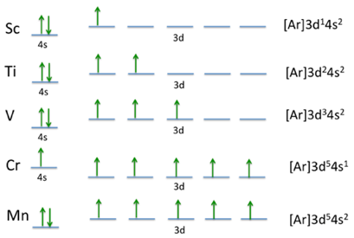
- Transition metals: Elements whose atoms have incomplete d-orbitals or can form positive ions with an incomplete d sub-level
  - Zinc is not considered a transition element as it does not have an incomplete d orbital
- Transition metals have variable oxidation states, display catalytic and magnetic properties, form complex ions with ligands and have colored compounds (13.2)
Oxidation states
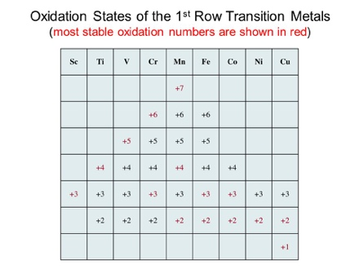
- All the d-block elements (except scandium and zinc) can exist in more than one oxidation state
- There is no increase in successive ionization energies in transition metals. There is only a slightly higher effective nuclear charge so there are no great jumps in successive ionization energies. So, ions can lose varying numbers of electrons with the same relative ease, depending on the oxidative nature of the surrounding environment.
- All transition elements can form ions with an oxidation number of +2 (by losing the 2e⁻ from the 4s shell). So, transition elements show an oxidation state of +2 when the s-electrons are removed
- In addition, each element can form a number of ions with different oxidation numbers
- In order to form ions:
  - Electrons in the 4s subshell have less energy than the 3d subshell
  - Ions are formed as the electrons are lost from the 4s and 3d subshell’s
  - Electrons are removed from the valence shell (4s) before the 3d subshell
Properties of transition metals
Physical properties | Chemical properties
- High electrical and thermal conductivity  - High melting point  - High tensile strength  - Malleable (Can be beaten into shape)  - Ductile (Can be drawn into wires) | - Variable oxidation states  - Formation of complex ions  - Colored compounds  - Catalytic behavior  - Fe in the Haber process  - V₂O₅ in the Contact process  - Fe²⁺

Metal complexes
- Transition metals and transition metal complexes may be classified as diamagnetic, paramagnetic or ferromagnetic
- Any unpaired electrons will cause metals to be paramagnetic. And the more unpaired electrons there are, the stronger it becomes. This is because the unpaired electron (which is negatively charged and spinning) creates a small magnetic field itself
- If all the electrons are paired, the effect of the spinning is cancelled out – so the small magnetic field is not created
Diamagnetic
- No unpaired electrons. Weakly repelled in an external magnetic field
Paramagnetism
- One or more unpaired d-orbital electrons. Attracted by an external field
- Paramagnetism increases with the number of unpaired electrons
Ferromagnetism
- Only occurs in iron, cobalt and nickel. The attraction to a magnetic field is much stronger
- In these metals large numbers of unpaired electrons line up in the regions called domains
Ligands
- Ligands are molecules or ions with a lone pair of electrons (or more) that form coordinate covalent bonds with a central metal ion
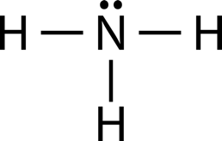
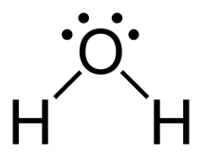
- Ligands such as H₂O and CN⁻ are known as monodentate ligands as they use just one lone pair of electrons to form a coordinate covalent bond to a central metal ion
- Polydentate ligands are species that have more than one lone pair of electrons to form coordinate covalent bonds to a central metal ion
- Example: H₂O and NH₃ are both ligands because they have a lone pair of electrons
Question: Deduce the charge on the central metal ion given the formula of the ion and the ligands present
$[Co(H_{2}O)_{6}]^{2+}$
H₂O is a neutral molecule (No charge). The charge on the complex ion is 2+ ∴oxidation state is 2+

13.2 | Colored complexes
13.2.1 | The d sub-level splits into two sets of orbitals of different energy in a complex ion
13.2.2 | Complexes of d-block elements are colored, as light is absorbed when an electron is excited between the d-orbitals
13.2.3 | The color absorbed is complementary to the color observed
13.2.4 | Explanation of the effect of the identity of the metal ion, the oxidation number of the metal and the identity of the ligand on the color of transition metal ion complexes
13.2.5 | Explanation of the effects of different ligands on the splitting of the d-orbitals in transition metal complexes and color observed using spectrochemical series
13.2.6 | Construction of equations to explain the pH changes for reactions of Na₂O, MgO, P₄O₁₀ and the oxides of nitrogen and sulfur with water

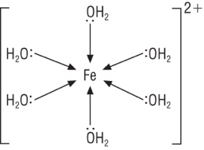
Complex ions
- A complex is formed when ligands dative covalently (coordinate bond) bond to a central metal ion (or atom) by donating a pair of electrons
- Ligands can be replaced by other ligands and the complexes will have different colours
- The number of lone pairs bonded to the metal ion is known as the coordination number
- In this example H₂O is the ligand as it surrounds a central metal ion and it has a coordination number of 6
Colored Compounds
- Compounds of group 1, 2 and 3 are typically white. Similarly compounds of zinc, one of the d-block elements not classified as a transition metal is also white
- Complexes of d-block elements are colored, as light is absorbed when an electron is excited between the d-orbitals:
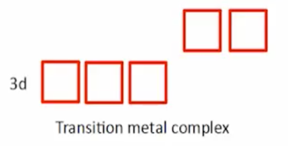
  - As the ligand approaches the metal to form a complex ion the non-bonding pairs of electrons on the ligand will repel the d orbital causing the five d orbitals to split: 3 to lower energy and two to higher energy

  - The energy gap between the two levels correspond to the wavelength of visible light
  - Electrons can transition from the lower to a higher set of d orbitals by absorbing certain wavelengths of light. The complementary color of the color that is absorbed is transmitted
- The greater the oxidation state the greater the split between the d-orbitals
- There are four factors that affect the color of a transition metal:
  - Nature of the transition element
  - The identity of the metal ion
  - The identity of the ligand
  - Oxidation State
The Spectrochemical series
- The spectrochemical series arranges ligands in order of their ability to split d-orbitals in an octahedral complex ion

- Iodine ions cause the smallest splitting while the carbonyl group, while CO causes the largest splitting

